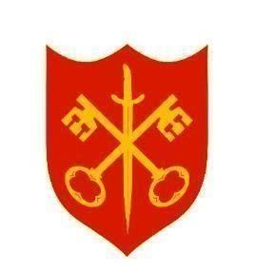
The Abbey Church of St Peter & St Paul
serving the communities of Bourne
Dyke Twenty and Cawthorpe

PARISH MAGAZINE




JUNE 2026 50p
www.bourneabbey.uk Bourne Abbey Church Group

WORSHIP AT THE ABBEY DURING JUNE
Morning Prayer and Evening Prayer are said every weekday at 9.00am and 5.30pm The Abbey is open between 9am and 6pm.

Tuesday 2nd |  | Said Eucharist CW | 7.00pm
Thursday 4th |  | Holy Communion BCP | 10.00am
Sunday 7th | First Sunday after Trinity | Sung Eucharist CW | 11.00am
 |  | Sung Evensong | 6.30pm
Tuesday 9th |  | Said Eucharist CW | 7.00pm
Thursday 11th |  | Holy Communion BCP | 10.00am
Sunday 14th | Second Sunday after Trinity | Sung Eucharist CW | 11.00am
Tuesday 16th |  | Said Eucharist CW | 7.00pm
Thursday 18th | MU Corporate Communion | Holy Communion BCP | 10.00am
Sunday 21st | Third Sunday after Trinity | Sung Eucharist CW | 11.00am
 |  | Sung Evensong | 6.30pm
Tuesday 23rd |  | Said Eucharist CW | 7.00pm
Thursday 25th |  | Holy Communion BCP | 10.00am
Saturday 27th | Lincoln Cathedral | Ordination Service | 10.30am
Sunday 28th | Fourth Sunday after Trinity | Said Communion CW | 9.00am
 |  | All Age Eucharist | 11.00am
Monday 29th | Saints Peter and Paul
Tuesday 30th |  | Said Eucharist CW | 7.00pm


Please pray for those to be ordained this Petertide,
among them ISAAC FRISBY
to be ordained priest
by Nicholas, Bishop of Grantham and Acting Bishop of Lincoln
in the Cathedral Church of the Blessed Virgin Mary of Lincoln
at 10.30am on 27th June

We welcome the names of those who are ill or awaiting an operation so that prayers may be offered for them. We also welcome the names of loved ones departed to be inscribed in the Abbey’s Book of Remembrance.
Contact Churchwarden Jennifer Maclean
THE ABBEY’S BOOK OF REMEMBRANCE FOR JUNE

5th Geoffrey Moorhouse : 7th Phyllis Cope : Elizabeth Fels
8th James York : Doreen Newell : 10th Sheila Lee
11th Patricia Crosby : Ian Darby : William Johns
13th William Hewitt : Albert Cheetham : 14th Phyllis Sinfield
15th Janet Staples : Guy Cudmore : 16th Howard Bostock
18th Phyllis Sheffield : 21st Jean Thornton
24th Anthony Saunders : 26th Christina Davies
27th Olwen Hughes : 28th Adrian Todd
29th John Stennett : Brenda Read : 30th John Cushen

Guiding Star

My dearest Lord, be thou a bright flame before me, be thou a guiding star above me, be thou a smooth path beneath my feet, be thou a kindly shepherd behind me, now and ever more.
ST COLUMBA (521 – 597) Feast day 9th June

THE VICAR’S LETTER
Dear Friends in Christ,
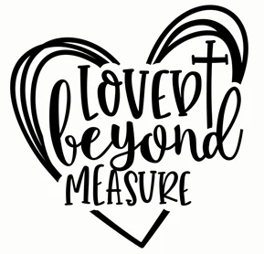
We live in a fast-paced, image-driven world. We live in a world where the smiles must always be bright, where faith must always be strong and where our prayers must always be confident. But … what happens when we feel broken, weary, anxious or distant from God? Too often we succumb to those external pressures which demand that we hide our pain and pretend to be ‘fine’ even when we are not. But scripture tells a different story, a story that reminds us: It’s okay to not be okay!
Throughout the gospel narrative, Jesus consistently draws near to those who are hurting. He meets the woman at the well in her shame (John4); the bleeding woman in her despair (Mark 5); the disciples in their fear and doubt (John 20). Jesus does not wait for people to get their lives together before extending grace. Instead, he brings healing because they are not okay.
Jesus said: “Come to me, all you that are weary and are carrying heavy burdens, and I will give you rest.” Jesus does not say: Come to me when you are strong! His invitation is to those who are feeling weak and overwhelmed. Jesus does not despise our weakness, instead he welcomes it and offers a level of relief that can come from nowhere else.
In his psalms, King David, described as a man after God’s own heart, wrote of anguish, doubt, anger and sorrow. He did not hide his emotions; he brought them to God in raw honesty. In Psalm 10, verse 1, we read: Why, O Lord, do you stand far off? Why do you hide yourself in times of trouble? And, in Psalm 42, verse 3, we read: My tears have been my food day and night …These are not the words of someone who is ‘okay’. These are the cries of someone struggling – and yet, they are part of sacred scripture. In God’s world there is room for lament, reminding us that vulnerability before God is not weakness, it is worship.
The early Church, as described in the Acts of the Apostles, was marked by its authenticity, its vulnerability and its shared burdens. Today, however, churches can sometimes feel like places where only the ‘perfect’ belong. But, if the Church were to reflect the true heart of Christ, then it would see itself primarily as a refuge for the broken – a place where it is safe to say: I’m not okay right now! In his letter to the Galatians, Paul wrote: “Bear one another’s burdens, and in this way you will fulfil the law of Christ.” We fulfil God’s law not by perfection, but by having compassion.
Rather than hiding our struggles, scripture encourages us to boast of them, because that is where God’s grace becomes most visible. Our pain can be the very place where God becomes evident in the most powerful ways; the place where he reminds us, and those around us, that he is near to the broken-hearted.
If you are reading this as you are travelling through a time of sadness, anxiety, doubt or exhaustion – take heart. Your feelings of weakness have nothing to do with failure. You are human, and your Saviour understands that. Jesus himself wept; Jesus was betrayed; Jesus sweat blood in the Garden of Gethsemane. Jesus has been there before you – he knows what it feels like to not be okay!
It is our calling, in our community, in our churches and in our hearts, to stop pretending and to start embracing grace. A place where we can say with courage and compassion: It’s okay to not be okay. You are not alone; and you are deeply and endlessly loved.
With every blessing to you all,
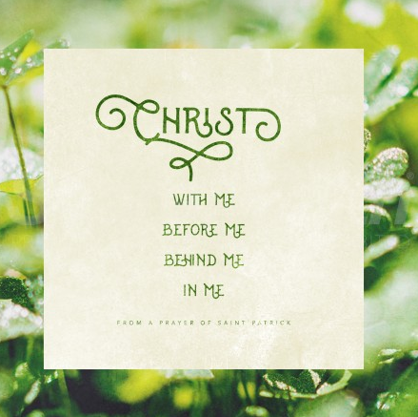
Fr Stephen

MU REPORT - MUSICAL NOTES FROM THE VICAR
At our May meeting Fr. Stephen gave us an eagerly anticipated and entertaining talk about his career as a musician, which started early. He passed his Grade 8 keyboard exam at the age of 12. He proceeded to study organ, voice, conducting and composition at the Royal Academy of Music, leading to further study with Olivier Messiaen in Paris and then conducting in New York. The famous conductor Sir Adrian Boult took him under his wing and gave him conducting opportunities, sharing concerts with him.
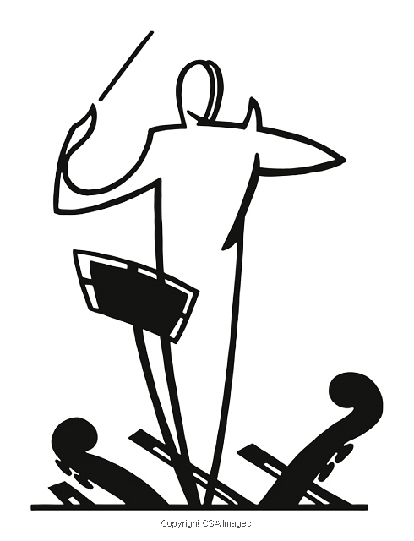
When Stephen returned to London, he was anticipating continuing to work as a classical musician but by chance he was asked to fill in on the keyboard at a performance of ‘Jesus Christ Superstar’ in a West End theatre. This completely changed the direction of his career. Over the next years he conducted, acted as a voice coach, and directed in a dizzying number of hit musicals in London. Fr. Stephen has also conducted choirs and orchestras throughout the UK, Europe and the United States. From early in his career, he became an established composer for TV and radio.
After marrying and having a family, Fr. Stephen realised that continuing in his work would mean that he missed seeing his children grow up. So he took the decision to leave the professional podium and to train as a teacher. He completed a degree in Philosophy at Sussex University and became a Senior Research Fellow there, combining this with leading Music and Performing Arts faculties in two schools. He also continued to play the organ in church and to lead choirs.
Fr. Stephen had first felt a calling to the ordained ministry when he left school. This calling was recognised by the Bishop for whom he often played the organ at ordination services in parish churches. And so it came to be. When Vicky became head of a prestigious local school in Lincolnshire Fr. Stephen moved to become Vicar of the parish of Corby Glen and from there to Bourne Abbey.
Thank you, Fr. Stephen, for sharing your fascinating life story (so far) which we all enjoyed enormously.
On June 3rd there will be a Garden Party hosted by Elizabeth Page in her garden. Members are invited to bring a guest if they wish. Sarah Speers , MU Leader

CHURCHWARDEN’S CHAT
Alpine butterflies were seen on the tower roof last month. No, not some exotic form of papilio but mountaineering knots to secure a steeplejack’s lifelines to the tower. Now read on. .
Once every five years each church must undergo its ‘QI’ or quinquennial inspection. An architect approved by the Diocese undertakes a full survey of the church building, inside and out, and submits a report to the PCC with recommendations for any work that needs to be done and the suggested timescale. This can range from major works to small but important actions in the immediate to longer-term, all of which are intended to maintain the integrity of the building for the future.
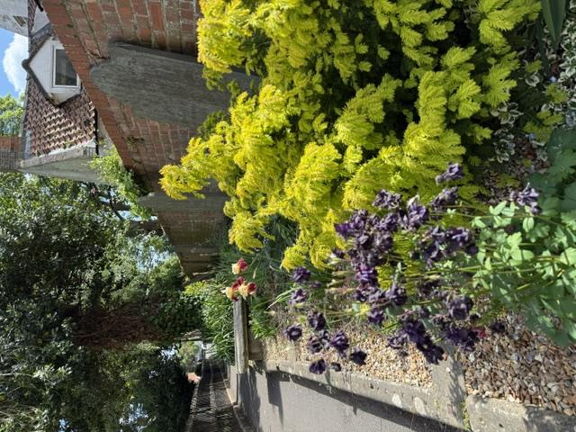
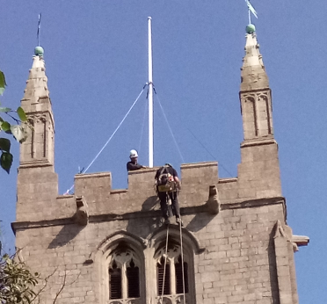
The Abbey had its latest QI in March. Our architect employed two pieces of equipment new (to me) since the last inspection: a drone for photographing the roof and tower; and something resembling an X-ray machine as part of the structural survey. Photographs taken from the drone identified an area of the tower that merited close visual inspection, which required the engagement of a steeplejack, who abseiled down to the area of interest from the top of the tower. It was the school lunch hour and comments from some pupils coming along Church Walk varied from ‘I would love to do that’ (3) to ‘You wouldn’t get me up there’ (1)!
The area immediately around the church is maintained through the efforts of the joint Abbey/U3A Garden Group. The results are visible along the pedestrian part of church walk, within the Garden of Remembrance where the replacement hedge is starting to grow, and along the margins of the Abbey building where weeds are removed before they can become established and potentially damage the stonework. It is, however, disappointing that some people continue to discard their rubbish into the flowerbed along Church Walk, despite the presence of litter bins at each end of that pathway.
Jennifer Maclean
xxxxxxxxxxxxxxxxxxxxxxxxxxxxxxxxxxxxxxxxxxxxxxxxxxxxxxxxxxxxxxxxxxxxxxx
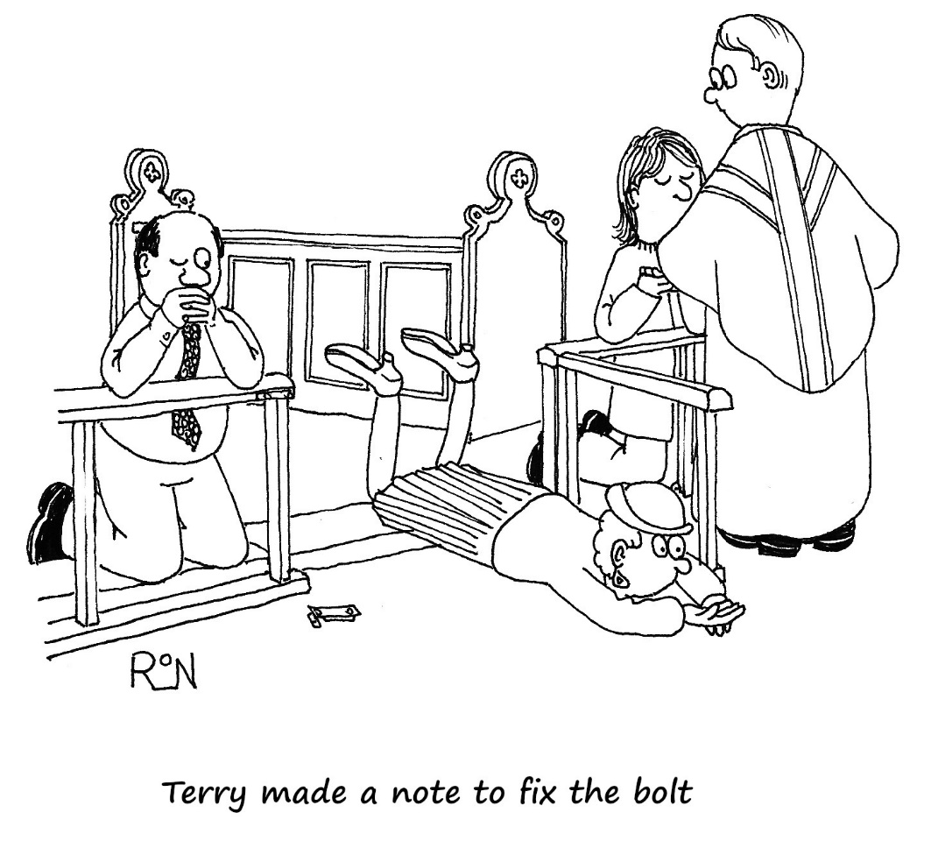

xxxxxxxxxxxxxxxxxxxxxxxxxxxxxxxxxxxxxxxxxxxxxxxxxxxxxxxxxxxxxxxxxxxxxxx

FROM LEN CAUSTON
This year I am again taking part in the "MARCHFORMEN" in aid of Prostate Cancer UK,
which will take place on Saturday 13th June 2026
in Battersea Park, London.
If anyone would like to sponsor me or make a donation, I will have the relevant form with me in church or you can sponsor me through my "Just Giving" Page at:
https://marchformen.prostatecanceruk.org/fundraising/matthews-fundraising-page1145


ATTENDING A GARDEN PARTY AT BUCKINGHAM PALACE

The King holds three Garden Parties a year to honour members of the public for community service and invites 8000 guests to each one. Hall and I were privileged to be invited to one of these. It was a very chilly but dry afternoon and included a great deal of queuing. There are two entrances to this event, one through the main gates of Buckingham Palace and the other through the Hyde Park Corner Gate, which we used. We arrived with an hour in hand, to discover that the queue to get in was already stretching as far as the eye could see. It all moved forward quite quickly and we had to present both our invitation and identification.

Once inside we wondered at the Palace Gardens, immaculately kept and with shrubs of all kinds in glorious flower. There were two bands playing popular music to entertain us. We strolled in the direction of the Palace, past the lake, past the marquees for the royal party and diplomatic corps to take their tea and joined one of 20 queues to get our own tea. There were 20 impressive flower displays in tall vases in the tea tent, 20 tea urns, a generous selection of sandwiches and cakes, and myriad staff to serve. It is estimated that at each event guests consume approximately 27,000 cups of tea, 20,000 sandwiches and 20,000 slices of cake. The cup of tea and food are put on one rectangular plate, and most people eat standing as there are not enough chairs to seat everyone.

Despite the temperature most ladies were wearing lightweight dresses, positively flimsy
among the younger guests, with hats and fascinators galore. Those wearing flatter shoes
fared better than those struggling with high heels on the grass. There were an impressive
number of gentlemen in morning dress, with top hats and furled umbrellas. We had a good view of the arrival of guests at the royal marquee. All the men were in morning dress and all the ladies had hats, and cream-coloured flat shoes seemed to be the popular choice of footwear. We had plenty of time to observe this since we were in another queue lining the roped off section in front of the royal tent. We were waiting for the King and Queen to emerge from the lane they were slowly making their way down and speaking to people selected in advance. All the queues were 5 or 6 people deep, tightly packed and craning their heads. Indication of the royal progress down the lane was provided by the heads of the spears carried by the Beefeaters escorting their Majesties and the forest of phones which rose to take photos as they passed by. We were standing there for more than an hour before Queen Camilla suddenly appeared and walked across the green to the tent. Easily missed.

King Charles did not emerge from the throng for another half hour and we only had a
glimpse of him as he made his way for what must have been a very welcome cup of tea.

By this time the chill factor was winning and we made our way to the main gates of the
Palace to exit. The whole event was so well organised, so good humoured, and so much
appreciated by everyone present. We left feeling very privileged to have been there and
patriotic in the best sense.
Sarah Speers

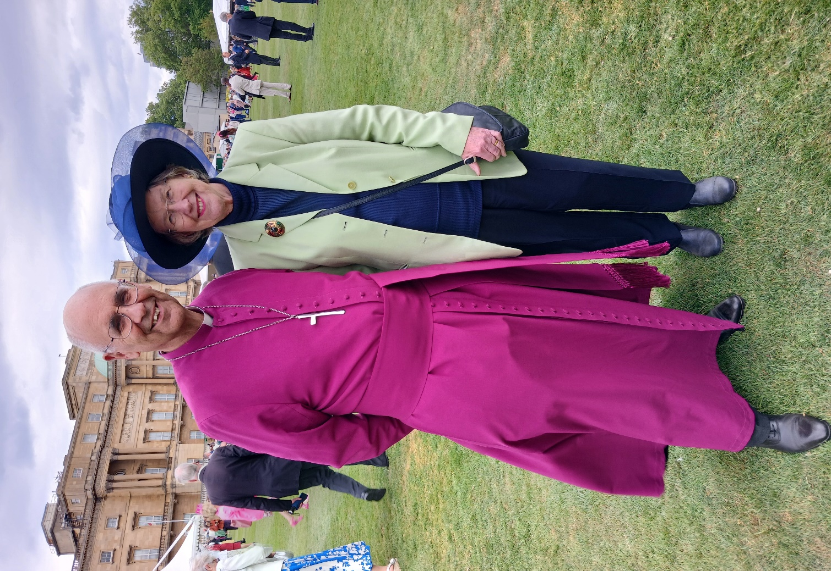




0n Saturday 20th June
Messy Church
is celebrating
Father’s Day
from 2 – 4pm
in the church hall


Families and accompanied children all welcome!
Bourne Abbey’s patron saints are Peter and Paul. In this, the month when we celebrate them, here are two pieces from ‘An Anthology of the Church Year’, edited by H J Richards.

BETRAYER
There’s something magnificent about the way the Bible is so open and frank about its heroes. Most religious groups have taken care to present a very hygenic portrait of their leaders. And if these leaders ever let them down in times of crisis, you’d hardly supect it from the official documents. Yet Jews and Christians haven’t been afraid to be more honest (at least, once upon a time!)
In both the Jewish and the Christian Bible, the religious leaders are again and again shown up in all their human weakness. Jacob the cheat and trickster. David the adulterer and murderer. Solomon the sensual weakling who couldn’t hold his people together. The kings of Israel almost universally condemned for ‘doing that which was evil in the sight of the Lord’. Even the people of Israel as a whole have their faults listed and their weaknesses exposed, in a way you or I wouldn’t care to do for our own family.
And it’s the same in the New Testament. The Apostles are invariably said to have been so stupid that they didn’t understand what Jesus was saying. Thomas is so lacking in faith that he asks for Jesus’ fingerprints, as it were, before he’ll commit himself. And even Peter, the acknowledged leader of the Christian community, so loud in promises, and so poor in performance. In the long run, says the gospel, he didn’t do any better than Judas himself. He betrayed Jesus just as deeply.
I find it encouraging that the Bible tells us stories like that. They’re true to life. I can recognise myself in them. The good news is that people like that are forgiven.
Even Peter. Indeed, Peter’s forgiveness is central to the gospel story. In a way, the whole gospel is based on his expereince of being forgiven, in spite of his failure. And that gives me hope and encouragement. And I need to be encouaged like that. I need to be assured that God loves me, not because I’m godly, but because he is.
HUBERT RICHARDS

JAILBIRD
A parish needing a new incumbent advertised for applications. A letter was eventually received from an applicant setting out his qualifications:
‘ I am regarded as a powerful preacher, and I have had some success as a writer. I am said to be a good organiser, and I have been a leader in most of the places to which I have gone. I have to admit that I have never preached in the same place for more than three years at a time, and that in some places I have had to leave because my work caused riots. The fact is, I have not got on too well with the religious leaders in many of the towns where I have preached. Some of them have attacked me and even taken me to court. As a result I have been in jail four or five times, though not because of any real crime. My health is none too good but I can still manage to get a good deal done, though I am fifty years old. I have regularly worked at a trade to help me pay my way. If I can be of any use in your parish, I shall do my best for you.’
The letter was read out to the PCC. They all felt it must be sort of joke. How could they seriously consider an application from such a sickly, half-time, trouble-seeking ex-jailbird? In any case he was far too old. Who was he? The secretary looked at the bottom of the page. ‘Paul the Apostle.’
UNKNOWN

A disciple asked the Master what the first requirement was for becoming a saint.
“You must be prepared to be ridiculed, ignored and starving until you are forty-five.”
“What will happen when I’m forty-five?”
“You’ll have got used to it.”
ANTHONY DE MELLO SJ (1931 – 1987)

Miscellaneous observations of modern life …
Government expert: one who complicates simple things.
Gentleman: one who holds the door open while his wife carries in the groceries.
Friend: what you call a person who dislikes the same people you dislike.
Do not confuse a reckless driver with a wreckless driver.
Reformer: one who makes his associates feel miserable about their pleasures.
Prosperity: something private citizens create, for which politicians take credit.
Politician: the fellow who shakes your hand before the election and shakes you after the election.
We always like those who admire us, but we do not always like those whom we admire. – La Rochefoucauld
One learns in life to keep silent and draw one’s own confusions. – Cornelia Skinner
At a certain age some people’s minds close up; they live on their intellectual fat. – W L Phelps

The first half of our lives is ruined by our parents and the second half by our children. – C S Darrow
When a boy marries, two opinions prevail at the home he is leaving. His mother thinks he is throwing himself away, and his sisters think the girl is. – Anon
Why is it that when you tell a man there are 400 billion stars he will believe you, but when you tell him there’s wet paint, he has to touch it?

If your supermarket has been lowering prices every day, how come nothing is free yet?


FARMERS, TIKTOK AND PEOPLE KISSING COWS
Here is a story that you couldn’t make up. There is a craze on TikTok of influencers interacting with cute cows, and they have attracted thousands of followers.
So now people are wandering onto farms in search of cute cows, to cuddle and kiss for the camera. Highland type cattle, with their ‘floofy’ adorable thick fringes and shaggy coats are especially targeted. Except that the cows, however cute, do not know about TikTok. So they do not welcome complete strangers who want to wrap their arms around their necks, or pull their tails about, to get “good online content”.
One Yoga teacher entered a field and did handstands among bewildered cows, to create an interesting backdrop to a video. A father slung his son up on top of a cow’s back and was surprised when the cow ran off with his son still on board. 30 people cornered one herd at sunset and used flashing cameras to take pictures and videos of the frightened animals.
The farmers are worried. As one said: “these people risk being trampled, charged or attacked. Cows are not domesticated animals. They are highly unpredictable creatures. They can kick hard. If you upset one, you will regret it – and you will never out-run it.”
COUNTRY ROADS CAN BE BEAUTIFUL - BUT DEADLY
Be careful on rural roads. In the ten years to the end of 2024, nearly 10,000 people died on Britain’s rural roads. And so NFU Mutual launched an on-going campaign in 2020, to warn people of the dangers. The website offers some excellent, practical tips to staying safe. Visit: Ruralroadsafety@nfumuutal.co.uk
Above, don’t speed, because anything might be waiting for you in the road just around the next bend: bales of hay, cows, sheep or even a tractor!

Oops
I went grocery shopping on an empty stomach. I’m now the proud owner of Aisle 4.

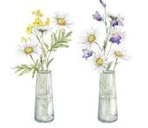
MARGARET’S PAGE
I had intended to write about my day out but it was cancelled , so I am writing about something personal, for which I apologise.
Growing old can be quite interesting. I do not recommend it but unfortunately there is nothing we can do to avoid it so the only thing to do is to grin and bear it and get on with life. A friend of mine used to say, “Getting old isn’t for wimps!” and how right she was.
When I read a newspaper or listen to the news on television I frequently think ”What is the world coming to?” When I was young, teenagers did quite a lot of mischief but I’m sure they didn’t deliberately destroy cricket pavilions or steal money from charity events. Sometimes I think the world is a horrible place BUT then I go shopping and try to cross the road and a car stops to let me cross safely. I go into a shop and lean my stick against the counter. It falls to the ground and immediately somebody comes and picks it up for me. It is amazing how many people are really kind and thoughtful, and I realise that the world is not so bad after all.
When I go to church I struggle with the step down from the altar and there is almost always someone who holds out a hand to steady me. It is surprising how one little act of kindness can lift one’s spirits for the rest of the day.
Many years ago, my friend and I were walking in the French Alps and she bought me a stick to help on the steep tracks. At the time I was not grateful but now I find it
indispensable. Sadly, I can’t thank her as she died some years ago, but I have many
happy memories of the holidays we spent together,
For some time, my pride stopped me from using a stick but now I couldn’t manage without one. The trouble with sticks is trying to find somewhere to put them when you open your purse or sit at a table and they can be a decided nuisance particularly when they fall on the floor and you struggle to pick them up.
I will end with a limerick I wrote which I hope will show that I am not really a ‘grumpy old woman’ and I still have a sense of humour.
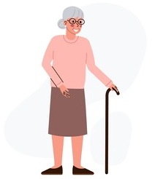
Being old is becoming a chore;
How to face every day I’m not sure.
For my stick I am glad,
But it’s driving me mad,
‘Cos it keeps ending up on the floor.


JUNE QUIZ
- What was the first film to feature fictional spy Harry Palmer?
- Botanically, what is alstromeria?
- For what does the C in ACAS stand?
- Sir John Mills played Ordinary Seaman Shorty Blake in which 1942 film?
- Fetlar belongs to which island group?
- The Indus River flows through which three countries?
- How is the rugby league position five-eighth also known?
- The King George VI Chase is traditionally run on which day of the year?
- The quagga, an extinct species native to South Africa, was what type of animal?
- What political party did Arthur Scargill found in 1996?
- Which financial institution is based at 1 Lime Street?
- What birthday is Tom Good celebrating in the first episode of The Good Life?
- What is the meaning of the Latin word thesaurus?
- What is the official language of the South American country Suriname?
- What name is given to carvings made from shells or other materials by sailors?
- An icosagon has how many sides?
- What was the name of Dot Cotton’s first husband in Eastenders?
- How many keys does a modern piano have?
- Which Dickens novel features the character of Mr Fezziwig?
- Hubert Humphrey was vice-president to which American president?

May answers
1 W somerset Maugham 2 Helios 3 1990s (1990) 4 Portugal 5 Baseball 6 Salford 7 Tatooine 8 Acid soil 9 Ultramarine 10 New Mexico 11 Underwater 12 Butterfly 13 Manchester 14 Leicestershire 15 Chemist 16 Chantilly 17 Pasta 18 George Orwell (in 1984) 19 Harold Macmillan 20 Robert de Niro

Going somewhere
Older people often go to another room to get something, and when they get there, they stand there wondering what they came for. It is not a memory problem. It is God’s way of helping older people get more exercise.


WHAT’S ON IN JUNE
Monday 1st | 10am in the Abbey
 | Julian Group meet for prayer and meditation
Wedn’sday 3rd | Sadly, the MU Meeting this month has been cancelled.
Saturday 6th | 10 – 12 noon in the Church Hall
 | NIBBLE ‘N NATTER Coffee morning Raffle Books A Warm Welcome!
Wednsday 17th | 2 – 4pm in the Church Hall
 | The Knit and Sew Friendship Group
Friday 19th | 10 – 11.30am at 34 Arnhem Way, PE10 9UD
 | The Abbey at Home: Christian Fellowship, Bible Study and Prayer
Saturday 20th | 2 – 4pm in the Church Hall
 | Messy Church for families & accompanied children. See page 11
Friday 26th | 10am in the Abbey
 | Team Clean All welcomed. Bring dusters and handhelds!
Saturday 27th | Priesting of Father Isaac in Lincoln Cathedral at 10.30am
 | Coach leaves Bourne at 8.30am
Father Isaac has been with us for a year. Now his diaconate is drawing to an end, and he prepares for his ordination as a priest. Some 50 of the Bourne congregation are travelling to Lincoln to be there for this wonderful occasion. Even if you can’t be in Lincoln, please hold Isaac and his wife Jenny, who is also to be made priest and their family in your prayers.
‘Almighty and eternal God,
in your unfailing love you provide ministers for your Church.
We pray for those whom you call to serve the Church as priests
Inspire in them a generous response.
Grant them courage and vision to serve your people.
May their lives and service call your people to respond to the presence
of your Spirit among us that, faithful to the Gospel and hope of Jesus the Christ, we may announce glad tidings to the poor
proclaim liberty to captives, set prisoners free
and renew the face of the earth. Amen.’
THE PENULTIMATE PAGE
They say that actions speak louder than words. In church we speak and sing words. We also stand and sit, kneel , shake hands, perhaps make the sign of the cross. All these actions speak too and they convey meaning across the barrier of language.
An action perhaps strange to this congregation is kissing the altar at the beginning and end of the Eucharist. Why is this done? A kiss signifies affection, greeting, honour, reverence, devotion, love. Apparently in the pagan Roman empire, devotees kissed the door of a temple before entering, and families at home would reverence the family table before beginning their meal. The early Church used these familiar gestures as Christians gathered around the altar where Jesus offers himself to the Father and feeds us with his Body and Blood.
The custom has continued and still speaks to us. Jesus is the centre of our worship and the altar is the centre point of the celebration of the Eucharist so, when the priest reverences the altar with a kiss, he is showing his love for Christ who is the centre of life and worship.

During the first centuries, the altar was often a stone slab placed over the tomb of a martyr. If you visit the catacombs in Rome, you can still see such altars. Could the memorial of the death of the Saviour be anywhere more fittingly celebrated than on the tombs of the faithful who had died for Christ? In later centuries stone altars had a cavity in which the relic of a saint was enclosed for the bodies of the saints were venerated and were the object of pilgrimage. In the fifth century a major church council had laid down that every new church altar must have such a relic, even a finger bone or nail, a symbol of Christian triumph over the forces of evil. Even such things as filings from the chains of St Peter were sought after. The altar of the new Abbey here would probably have housed a relic but it has long since disappeared.
Like many actions, reverencing the altar speaks louder than many, many words. It reminds us to thank God for the gift of his Son. It also reminds us of the many saints, known and unknown, who worship with us in heaven.

THE ABBEY CHURCH OF ST PETER AND ST PAUL
Church Walk, Bourne PE10 9UQ what3words:///petrified wrong trees
https://bourneabbey.uk Charity number:1132631

Vicar
Rev. Father Stephen Buckman | The Vicarage, Church Walk PE10 9UQ
Please note that the Vicar’s normal rest day is Friday | revstephen@btinternet.com | 01778 782779 07464 728545
Curate
Rev. Father Isaac Frisby | curate@bourneabbey.uk | 07587893966
Authorised Lay Ministers
Jennifer Maclean | j.maclean36@btinternet.com | 01778 393590
Marilyn Roberts | marilynroberts17@gmail.com | 07443 599217
Churchwardens
Jennifer Maclean | j.maclean36@btinternet.com | 01778 393590
Vicky Buckman | vbuckman@btinternet.com | 07769 804138
Director of Music | Vacant
Treasurer and Ringers
Alan Payne | alanpayne684@gmail.com | 01778 560633
Safeguarding Officers
Denis and Jayne Smith | denis-smith@outlook.com | 07578 653435
Website Manager
Jennifer Maclean | j.maclean36@btinternet.com | 01778 393590
Hall Bookings& Magazine Editor
Celia Howes | celia.howes45@gmail.com | 01778 702627
Flowers in Church
Ann Northen | mikeann24@sky.com | 01778 423353

