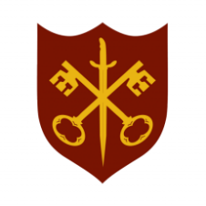 | This Week at the Abbey
31 May – 7 June 2026
The church is open during the day.
Day | Time | Details
SUNDAY 31st | TRINITY SUNDAY
 | 11.00 a.m. | Sung Eucharist
MONDAY 1st | 9.00 a.m. | Morning Prayer
 | 10.00 a.m. | Julian Group
 | 5.30 p.m. | Evening Prayer
 | 6.45 p.m. | Bourne Choral
TUESDAY 2nd | 9.00 a.m. | Morning Prayer
 | 5.30 p.m. | Evening Prayer
 | 7.00 p.m. | Said Eucharist
WEDNESDAY 3rd | 9.00 a.m. | Morning Prayer
 | 5.30 p.m. | Evening Prayer
THURSDAY 4th | 9.00 a.m. | Morning Prayer
 | 10.00 a.m. | Said Eucharist (BCP)
 | 5.30 p.m. | Evening Prayer
 | 7.00 p.m. | PCC meeting
FRIDAY 5th | 9.00 a.m. | Morning Prayer
 | 5.30 p.m. | Evening Prayer
 | 6.30 p.m. | Choir practice
SATURDAY 6th | 9.00 a.m. | Morning Prayer
 | 10.00 a.m. | Nibble & Natter, Church Hall
 | pm | Bourne Choral rehearsal
 | 5.30 p.m. | Evening Prayer
 | 7.00 p.pm | Bourne Choral Concert
SUNDAY 7th | 11.00 a.m. | Sung Eucharist
 | 6.30 p.m. | Sung Evensong

