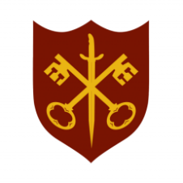 | This Week at the Abbey
3 - 10 May 2026
The church is open during the day.
Day | Time | Details
SUNDAY 3rd | 11.00 a.m. | Said Eucharist
 | 6.30 p.m. | Sung Evensong
MONDAY 4th | 9.00 a.m. | Morning Prayer
 | 10.00 a.m. | Julian Group
 | 5.30 p.m. | Evening Prayer
 | 6.45 p.m. | Bourne Choral
TUESDAY 5th | 9.00 a.m. | Morning Prayer
 | 5.30 p.m. | Evening Prayer
 | 7.00 p.m. | Said Eucharist
WEDNESDAY 6th | 9.00 a.m. | Morning Prayer
 | 2.15 p.m. | MU Meeting, Church Hall
 | 5.30 p.m. | Evening Prayer
 | 7.00 p.m. | Band practice
THURSDAY 7th | 9.00 a.m. | Morning Prayer
 | 10.00 a.m. | Said Eucharist (BCP)
 | 5.30 p.m. | Evening Prayer
 | 7.00 p.m. | PCC meeting
FRIDAY 8th | 9.00 a.m. | Morning Prayer
 | 5.30 p.m. | Evening Prayer
 | 6.30 p.m. | Choir practice
SATURDAY 9th | 9.00 a.m. | Morning Prayer
 | 3.00 p.m. | Pet Service
 | 5.30 p.m. | Evening Prayer
SUNDAY 10th | 11.00 a.m. | Said Eucharist
 | 6.30 p.m. | Sung Evensong

