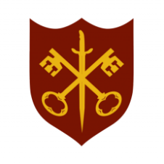 | This Week at the Abbey
17 - 24 May 2026
The church is open during the day.
Day | Time | Details
SUNDAY 17th | 11.00 a.m. | Sung Eucharist
 | 6.30 p.m. | Sung Evensong
MONDAY 18th | 9.00 a.m. | Morning Prayer
 | 5.30 p.m. | Evening Prayer
 | 6.45 p.m. | Bourne Choral
TUESDAY 19th | 9.00 a.m. | Morning Prayer
 | 12.00 p.m. | Funeral & Requiem Mass – Lynette Fuller
 | 5.30 p.m. | Evening Prayer
 | 7.00 p.m. | Said Eucharist
WEDNESDAY 20th | 9.00 a.m. | Morning Prayer
 | 5.30 p.m. | Evening Prayer
 | 7.00 p.m. | Band practice
THURSDAY 21st | 9.00 a.m. | Morning Prayer
 | 10.00 a.m. | Said Eucharist (BCP)
 | 12.30 p.m. | Funeral – Jane Bates
 | 5.30 p.m. | Evening Prayer
 | 7.00 p.m. | Said Eucharist
FRIDAY 22nd | 9.00 a.m. | Morning Prayer
 | 10.00 a.m. | Team Clean – all welcome to help
 | 5.30 p.m. | Evening Prayer
 | 6.30 p.m. | Choir practice
SATURDAY 23rd | 9.00 a.m. | Morning Prayer
 | 5.30 p.m. | Evening Prayer
SUNDAY 24th | PENTECOST
 | 9.00 a.m. | Said Eucharist
 | 11.00 a.m. | Sung Eucharist with Abbey Band

