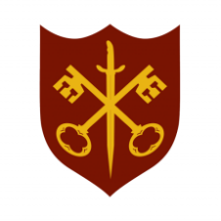 | This Week at the Abbey
10 - 17 May 2026
The church is open during the day.
Day | Time | Details
SUNDAY 10th | 11.00 a.m. | Said Eucharist
MONDAY 11th | 9.00 a.m. | Morning Prayer
 | 10.00 a.m. | Visit of Grantham Civic Society
 | 5.30 p.m. | Evening Prayer
 | 6.45 p.m. | Bourne Choral
TUESDAY 12th | 9.00 a.m. | Morning Prayer
 | 5.30 p.m. | Evening Prayer
 | 7.00 p.m. | Said Eucharist
WEDNESDAY 13th | 9.00 a.m. | Morning Prayer
 | 5.30 p.m. | Evening Prayer
 | 7.00 p.m. | Band practice
THURSDAY 14th | ASCENSION DAY
 | 9.00 a.m. | Morning Prayer
 | 10.00 a.m. | Said Eucharist (BCP)
 | 5.30 p.m. | Evening Prayer
 | 7.00 p.m. | Said Eucharist
FRIDAY 15th | 9.00 a.m. | Morning Prayer
 | 10.00 a.m. | The Abbey at Home (see inside for details)
 | 1.00 p.m. | Bourne Grammar School lunchtime concert
 | 5.30 p.m. | Evening Prayer
 | 6.30 p.m. | Choir practice
SATURDAY 16th | 9.00 a.m. | Morning Prayer
 | 2.00 p.m. | Messy Church, Church Hall
 | 5.30 p.m. | Evening Prayer
SUNDAY 17th | 11.00 a.m. | Said Eucharist
 | 6.30 p.m. | Sung Evensong

