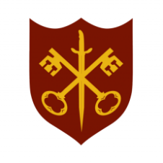 | This Week at the Abbey
26 April – 3 May 2026
The church is open during the day.
Day | Time | Details
SUNDAY 26th | 9.00 a.m. | Said Eucharist
 | 11.00 a.m. | All Age Eucharist
MONDAY 27th | 9.00 a.m. | Morning Prayer
 | 3.00 p.m. | Sound system review
 | 5.30 p.m. | Evening Prayer
 | 6.45 p.m. | Bourne Choral
TUESDAY 28th | 9.00 a.m. | Morning Prayer
 | 5.30 p.m. | Evening Prayer
 | 4.00 p.m. | Administration meeting
 | 7.00 p.m. | Said Eucharist
WEDNESDAY 29th | 9.00 a.m. | Morning Prayer
 | 5.30 p.m. | Evening Prayer
 | 7.00 p.m. | Band practice
THURSDAY 30th | 9.00 a.m. | Morning Prayer
 | 10.00 a.m. | Said Eucharist (BCP)
 | 5.30 p.m. | Evening Prayer
FRIDAY 1st | 9.00 a.m. | Morning Prayer
 | 5.30 p.m. | Evening Prayer
 | 6.30 p.m. | Choir practice
SATURDAY 2nd | 9.00 a.m. | Morning Prayer
 | 10.00 a.m. | Nibble & Natter, Church Hall
 | 12.00 p.m. | Baptism
 | 5.30 p.m. | Evening Prayer
SUNDAY 3rd | 11.00 a.m. | Said Eucharist
 | 6.30 p.m. | Sung Evensong

