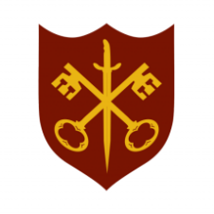 | This Week at the Abbey
12 - 19 April 2026
The church is open during the day.
Day | Time | Details
SUNDAY 12th | 11.00 a.m. | Sung Eucharist
MONDAY 13th | 9.00 a.m. | Morning Prayer
 | 5.30 p.m. | Evening Prayer
 | 6.45 p.m. | Bourne Choral
TUESDAY 14th | 9.00 a.m. | Morning Prayer
 | 5.30 p.m. | Evening Prayer
 | 7.00 p.m. | Said Eucharist
WEDNESDAY 15th | 9.00 a.m. | Morning Prayer
 | 5.30 p.m. | Evening Prayer
 | 7.00 p.m. | Band practice
THURSDAY 16th | 9.00 a.m. | Morning Prayer
 | 10.00 a.m. | Said Eucharist (BCP)
 | 5.30 p.m. | Evening Prayer
 | 7.00 p.m. | Vestry & Annual Parochial Church Meeting
FRIDAY 17th | 9.00 a.m. | Morning Prayer
 | 10.00 a.m. | The Abbey at Home -see noticeboard for details
 | 5.30 p.m. | Evening Prayer
 | 6.30 p.m. | Choir practice
SATURDAY 18th | 9.00 a.m. | Morning Prayer
 | 5.30 p.m. | Evening Prayer
SUNDAY 19th | 11.00 a.m. | Sung Eucharist
 | 6.30 p.m. | Sung Evensong

