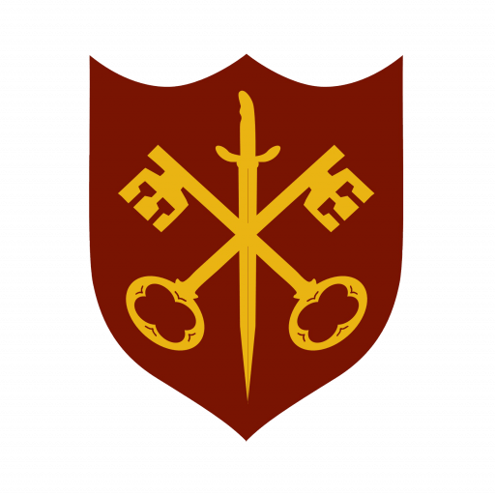 | The Abbey Church  of Ss. Peter & Paul

Services for May 2026
Sunday / Tuesday / Thursday

3rd | 11.00 a.m. | Sung Eucharist with Baptism
 | 6.30 p.m. | Sung Evensong
5th | 7.00 p.m. | Said Eucharist
7th | 10.00 a.m. | Said Eucharist (BCP)
10th | 11.00 a.m. | Sung Eucharist
12th | 7.00 p.m. | Said Eucharist
14th | Ascension Day
 | 10.00 a.m.  7.00 p.m. | Said Eucharist (BCP)  Said Eucharist
17th | 11.00 a.m.  6.30 p.m. | All Age Eucharist  Sung Evensong
19th | 7.00 p.m. | Said Eucharist
21st | 10.00 a.m. | Said Eucharist (BCP)
24th | Pentecost
 | 9.00 a.m.  11.00 a.m. | Said Eucharist  All Age Eucharist + Abbey Band
26th | 7.00 p.m. | Said Eucharist
28th | 10.00 a.m. | Said Eucharist (BCP)
31st | Trinity Sunday
 | 11.00 a.m. | Sung Eucharist

