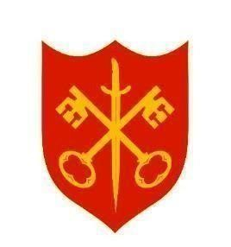
The Abbey Church of St Peter & St Paul
serving the communities of Bourne
Dyke Twenty and Cawthorpe

PARISH MAGAZINE
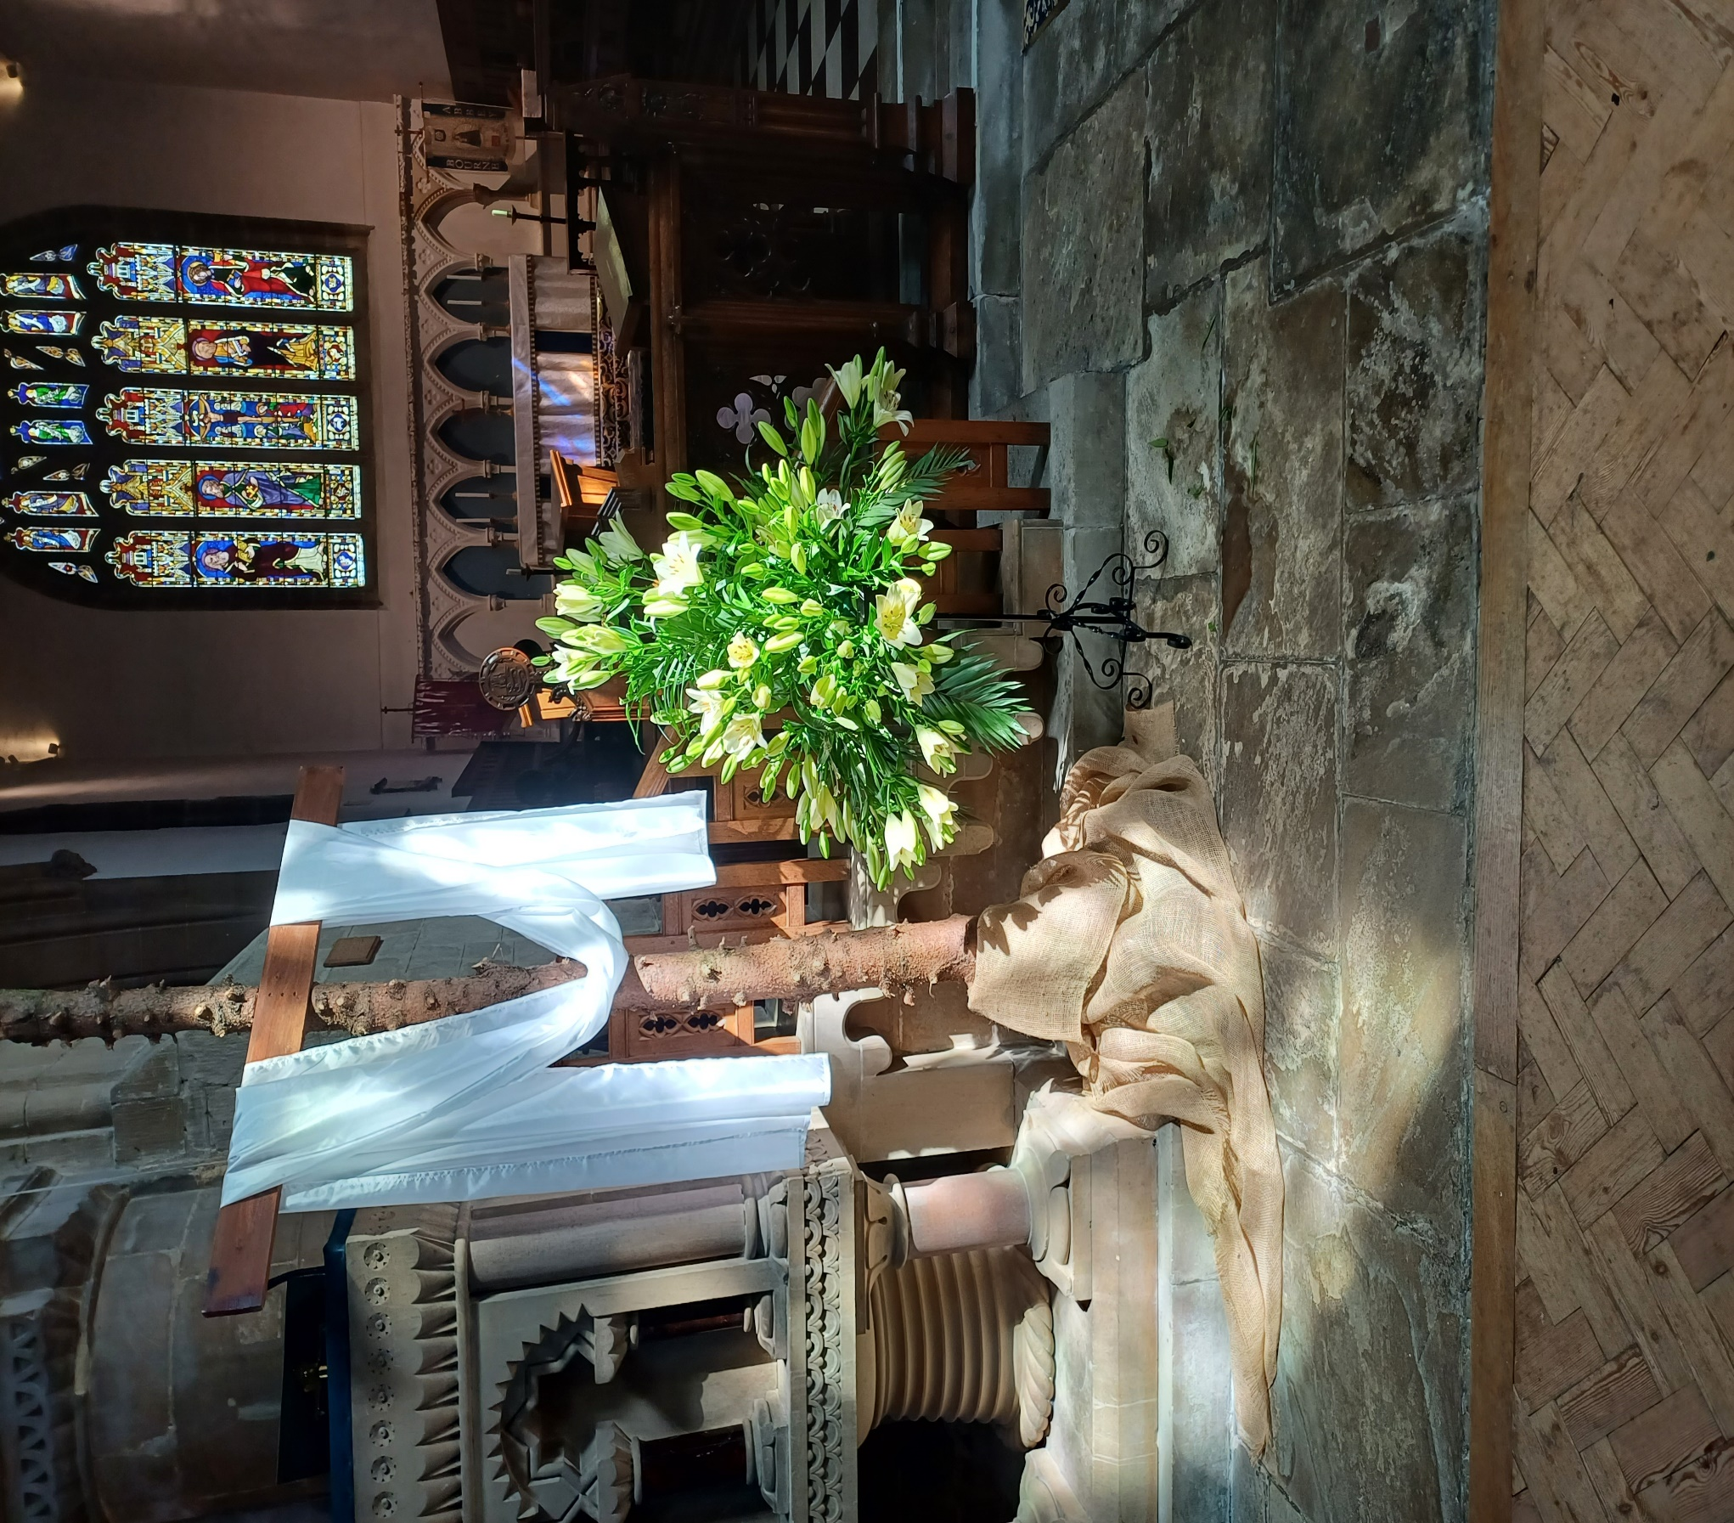


MAY 2026 50p
www.bourneabbey.uk Bourne Abbey Church Group

WORSHIP AT THE ABBEY DURING MAY
Morning Prayer and Evening Prayer are said every weekday at 9.00am and 5.30pm The Abbey is open between 9am and 6pm.

Sunday 3rd | Fifth Sunday of Easter | Sung Eucharist CW | 11.00am
 |  | Sung Evensong | 6.30pm
Tuesday 5th |  | Said Eucharist CW | 7.00pm
Thursday 7th |  | Holy Communion BCP | 10.00am
Sunday 10th | Sixth Sunday of Easter | Sung Eucharist CW | 11.00am
Tuesday 12th |  | Said Eucharist CW | 7.00pm
Thursday 14th | Ascension Day | Holy Communion BCP | 10.00am
Sunday 17th | Sunday after Ascension | Sung Eucharist CW | 11.00am
 |  | Sung Evensong | 6.30pm
Tuesday 19th |  | Said Eucharist CW | 7.00pm
Thursday 21st | MU Corporate Communion | Holy Communion BCP | 10.00am
Sunday 24th | Day of Pentecost | Said Communion CW | 9.00am
 |  | All Age Eucharist | 11.00am
Tuesday 26th |  | Said Eucharist CW | 7.00pm
Thursday 28th |  | Holy Communion BCP | 10.00am
Sunday 31st | Trinity Sunday | Sung Eucharist CW | 11.00am

The Cover Picture was taken by Marilyn Roberts, one of the Abbey’s team of talented flower arrangers. Her pedestal of Easter lilies, just beginning to come out, stands beside the cross which has been fashioned from the trunk of our Christmas tree. Christ’s birth, life, death and resurrection – all part of God’s amazing love for us, opening the way to eternal life. No wonder the celebration of Easter lasts fifty days until Pentecost!

‘Blessed be God, the Father of Jesus,
who loved him and raised him from the dead, who has given us a new life and a future, a treasure that cannot be taken from us.’ (First Letter of Peter 1: 3)

We welcome the names of those who are ill or awaiting an operation so that prayers may be offered for them. We also welcome the names of loved ones departed to be inscribed in the Abbey’s Book of Remembrance.
Contact Churchwarden Jennifer Maclean
THE ABBEY’S BOOK OF REMEMBRANCE FOR MAY

1st Kathleen Lingard : John Hubbard
3rd Vera Bristow : Damien Gaunt
4th Laurence Cope : Mary Wells : Elizabeth Mary Pignatiello
5th Philip Hodgson : Carole Kitchener : 6th Albert Heather
7th Henry Rose : Norman Ralph
8th Lillian Johns : Alan Shawley : Reginald Howlett
11th Kenneth Norris : Cecilia Byrne : Dawn Mary Townsend
13th Daisy Cunnington
14th Timothy James : Robert (Bob) Currell
15th Philip Atkinson : Margaret Doyle : Louise Burgess
16th Kenneth Keefe : 17th Robert Hitchens : Malcolm Shipley : Norman Ward
18th Kathleen Ferguson : 19th Lloyd Hughes : Kevin Hicks
23rd Jack Calvert : 24th Arthur Anslow
25th Jennifer Moor-Radford : Barbara Stancer : Margaret Harwood
29th Hannah Smith : 31st Ivy Danby : John Knight : Janet Sharp



THE VICAR’S LETTER
Dear Friends in Christ,
In a lyric written by the Canadian songwriter, singer, poet and novelist, Leonard Cohen, we find these words: “There is a crack in everything, that’s how the light gets in.” Whilst these words come from popular culture, for those of us who walk in faith, they ring with a deep spiritual truth. Life is not perfect, and neither are we. Despite our best efforts to hide the ‘cracks’, those broken places, wounded hearts and jagged stories are all seen by God, and yet he still chooses to work through them.
We live in a culture that celebrates strength and polish. However, scripture reveals another story. From Genesis to Revelation, God consistently uses those who are broken, imperfect and overlooked to fulfil his purpose in this world. Moses had a stutter; David had a scandal; Peter had a temper; Paul had a past! And yet, all of these flawed human beings became vessels of God’s glory, not in spite of their cracks, but often because of them.

In 2 Corinthians 4, verse 7, Paul writes: “But we have this treasure in clay jars, so that it may be made clear that this extraordinary power belongs to God and does not come from us.” Jars of clay are fragile, flawed and prone to breaking. That is us! But we should never forget that inside those cracked vessels, the light of Christ shines brightly.
It is often in our lowest moments that we become most aware of God’s presence in our lives. When everything is going well, we often feel self-sufficient controllers of our own destiny. But, when life breaks open (or apart), through grief, failure, illness or loss, we become ‘open’ in a way that allows the light to get in. This is grace. God does not wait for us to be whole before he enters. God comes into the cracks, the mess, the in-between places. God is there, in the very areas we try to hide, for these are the places where he reveals himself most powerfully.
Think of the cross, the place of ultimate brokenness. Jesus’ body was pierced, his spirit crushed. But, through that agony the greatest light the world has ever known broke forth! Salvation came not through strength, but through surrender.
God’s light does not only enter through our cracks, it also shines out from them. The story of how God met us in our brokenness is a beacon for others who find themselves struggling in the darkness. When we pretend that everything is fine, we shut others out. When we share our weaknesses and show how God has met us in the midst of those same weaknesses, we offer hope. Our honesty makes us like stained glass windows: fragments of pain and colour that, when touched by light, glow with beauty.
Instead of hiding our brokenness we are called to hold it up to the light. We are called to recognize that our stories – cracks and all – are canvasses for God’s glory. We are called to remember that God does not ask us to be perfect. God asks us to be open – open to healing; open to grace; open to the light that only shines through the cracks.
Next time we feel as though we are falling apart, I pray that we may remember that that is how the light gets in, and that once it is in, it never stops shining.
With every blessing to you all,
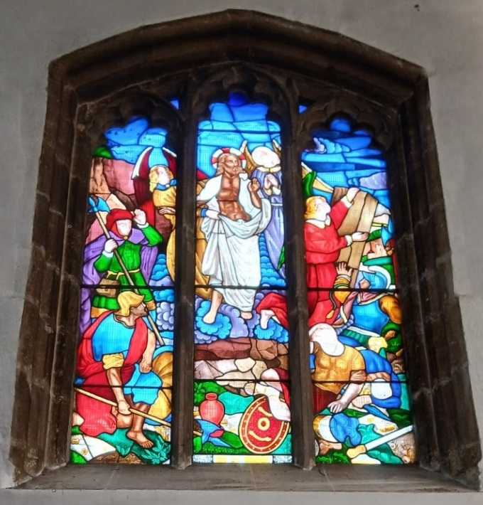
Fr Stephen

‘like stained glass windows that, when touched by light, glow with beauty.’ The Dove window in the chancel. See also Churchward’s Chat on following page
CHURCHWARDEN’S CHAT
Preserving the Abbey for the Present and the Future – the Dove window
Back in February, I wrote about the duty of a Churchwarden to preserve the past while also ensuring that the church continues to serve the present and future population of Bourne. To that, I would now add the importance of keeping alive the stories behind some of the Abbey’s features.
One such feature is the stained-glass window on the north side of the Chancel – do take a look next time you are near the High Altar rail. For some time, one of our serving team has been sitting opposite this window, gazing at a badly tarnished plaque mounted below it and wondering what it once said, how it might be cleaned, and how on earth it could be reached, given that it sits well above the reach of even the tallest parishioner.
With some careful assistance, the plaque was eventually unscrewed and thoroughly cleaned, revealing its original inscription once more.
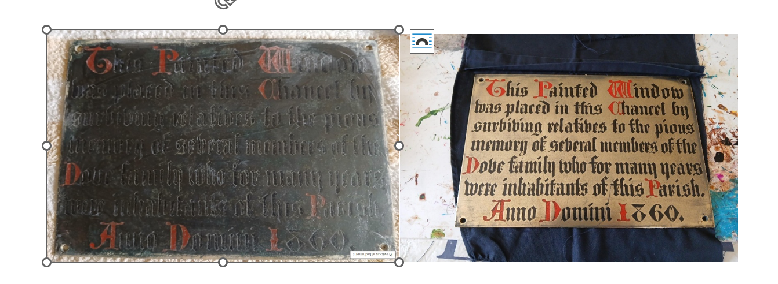
So who were the Dove family, to whom the plaque refers? A little internet research revealed that the Doves were a prominent Bourne family in the 18th century, earning their fortune through farming and brewing. Records suggest that they became the largest landowners in the area. Not only did they donate the beautiful window above the plaque, but their graves are also marked by a substantial memorial just outside the South Porch in the churchyard.
There is still some debate about what, or whom, the window depicts. Some sources suggest it represents Saints Peter and Paul, though the jury is still out – the Vicar is doubtful (as is this Churchwarden!). What cannot be disputed, however, is the richness of

its colour and its visual impact. It was acquired at a time when such windows could simply be purchased from skilled craftsmen and installed, rather than being specially commissioned for a particular church. Nevertheless, it has become a real treasure of Bourne Abbey.
Part of our stewardship is ensuring that such gifts, and the stories behind them, are not lost but recorded for future generations. I hope that those who come after us will look back on some of the restoration work currently taking place – the chandelier, the reredos, and indeed this plaque – and recognise that we took our responsibilities seriously, caring for the Abbey with respect for both its history and its future.
Vicky Buckman
Your Editor thinks the window depicts the Resurrection with helmeted soldiers guarding the tomb, the angel on the right lifting away the stone and Christ rising supported by rather watery-looking blue clouds. Have a look and see what you think!





FROM LEN CAUSTON
This year I am again taking part in the "MARCHFORMEN" in aid of Prostate Cancer UK,
which will take place on Saturday 13th June 2026
in Battersea Park, London.
If anyone would like to sponsor me or make a donation, I will have the relevant form with me in church during April and May, or you can sponsor me through my "Just Giving" Page at:
https://marchformen.prostatecanceruk.org/fundraising/matthews-fundraising-page1145

Garden of Remembrance
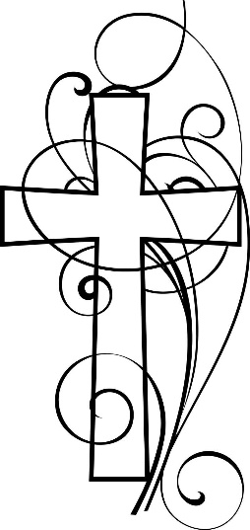
More than a century ago, the Abbey churchyard was declared full and formally closed for burials. In recent years, by faculty granted through the Diocesan Chancellor, a small part has been reopened as a Garden of Remembrance—a place set apart for the interment of ashes following cremation.
As many will understand, such sacred spaces can sometimes give rise to concern or misunderstanding, especially when we are grieving those we love. It is therefore important to gently clarify how the Garden of Remembrance is cared for, and why certain guidelines are in place.
All Church of England churchyards are governed by national Churchyard Regulations. These apply equally to the Abbey’s Garden of Remembrance. They remind us that churchyards are consecrated ground—places dedicated to God, set apart for holy use, and entrusted to the Church’s care for all time. This sacred character means they are treated differently from municipal cemeteries, where different standards and expectations apply.
Responsibility for churchyards ultimately rests with the Diocesan Chancellor, an expert in ecclesiastical law. While parish clergy are entrusted with day-to-day oversight, they are required to act within these Regulations and do not have authority to set them aside.
One area that can cause confusion is ownership. Families do not purchase a plot of land; rather, they contribute towards the interment and the ongoing care of the churchyard. The land itself remains part of the Church, held in trust as a shared sacred space for all.
Questions also arise about memorials. The size, materials, wording, and design of memorials are carefully guided by the Regulations, ensuring that the churchyard remains a place of dignity, simplicity, and harmony. The presence of an existing memorial does not necessarily mean that a similar one may be permitted. Where a proposal falls outside the Regulations, clergy are not able to grant approval.
A Garden of Remembrance carries additional requirements. Memorial stones must be no larger than 30cm by 30cm (12 inches by 12 inches) and set flat, slightly below ground level. The garden must remain level to allow for proper care, which means that additional planting, edging, or personal decorations are not permitted.
At first, these guidelines may feel restrictive. Yet they exist to protect the peace, beauty, and shared sacredness of this place—so that all who are laid to rest here are honoured equally, and all who come to remember may find quiet and comfort.
It has been suggested that these Regulations are outdated or optional. In truth, they remain in force across the Church of England, with their most recent revision in 2012. They are not local rules, but part of the wider care and stewardship of consecrated ground.
If the application of these Regulations has caused distress, I am truly sorry. Please know that they are upheld not to cause hurt, but to preserve a place of prayerful stillness at the heart of our community. It is my hope and prayer that the Garden of Remembrance may remain a place where those who rest are held in peace, and where all who grieve may encounter God’s comfort and gentle healing.
With every blessing to you all,
Fr Stephen



DON’T DRIVE WHEN SAD
You’ve seen those motorway signs warning you not to drive when you are tired. But now it seems you are far more likely to crash your car if you drive when you are sad, or when you are angry, or when you are agitated.
A study has found that a healthy emotional state is hugely important for your safety at the wheel; being sad, mad or upset can increase your likelihood of a crash by nearly ten-fold. That compares with fatigue making a crash only three times more likely, while talking on a mobile phone doubles the risk.
Having children in your back seat is a very low risk, and chatting to your passenger or moving to music barely raises the risk at all. The study was carried out at Virginia Tech.

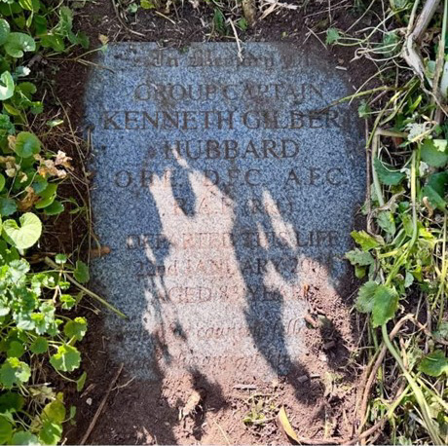
BALL OF FIRE
The grave of a senior RAF commander reminds me of my own experience of working alongside WW2 veterans whose service had extended into the later cold war period. Group Captain Ken Hubbard had a distinguished career both in war and in peacetime.
It has been noted that he was also instrumental in defining defence capability during the cold war when he piloted the aircraft which tested Britain’s first thermonuclear device at Christmas Island in 1957.
Flying in the vicinity at the time, I well remember the scene. My article “Easter at Christmas” which was published in an edition of 2024 recounted the strange coincidence of Easter and the testing of weapons of mass destruction. Seeing this commemoration of our senior colleague, I am again reminded of the occasion. I notice the sunlight playing on the inscription and remember the bright sunlight of the Pacific pouring overhead into our cockpit but then there was a brighter light to follow.
Safety screens had limited our view until the blinding flash had passed and we were able to look. I remember how bright the other light was, as if the sun had moved to the horizon on our left-hand side. I wonder how the nuclear flash on the earth would have been visible from space. Recent space travel has reminded us of the limits of our capabilities and the problems of terrestrial conflict. As Patrick Moore once said, “We will get to Mars, if there is peace on Earth.”
If our “Easter at Christmas” was a mixed experience, then I remember it had also been a time of enlightenment. We had come home to ponder our future on a planet later to be admired as a bright blue globe in space. On it were cities and the graves of veterans who had known wartime grief. As we think of Easter today, how do we pray “Your kingdom come”?
With future hope,
Malcolm

The MU Report - How do we see Jesus?
We do not know what Jesus looked like. There is no description of Him in the Gospels. He may have been bearded like the Jews of his time. Over the centuries artists have presented images of Jesus in a number of different ways. Some have tried to show Jesus as he might have been in Palestine in the 1st century. Others show Jesus in a particular culture, country or age other than His own.
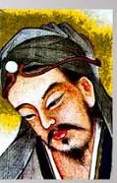
At our April meeting Mothers Union members were invited to look at a variety of portrayals of Jesus and discuss them in small groups. They were encouraged to describe what they were seeing and to think about what the artist was trying to show. It soon emerged that people had strong likes and dislikes of the material they were seeing. Several of the paintings were from different cultures and showed Jesus in an African, Indian or Chinese context with racial characteristics to match. Some were from the Middle Ages with a definite Italian air about them. There were scenes showing Jesus healing or performing a miracle such as feeding the 5000. There were pictures which showed Jesus suffering. Some were clearly intended to shock.
The images which people responded to most positively tended to be ones which portrayed Jesus in a caring role, such as a shepherd. Some had a picture of Jesus in their mind which they had held since childhood. The most popular portrayals seemed to be those where Jesus was represented as a figure from our own culture and were most like a human portrait.
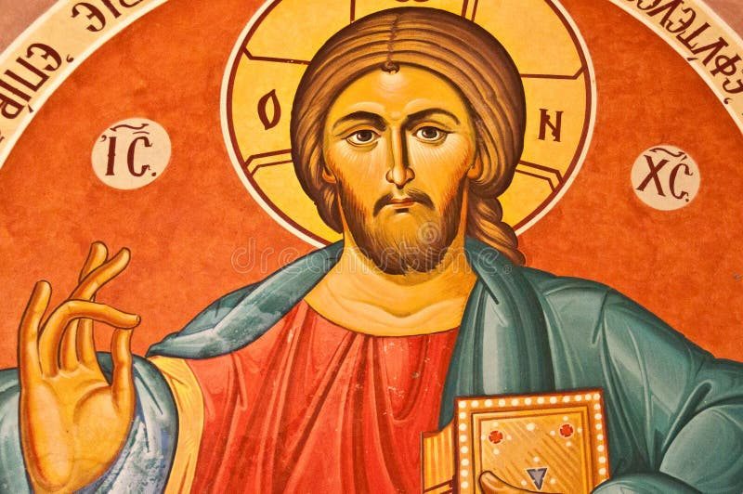
All these pictures showed the Jesus of history and the events of his earthly life. But we seemed to be seeking an image of a living Jesus to which we could relate personally and who can speak to us now.
Sarah Speers

Christ has no body now on earth but yours; yours are the only hands with which he can do his work, yours are the only feet with which he can go about the world, yours are the only eyes through which his compassion can shine forth upon a troubled world. Christ has no body now on earth but yours.
TERESA OF AVILA

Electoral Roll Report 2025 – 2026
The Roll is the list of people who can vote at the Annual Meeting. Members live in the parish or worship regularly at the church, are over 16 years old and have applied to have their names entered.
A new Electoral Roll was prepared in 2025. The number on the Roll at the APCM 2025 was 190. The number on the revised Electoral Roll is 183.
166 members are resident in the parish. 17 live outside the parish. There have been 3 applications to join the Roll from people not previously members. 10 members have died.
Please pray for the repose of the souls of the members who have died:
Francis Henry Philip Brierley : Janet Irene Eyre : Brenda Lilian Jones Michael McGregor : Michael John Northen : Peter Rolt : Joan Anne Marion Norville Brian George Salmon : Laura Maria Stevenson : Alan John Williams
Sarah Speers

Electoral Roll Officer


EASTER LILIES
The flowers in the Abbey at Easter were magnificent. Our thanks go to Marilyn, Joan and Pat who displayed the lilies which had been given to the glory of God and in memory of loved ones, listed opposite. Thank you too to Eleanor and Linda who decorated the windows and to Ian who made the crosses for each one.
‘Walking in a garden at the break of day, Mary asked the gard’ner where the body lay; but he turned towards her, smiled at her and said, ‘Mary, spring is here to stay, only death is dead.’
From a hymn by Hilary Westward, sung to ‘Au clair de la lune.’

EASTER LILIES were donated in loving memory of those listed below
Albert Beckley | Eve Frazer |  | Brenda Jones | Harold Peasley
Arthur Beckley | Reginald Frazer |  | Joan Jones | Norah Peggs
Marjorie Beckley | Gladys Frost |  | John Jones | Eric Roberts
Audrey Bloodworth | Harold Frost |  | Clarence Roy Kelby | Maisie Roberts
Charles Bloodworth | Kenneth Frost |  | Jacqui Key | Daisy Farrow Robinson
Gladys Bloodworth | John Goodacre |  | Tom Key | George Ernest Robinson
Harold Bloodworth | Doreen Goddard |  | Carole Kitchener | Andrew Rodgers
Christine Buckman | Pamela Grace |  | Robert Kitchener | Kathleen Rodgers
Leslie Buckman | Emily Green |  | Albert Knowles | Roy Rodgers
John Budd | Jane Green |  | Florence Knowles | Tony Rodgers
David Edwin Casbon | Percy Green |  | Granny Knowles | Charlie Roffe
Geraldine Casbon | Dudley Guppy |  | Molly Knowles | Eva Roffe
Daren Causton | James Haggerty |  | Mary Lister | Herbert Rowsell
Lilly Cavanagh | Margaret Haggerty |  | William Lister | Brian George Salmon
Terry Cavanagh | Helen Harris |  | Kathline Lofts | Patricia May Salmon
Doris Churchman | Alan Hart |  | J. McGregor | Audrey Scotney
Shirley Clark | Benjamin Henry Hart |  | Michaell McGregor | Bernard Scotney
Douglas Clarke | Bessie Hart |  | Robert Marrell | Leah Scott
Brenda Coffey | David Hart |  | Kevin Moss | Marie Scott
Henry Cole | Ronald Hart |  | Pauline Nelson | Peter Smith
June Cole | Cynthia Hatfield |  | Michael Northen | Janet Staples
Ivy Coleman | Ethel Hicks |  | Fred Norville | Leslie Sutton
Harry Coleman | James William Hicks |  | Joan Norville | Phyllis Sutton
Gerry Colyer | John Hitchman |  | Jessie Nunn | Angela Taylor
Cindy Curtis | Basil Hodgkinson |  | Patrick English Nunn | John Taylor
Mick Curtis | Dorothy Hodgkinson |  | Peter Edward Oakley | Chris Thorrold
Danny Dagger | Ann Horn |  | John William Osborne | Derek Thorrold
Gwendoline Dandridge | Betty James |  | Frank Page | Jill Thornton
William Dandridge | Jim James |  | Patricia Page | Mary Ward
Audrey Darby | Emma Johns |  | Bernard Partridge | Doris Wells
Ian Darby | Lillian Johns |  | Mary Partridge | John Williams
Ellen Dynes | William Johns |  | Robert Partridge | Cecil William Wright
Peter Dynes | Alan Richard Jones |  | David Pask | James York

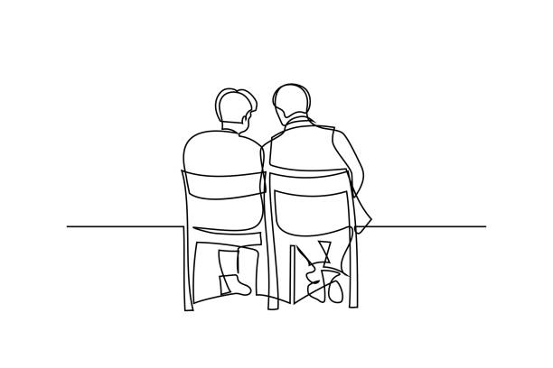
MARGARET’S PAGE
Many years ago I went to school in Sleaford. There I made friends with a little girl called Helen and we have stayed friends throughout our lives. Neither of us married so have no children or grandchildren to share our birthday celebrations so, whenever possible, we try to spend our birthdays together.
This year we decided to spend my birthday at a place called Woodland Waters which we discovered some time ago at Ancaster. It has the advantage of being almost equidistant from our homes so we can both reach it in just over half an hour. I believe it must originally have been gravel pits because there are a number of attractive little lakes which you can walk round, enjoying the ducks and geese as you go. There are holiday huts to hire, a caravan park, and fishing facilities for those who enjoy that sort of thing. We go to make use of the lovely bar and restaurant, which has a good menu in a beautiful setting.
This year my birthday fell on one of the days in March when the weather was perfect and
the blossom was just coming out so I thoroughly enjoyed the journey. If you are eating at the restaurant you need to take a ticket at the barrier and have it stamped when you have your meal. By some ‘magic’ when you leave the barrier opens automatically without you having to insert your ticket and you do not have to pay for parking.
I arrived at the time we had arranged and found Helen waiting for me. We went for a short walk. Then we sat on one of the seats provided and enjoyed the view and the geese (but not the wind) for about half an hour, after which we went into the restaurant and chose our meal. As it is now classed as a bar one must go up to the counter to order, but the meal is brought to your table. I had a pleasant surprise as someone spoke to me, making me jump. It was my niece who lives in Grantham. Apparently, she and her husband frequently take the dog for a walk there.
After our meal we decided to call at Pennell’s Garden Centre on the way home to do some shopping and have a coffee in their new restaurant. Pennell’s are making a lot of alterations
and improvements, but they are not so convenient for disabled people as they used to be as
it is a very long way from the car park to the restaurant and toilets, whereas they used to be just inside the door. They do, however have a very good butchery and sell lots of cards and
gifts in addition to the plants you would expect. It is an ideal place for buying Christmas and birthday presents and I always enjoy a visit there.
If you have never been to Woody’s I would highly recommend it, especially if it is a nice,
sunny day. I thoroughly enjoyed my birthday, and it was lovely to be able to spend it with
Helen. I have made many friends in my life, but, sadly, many of them have died or are in hospital. And life can be lonely as one gets older. I thank God for the friends I still have –
they are very precious.

A Letter from Penny Herdman of Aswarby
.
Firstly, I would like to thank you for the very good response to the Bishop Hall Lunch in February. Many people came from the Bourne area. It was a sell-out which gave us a very good result for Aswarby Church.
We are holding an Open Gardens Day in aid of Lincolnshire Churches Trust on 21 June. Could you perhaps insert the following in the Bourne Magazine?

LINCOLNSHIRE CHURCHES TRUST OPEN GARDENS 2026
ASWARBY, SLEAFORD, NG34 8SE

SUNDAY 21ST JUNE 2026 2pm - 5pm Admission £5.00 Children free

Celebrate Midsummer with a Walk around Aswarby Village. You can see an Art Exhibition by local artists in the historic St Denys' Church which dates back to Norman times. A number of colourful village gardens will be open along with the stunning Rose Walk leading you up to the Church. Read about the birthplace of George Bass, explorer of Australia and Tasmania, with a fascinating display in the Church.
There will be Cream Teas as well as a Plant Stall and a map will be available showing which gardens are open.
Come and explore this picturesque village and bring your friends!



Short-staffed Two men were working for the town council. One would dig a hole and the other would follow behind him and fill the hole in. They worked up one side of the street, then down the other, then moved on to the next street, working furiously all day without rest, one man digging a hole, the other filling it in again. An onlooker was amazed at their hard work but couldn’t understand what they were doing. So he finally approached the hole digger, “I’m impressed by the effort you two are putting into your work, but I don’t get it – why do you dig a hole, only to have your partner follow behind and fill it up again?” The hole digger wiped his brow and sighed, “Well, I suppose it probably looks odd because we’re normally a three-person team. But today the guy who plants the trees called in sick.”


Bourne Abbey Pet Service
Saturday May 9th at 3pm
- Dogs welcome on leads
- Other smaller pets welcome in carriers/cages
- Larger animals welcome outside the Church in Church Walk
- Why not bring a photo of pets no longer with us

- All welcome, with or without a pet

Refreshments afterwards (pets and owners) in Abbey Church Hall
---------------------------------------------------------------


Come and join in our next service
at 2 – 4pm on Saturday 16 May in the church hall.

Families and accompanied children ALL WELCOME!


THE MAY QUIZ
- Who wrote the 1915 novel Of Human Bondage?
- The Colossus of Rhodes was a statue of which Greek god?
- In which decade was One Foot in the Grave first broadcast?
- In which European country is the city of Coimbra?
- Ernie Banks (d.2015) was a famous name in which sport?
- MediaCityUK is located in which English city?
- On which planet was Luke Skywalker raise in the Star Wars films?
- A blue hydrangea would typically be growing in which type of soil, acid or alkaline?
- I RAM RENAULT is an anagram of what colour?
- The Rocky Mountains stretch from British Colombia in Canada to which US state?
- Hans Hass was known for making documentaries filmed in what environment?
- What type of creature is a glasswing?
- The group 10cc was formed in which city?
- In which county is the parliamentary constituency of Bosworth?
- What was the occupation of Sidney Stratton in The Man in the White Suit?
- At which racecourse is the French Derby run?
- Durum wheat is the basis for what foodstuff?
- Which writer invented the term ‘doublespeak’?
- Which 1950s Prime Minister used the phrase ‘You’ve never had it so good.’
- Who played the young Viti Corleone in the Godfather films?

April Answers
1 5000m (4810m) 2 1981 3 Jules 4 Purpure 5 James Ellis 6 Mexico 7 Chester 8 Glide (in dancing) 9 River Doon 10 Montreux 11 PSV Eindhoven 12 Pyrenees 13 Essex 14 Washington 15 War 16 Nine 17 Cornflower 18 Newfoundland and Labrador 19 Chipmunks 20 Saving All My Love for You
Geraniums A man burst into a flower shop and urgently demanded two pink potted geraniums. The assistant explained that they did not have any but could offer him African violets instead. ”No,” said the man sadly. “It was geraniums that my wife told me to water while she was gone.”
Today is the oldest you’ve ever been, yet the youngest you’ll ever be, so enjoy this day while it lasts.


WHAT’S ON IN MAY
Saturday 2nd | 10 -12 noon in the Church Hall
Nibble 'n’ Natter Coffee Morning
Stalls will include books, jigsaws, raffle and refreshments. All welcome.
Proceeds to Church funds.
Wedn’sday 6th | 2.15pm In the Church Hall
 | MU Meeting : A talk by Father Stephen All Welcome
Saturday 9th | 3pm in the Abbey
Pet service followed by refreshments for owners and pets in the Church Hall.
See page 16
Sunday 10th | 1 – 3.30pm at Dyke Village Hall
 | Plant Sale Tea and cake too.
Friday 15th | 10 – 11.30am at 34 Arnhem Way, PE10 9UD
 | The Abbey at Home: Christian Fellowship, Bible Study and Prayer
Saturday 16th | 2 – 4pm in the Church Hall
 | Messy Church for families & accompanied children. See page 16
Wednesday 20th | 2-4pm in the Church Hall
 | Knit and Sew Friendship Group Do come along – all welcome!
Friday 29th | 10am in the Abbey
 | Team Clean All welcomed. Bring dusters and handhelds!

Encyclopaedias
Sorting out books for the local fete, a parishioner came across some well-worn and dusty illustrated encyclopaedias, treasured from his childhood. Unwilling to part with them, he put them on a shelf in the garage where his small grandchildren found them and spent many happy hours looking at the pictures. These books, however, caused him great embarrassment the day the vicar came to visit. One of his grandchildren suddenly said: “Grandad, can we go look at those dirty books you keep in the garage?”

THE PENULTIMATE PAGE
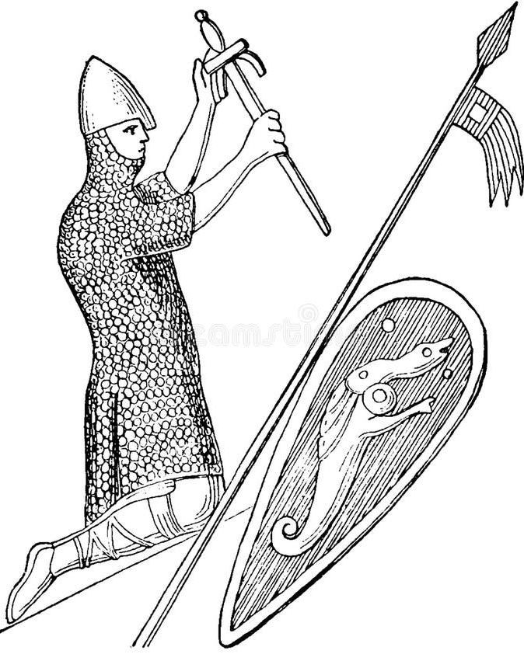
An abbey-related fact that surprised me: how monks were an essential back-up to the Norman military machine. ‘Thou shalt not kill’ is awkward if you are a fighting man and always has been. But it was believed that monks could save your soul. Warriors had every confidence in the power of prayer. They were also convinced that the purer and simpler a person’s life was, the more likely God was to listen favourably to them. Since monks were supposed to live the purest and simplest of lives, their prayers were seen a hotline to God, and they provided an essential service for the Norman armies, saving warriors’ souls once the fighting was over.
The soul of a tenth or eleventh- century fighting man would not be easy to save. It required the strenuous effort of a significant number of monks to pray him out of damnation. Homicide in a public war, even at the command of a legitimate ruler, required doing penance for 40 days and abstention from church. William the Conqueror, with overall responsibility for some 10,000 deaths, needed about 1100 years of serious religious effort. He would not have finished yet – not until 2162. After the Battle of Hastings each Norman soldier was told to do 120 days’ penance for every man he had killed which must have created a lot of problems. But of course the Church was ever willing to subcontract the work, at a price.
If William’s penance was split between a couple of hundred monks, his soul could be cleansed in less than six years. He founded an abbey at the site of the battle. He founded another at Barking in Essex and another at Selby in Yorkshire (he had to kill a lot of rebellious people in Yorkshire). And he and his wife and sons gave a great deal of money and lands to a great many other churches and abbeys. In fact, by the time Willam died, 26 per cent of all the land in England belonged to the Church.’
Taken from ‘Medieval Lives’(BBC Books 2004) by Terry Jones, of Python fame but also a well-respected medieval historian.

THE ABBEY CHURCH OF ST PETER AND ST PAUL
Church Walk, Bourne PE10 9UQ what3words:///petrified wrong trees
https://bourneabbey.uk Charity number:1132631

Vicar
Rev. Father Stephen Buckman | The Vicarage, Church Walk PE10 9UQ
Please note that the Vicar’s normal rest day is Friday | revstephen@btinternet.com | 01778 782779 07464 728545
Curate
Rev. Father Isaac Frisby | curate@bourneabbey.uk | 07587893966
Authorised Lay Ministers
Jennifer Maclean | j.maclean36@btinternet.com | 01778 393590
Marilyn Roberts | marilynroberts17@gmail.com | 07443 599217
Churchwardens
Jennifer Maclean | j.maclean36@btinternet.com | 01778 393590
Vicky Buckman | vbuckman@btinternet.com | 07769 804138
Director of Music | Vacant
Treasurer and Ringers
Alan Payne | alanpayne684@gmail.com | 01778 560633
Safeguarding Officer
Karen Key | karenkey@nhs.net | 07354 668966
Website Manager
Jennifer Maclean | j.maclean36@btinternet.com | 01778 393590
Hall Bookings& Magazine Editor
Celia Howes | celia.howes45@gmail.com | 01778 702627
Flowers in Church
Ann Northen | mikeann24@sky.com | 01778 423353

