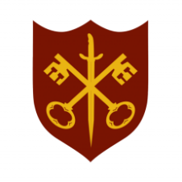 | This Week at the Abbey
 | 8 - 15 March 2026
The church is open during the day.

SUNDAY 8th | 11.00 a.m. | Sung Eucharist
MONDAY 9th | 9.00 a.m. | Morning Prayer
 | 5.30 p.m. | Evening Prayer
 | 6.45 p.m. | Bourne Choral
TUESDAY 10th | 9.00 a.m. | Morning Prayer
 | 5.30 p.m. | Evening Prayer
 | 7.00 p.m. | Said Eucharist
WEDNESDAY 11th | 9.00 a.m. | Morning Prayer
 | 5.30 p.m. | Evening Prayer
 | 7.00 p.m. | Band Practice
THURSDAY 12th | 9.00 a.m. | Morning Prayer
 | 10.00 a.m. | Said Eucharist (BCP)
 | 10.45 a.m. | Lent Course (3/5)
 | 5.30 p.m. | Evening Prayer
FRIDAY 13th | 9.00 a.m. | Morning Prayer
 | 5.30 p.m. | Evening Prayer
 | 6.30 p.m. | Choir Practice
SATURDAY 14th | 9.00 a.m. | Morning Prayer
 | 5.30 p.m. | Evening Prayer
SUNDAY 15th | Mothering Sunday
 | 11.00 a.m. | All Age Eucharist  with Abbey Band
 | 6.30 p.m. | Sung Evensong

