
The Abbey Church of St Peter & St Paul
serving the communities of Bourne
Dyke Twenty and Cawthorpe


PARISH MAGAZINE


APRIL 2026 50p
www.bourneabbey.uk Bourne Abbey Church Group
WORSHIP AT THE ABBEY DURING APRIL
Morning Prayer and Evening Prayer are said every weekday at 9.00am and 5.30pm The Abbey is open between 9am and 6pm.

Sunday 29th | Palm Sunday | Sung Eucharist CW | 11.00am
 |  | Sung Evensong | 6.30pm
Monday 30th | Monday in Holy Week | Said Eucharist CW | 6.30pm
Tuesday 31st | Tuesday in Holy Week | Said Eucharist CW | 6.30pm
April 1st | Wednesday in Holy Week | Said Eucharist CW | 6.30pm
April 2nd | Maundy Thursday | Holy Communion BCP | 10.00am
 |  | Maundy Thursday Liturgy | 8.00pm
April 3rd | Good Friday | Messy Church in Hall | 10.00am
 |  | Stations of the Cross | 12.00pm
 |  | Good Friday Meditation | 1.00pm
 |  | Good Friday Liturgy | 2.00pm
April 4th | Holy Saturday | Easter Vigil | 8.00pm
April 5th | Easter Day | Said Eucharist CW | 9.00pm
 |  | All Age Eucharist | 11.00am
 |  | Sung Evensong | 6.30pm
Tuesday 7th |  | Said Eucharist CW | 7.00pm
Thursday 9th |  | Holy Communion BCP | 10.00am
Sunday 12th | Second Sunday of Easter | Sung Eucharist CW | 11.00am
Tuesday 14th |  | Said Eucharist CW | 7.00pm
Thursday 16th |  | Holy Communion BCP | 10.00am
Sunday 19th | Third Sunday of Easter | Sung Eucharist CW | 11.00am
Tuesday 21st |  | Said Eucharist CW | 7.00pm
Thursday 23rd |  | Holy Communion BCP | 11.00am
Sunday 26th | Fourth Sunday of Easter | Said Eucharist CW | 9 00am
 |  | All Age Eucharist | 11.00am
Tuesday 28th |  | Said Eucharist CW | 7.00pm
Thursday 30th |  | Holy Communion BCP | 10.00am

We welcome the names of those who are ill or awaiting an operation so that prayers may be offered for them. We also welcome the names of loved ones departed to be inscribed in the Abbey’s Book of Remembrance. Contact Churchwarden Jennifer Maclean
THE ABBEY’S BOOK OF REMEMBRANCE FOR APRIL

1st Sarah Waters : 2nd Stuart Randall 3rd Brian Dodd : Gwen Garner 4th John Richard Rice-Oxley, priest
5th Sylvia Glover : Pauline Savage : Andrew Barnatt : Keith Watson : Robert Woodman 6th Gillian West : 7th Eileen Atkinson 8th Frederick Seymour : Robert Baker : Charles Glenn : John Smith : George Hobson
9th James Challis : Rowena Atkinson : 10th Leslie Fairbairn : Gillian Acland 11th Gerald Knight : Janet Faux : 12th McKensie Holmes : Dean Spencer 13th Gwendoline Dandridge : 14th Patricia Moisey
16th Phyllis Sutton : 17th Margaret Scales : Derrick Fortescue
18th John Legge : Ann Tabor : Adrian Burgin
19th Bernard Jackson : Ellen Schwarz : 20th Benjamin Thorold
21st Rosslyn Edwards : Sonya Chorazek : Winifred ‘Mary’ Burdett Lister
22nd David Pask : Harold Stephen Townsend
25th Samuel Danby : Barbara Stancer
26th Bridie Hurst : Douglas Clarke, priest : Marie Leaton : 27th Jack Leaton
28th Bernard Stubley : Christine Dunthorne : Francis Hewitt



THE VICAR’S LETTER
Dear Friends in Christ,
In a world hesitant to embrace change, the words of John Henry Newman resonate with both challenge and hope: To live is to change, and to be perfect is to have changed often. For many, change feels disruptive, even threatening. But, for the Christian, change is not only necessary, it is sacred. It is the means by which God moulds us into the people we are called to become.
From the moment we first say. ‘Yes,’ to Christ, we begin a lifelong journey of conversion. This journey of conversion is not a single event but a continual process. The early Church called this process metanoia – a turning of the heart and mind towards God. In his letter to the church in Rome, St Paul wrote: Do not be conformed to this world but be transformed by the renewing of your mind. This transformation, this holy change, is not optional. This is the Christian life.
Jesus himself modelled change, not in his divinity, but in his willingness to enter fully into the human experience. St Luke writes that he grew in wisdom and stature, and his public ministry was marked by calls to personal transformation: Repent, for the kingdom of heaven is at hand. To follow Jesus is to allow ourselves to be changed: by grace, by suffering, by love.
Despite the centrality of change in Christian discipleship, many resist it! There seems to be an innate fear of the unknown. Many cling on to familiar patterns, even when they hinder our growth. There seems to be a failure to understand that Jesus never promised comfort, rather he promised fullness of life. The ‘fullness’ promised by Jesus comes through the pruning of the vine, the refining of the fire and the following of the narrow path.
Consider the rich young man who approached Jesus eager to inherit eternal life. He walked away sorrowful because he could not part with his possessions. His unwillingness to change – his attachment to what was – kept him from becoming who he was meant to be. Without change, how do we become what we are called to be?
To change is not merely a matter of adapting to circumstances. To change is to cooperate with grace. God does not force transformation upon us. Instead, he invites us to respond.
In every trial, in every joy, in every season of uncertainty, there is an opportunity to become more Christ-like. This is sanctification – the daily, often hidden work of the Holy Spirit in our lives.
Our ultimate calling is holiness. This is not a matter of mere moral goodness, but of union with God. This journey demands a willingness to be reshaped again and again. It requires surrender, humility and courage. It is through this very process of change that we come nearer to being the person God calls us to be. Each step of change, every act of letting go, every step of faith is a movement towards becoming fully alive in Christ. As Newman wisely observed: To live is to change. As we reflect upon those words, we need to understand also that to refuse to change is to remain stagnant, stalling the work of the Spirit.
The prophet Isaiah reminds us: We are the clay, and You are the potter; we are all the work of Your hand. The clay does not shape itself; it yields to the hand of the potter. So must we! Let us not fear change but let us welcome it as the very tool by which God crafts us into the image of his Son.
To live is to change. To be holy is to change often.
May we have the grace to embrace this sacred journey, confident that he who began a good in us will bring it to completion.
With every blessing to you all,
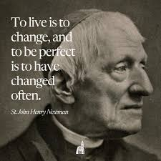
Fr Stephen

N
ow the green blade riseth from the buried grain, Wheat that in the dark earth many days has lain; Love lives again, that with the dead has been; Love is come again like wheat that springeth green.
In the grave they laid him, Love whom men had slain, thinking that never he would wake again, laid in the earth like grain that sleeps unseen; Love is come again like wheat that springeth green.

Forth He came at Easter, like the risen grain, he that for three days in the grave had lain; quick from the dead my risen Lord is seen; Love is come again like wheat that springeth green.
When our hearts are wintry, grieving or in pain, thy touch can call us back to life again; fields of our hearts that dead and bare have been; Love is come again like wheat that springeth green
J M C Crum (1872 – 1956)
In the early 1920’s, Bukharin was sent from Moscow to Kiev to address a vast anti-God rally. For one hour he brought to bear all the artillery of argument, abuse and ridicule upon the Christian faith, until it seemed that the whole ancient structure of belief was in ruins. At the end there was a silence. Questions were invited. A man rose and asked leave to speak, a priest of the Orthodox Church. He stood beside Bukharin, faced the people and gave them the ancient liturgical Easter greeting, ‘Christos Voskresje -Christ is risen.’ Instantly the whole vast assembly rose to its feet and the reply came back like a crash of breakers against the cliff. ‘Vosjestene Voskresje - He is Risen Indeed.’ There was no reply; there could not be. When all argument is ended, there remains a fact, the total fact of Jesus Christ, who requires no authority to recommend him, but who places every man in the position where an answer has to be given one way or another to the question he asks. LESLIE NEWBIGIN (B.1909)
THE MOTHERS’ UNION REPORT

At our MU March meeting Eileen Dilley gave us a fascinating talk on the origin of tea and its unprecedented effect on our culture after its introduction into Britain. It inspired your reporter, Sarah Speers, to do some further investigation.

HOW DID WE BECOME A NATION OF TEA DRINKERS and WHY DO WE HAVE A TRADITION OF AFTERNOON TEA?
Tea is an aromatic beverage prepared by pouring hot or boiling water over cured or fresh leaves of Camellia Sinensis, an evergreen shrub native to East Asia which originated in the borderlands of south-western China.
According to Chinese legend, tea was discovered by Emperor Shen Nong in 2737 BCE. As the “Divine Farmer” and father of Chinese medicine was boiling water under a tree, a few leaves drifted into his pot. Curious, he drank the infusion—and felt refreshed and revitalized. This serendipitous moment laid the foundation for tea's widespread cultivation and consumption in China.
The fortuitous discovery was not merely about a refreshing drink; it signalled the advent of tea in ancient Chinese culture. Shen Nong's finding underscored several vital aspects:
- Medicinal properties: Shen Nong recognized the health benefits of tea, establishing it as one of the earliest forms of medicine.
- Cultural significance: Tea began its journey as a crucial element of Chinese heritage.
- Ritual use: Initially, tea leaves were used in religious and medicinal rituals
- Myth and folklore: The legend of Shen Nong added a mystical dimension.
- Evolution into a beverage: Although initially medicinal, tea evolved into a popular drink by the Tang Dynasty. Over time, different types of tea—white, green, oolong, and black—were produced from the same tea plant, each serving unique purposes in Chinese society.
The tea ceremony In ancient China, offering tea to guests was a cherished tradition that symbolized respect and hospitality. Serving tea wasn't merely about quenching thirst; it was a profound gesture steeped in cultural significance. It showed visitors they were welcome and valued in your home.
Origins in England
Portuguese priests and merchants introduced tea to Europe during the 16th century. Tea drinking in England dates back to the 1660s, popularized by King Charles II’s Portuguese wife, Catherine of Braganza. Initially, tea was a luxury enjoyed in coffeehouses and by the aristocracy, often considered a medicinal beverage. The British later started to plant tea
on a large scale in India, where it had previously been used only as a medicine. By the early 19th century, tea consumption had increased dramatically, becoming a fashionable social drink.
The Duchess of Bedford
The formal concept of afternoon tea began with Anna, the seventh Duchess of Bedford, in 1840. She experienced hunger in the late afternoon because dinner was served late, around 8 PM. To satisfy her appetite, she requested a tray of tea, bread, butter, and cake in her private boudoir. This habit soon evolved into a social event as she invited friends to join her, creating a fashionable afternoon gathering.
Evolution into a Social Ritual
By the 1880s, afternoon tea had become a refined social occasion among the upper classes. Women would dress in long gowns, gloves, and hats, and tea was served in drawing rooms between 4 and 5 PM. Traditional afternoon tea included dainty sandwiches (like cucumber sandwiches), scones with clotted cream and preserves, and cakes and pastries, all served with tea poured from silver teapots into delicate bone china cups. The ritual emphasized elegance, etiquette, and social interaction, particularly among women, who used teatime as an opportunity to gather and converse.
The development of afternoon tea as we know it today
Afternoon tea became a symbol of refinement and social status, spreading to tea rooms and hotels, making it accessible beyond the aristocracy. It also provided a space for women to socialize independently, influencing social customs and even early suffragette meetings. Over time, the tradition has evolved, and today it is often enjoyed as a special treat or luxury experience, preserving the elegance and charm of Victorian England.
The term herbal tea refers to drinks not made from Camellia Sinensis. They are the infusions of fruit, leaves, or other plant parts, such as steeps of rosehip, chamomile, or rooibos. These may be called tisanes or herbal infusions to prevent confusion with tea made from the tea plant.

Sadly, the ubiquitous use of tea bags and mass marketed tea brands has deprived most of us of the pleasure of a more discerning approach to tea drinking. However, afternoon tea remains a quintessentially British tradition, reflecting both historical social practices and the enduring cultural love of tea.

Our next meeting will be during Holy Week
on Wednesday 1st April at 2.15 pm in the church hall,
when we shall be looking at different paintings of Jesus.
As ever, all welcome.

MARGARET’S PAGE
I have never owned a cat as I am definitely a ‘doggy person’, but just occasionally I encounter a cat which wins my heart.
Before I came to Bourne I lived at Tixover Grange, a complex near Stamford for people of 55 years or over. I was still working but fitted into the right age range. My neighbours, Ruth and Peter, owned a lovely tabby called Thomas. Every evening Thomas met me on the path on my way home from work and told me all about his day. (It’s amazing how humans can understand cat language if they stop to listen!) He would never come into my house although he frequently left me a present on the doorstep, a dead mouse or pigeon. One day he told me a longer story than usual and followed me home, then he stood at his own door and ‘cried’. He was afraid to go in because they had built a ramp up to the door for Peter’s new wheelchair. He followed me into my house and stayed there until I eventually took him home and persuaded him it was safe.
Last year I met another wonderful cat. Every week I go to visit my friend Barbara whom some of you may remember. She had a stroke some time ago and spends most of her time inside, unable to go anywhere. At first she was accompanied by her cat, whom she absolutely adored, but he eventually died of old age and she was heartbroken. For a number of reasons she was unable to have another cat although she longed for one. Then, last summer, she had a lovely surprise. She was adopted by a young ginger cat, who obviously belonged to one of the neighbours. I have been unable to find where he belongs and have no idea what his name is, but he spent most afternoons with her last summer and she left the door ajar so that he could come in. He is a very timid cat and would run out of the door as soon as he saw me arrive and then sneak back in again a few minutes later. He kept well away from me and ran out of the way as soon as I stood up to go.
Unfortunately, as the weather deteriorated ‘Ginger’s’ visits had to stop, but this week I arrived at the house to see him standing in the garden. Instead of running away from me he immediately came straight up to me and started ‘talking’. He went up the path a little way and then turned round to see if I was following, repeating this two or three times. It was obvious he was asking me to open the door to let him in. Having made a great fuss of Barbara he settled down on her knee for a few minutes and then left her and, to my amazement, came and sat on my knee. I couldn’t believe it. He alternated between the two of us for the rest of the afternoon. For a number of days I had been feeling depressed but now I felt much better: I had made a new friend.

Messy Church remembers Messy Helper JOAN NORVILLE
It was with great sadness that Messy Church learnt that Joan Norville, one of our Messy Church helpers, had died on 15th March.
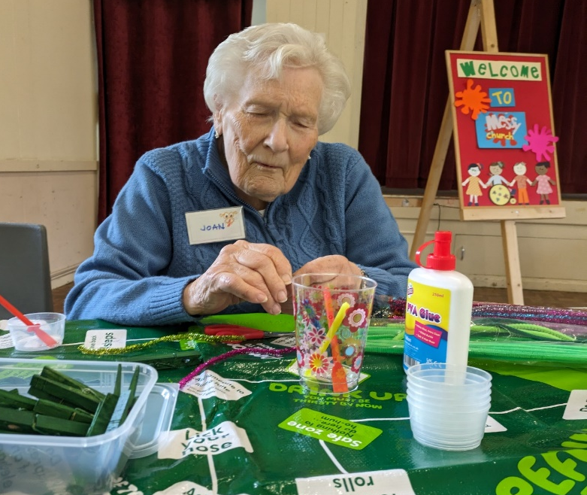
Joan had been actively involved with Messy Church right from its start in October 2024. She and Di were the face of Messy Church as they welcomed and registered families for Messy Church services. She was loved for her warmth, great sense of humour, laughter, infectious smile and hugs.
Joan never lost her inner child and had a wonderful twinkle in her eyes which we loved. We all have tales to tell how she would wink at you and make you giggle. Joan had a passion for music and Messy Church will say a musical goodbye to her on 3rd April at our Good Friday service.
Joan, you will be greatly missed by us all at Messy Church.




GOOD FRIDAY 3RD APRIL
in the Church Hall from 10am till noon
For families and accompanied children
Our theme: Courage to Follow Jesus

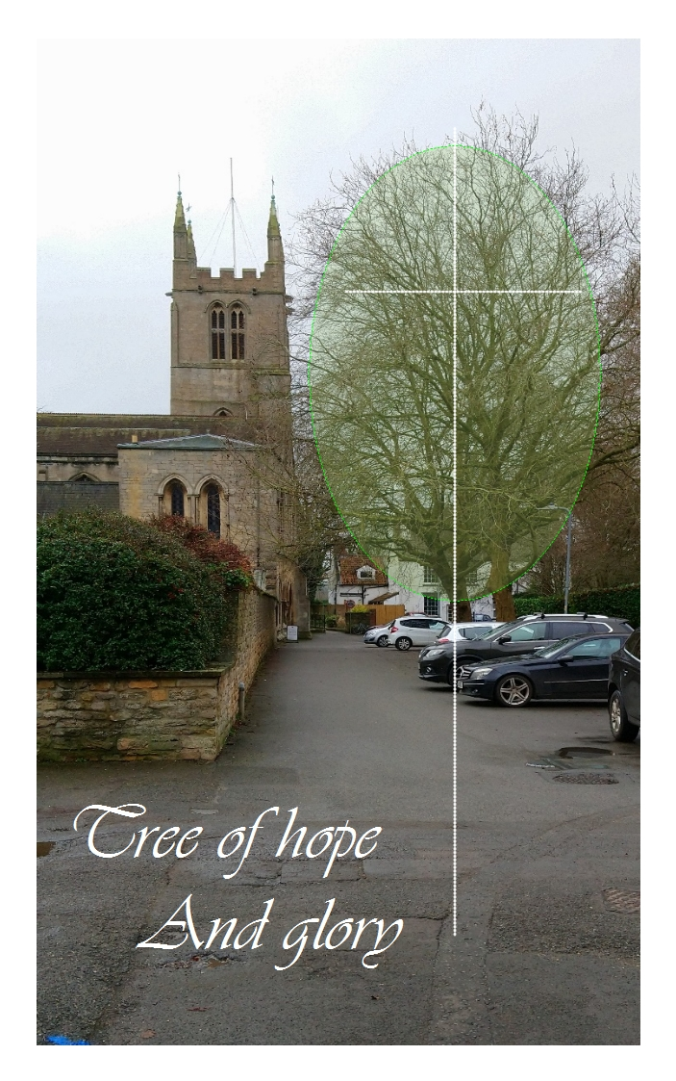
From Christmas to Easter, trees mark the seasons, unless you live in the tropics. This one photographed in February stands outside the Abbey and has had some green added by a computer along with the cross to anticipate the season. Now that Spring has returned, does this remind us of our Lord’s sacrifice on the tree of Calvary and of His triumphant resurrection? What do people think as they walk Church Lane?
The Abbey church has a remarkable building of ancient origin and large capacity. Regular congregations of average senior years welcome young people from time to time to discover the all-age appeal of the gospel. Easter is usually celebrated in numbers.
Whatever our number I am glad we rejoice in knowing that the gospel of Christ draws millions around the world to the same celebration. If you, like me, have travelled and celebrated Easter overseas you will no doubt know the joy of sharing this with people in other lands. Yet around the world today we see troubled peoples. In some of the places I once visited it would now be difficult for friends to meet. Yet I remember how former conflicts like WW2 eventually did give way to reconciling peace. A German student colleague and I could then see past the war which had caused the death of his father and rejoice in our heavenly Father’s greater provision.
At Christmas we shared a German song “O Tannenbaum.”
O Christmas tree, O Christmas tree, How faithfully you blossom! Through summer's heat and winter's chill Your leaves are green and blooming still. O Tannenbaum, O Tannenbaum, How faithfully you blossom.
Our own church Christmas tree has now been stripped and made into a cross. Perhaps a reminder of our Lord’s great work, “By one sacrifice he has perfected for ever those who are being made holy.” (Hebrews 10:14 )
With joy at Easter, Malcolm

A MESSAGE FROM MATTHEW ‘LEN’ CAUSTON

This year I am again taking part in the "MARCHFORMEN" in aid of Prostate Cancer UK,
which will take place on Saturday 13th June 2026
in Battersea Park, London.
If anyone would like to sponsor me or make a donation, I will have the relevant form with me in church during April and May, or you can sponsor me through my "Just Giving" Page at:
https://marchformen.prostatecanceruk.org/fundraising/matthews-fundraising-page1145


YOUR EASTER CHOCOLATE CAN BE GOOD FOR YOU
It all began in ancient Peru over 5,000 years ago. They liked to sip cacao, the purest form of chocolate. It took many centuries to find its way to Europe, but when it did arrive, it was a big hit. Now, with sugar added, chocolate is one of the most popular treats we know. In the UK we munch our way through about 4.5kg of it, per person, per year.
Dark chocolate is soaring in popularity. If it is of good quality, it will have less sugar and more beneficial plant compounds such as polyphenols and flavanols, which can help protect your brain, your heart and your gut from inflammation, among other things.


FOOLING AROUND
Probably the most famous April Fool’s joke of all time was the 1960’s BBC TV broadcast feature on the spaghetti farms of Italy. A BBC reporter interviewed Italian farmers about their work and the progress of the spaghetti plants in great detail. Spaghetti plants were filmed being carefully planted and then being harvested. And all in the BBC’s most serious documentary manner. It took a while to appreciate that this was Aunty playing games. Whatever next!


STAMFORD CONCERT SINGERS
Bourne Methodist Church
Friday 10th April at 7.30pm
Tickets £10 each, including light refreshments Available at the door


24 April MARK – disciple, apostle, writer of the second gospel
Mark, whose home in Jerusalem became a place of rest for Jesus and His 12 apostles, is considered the traditional author of the second gospel. He is also usually identified as the young man, described in Mark 14:51, who followed Christ after his arrest and then escaped capture by leaving his clothes behind.
Papias, a Greek bishop writing in 130, said that in later years Mark became Peter’s interpreter. If so, then this close friendship would have been how Mark gathered so much information about Jesus’ life. Peter referred to him affectionately as his ‘son’.

Mark was also a companion to Paul on his journeys. When Paul was held captive at Rome, Mark was with him. His Gospel, most likely written in Italy, perhaps in Rome, is the earliest account we have of the life of Jesus. Mark died about 74 AD. Early in the 9th century Mark’s body was brought to Venice, whose patron he became, and there it has remained to this day. The symbol of Mark as an evangelist is the lion and is much in evidence in Venice.
mmmmmmmmmmmmmmmmmmmmmmmmmmmmmmmmmmmmmmmmmmmm
At my age I …get my daily paper, look at the obituaries page and if I’m not there, I carry on as usual. – Patrick Moore

Why do people who know the least, know it the loudest? – Anon
LOVING PEOPLE IN LATER LIFE By the Revd Peter Crumpler, an Anglican priest in St Albans, Herts, and former C 0f E Communications Director
Nearly one in five people in England are aged 65 and over, with more than a quarter of the population expected to be above 65 by 2065. These figures illustrate why UK churches need to keep a focus on outreach to older people. To ignore them is to miss out on a major mission opportunity. And so current initiatives include lunch clubs, exercise sessions, singing classes, tea and coffee times, outings and a broad range of social activities open to the community.
But ‘later life’ or ‘retirement years’ is a catch-all term that says little about the fast-growing number of people in these age groups. A fit-and-well 65-year-old is very different to a 95-year-old person living in a care home. One – hopefully helpful – way of describing ministry to older people focuses on their health and ability. My proposed categories would be:
- The ‘go-go’ people: Men and women, often new to retirement, who are physically and mentally active and often looking for opportunities for voluntary service in areas, perhaps very different to their previous paid work. This age group is often the backbone of many churches, providing the voluntary support for all kinds of church activities – from staffing the church toddlers’ group to membership of the church council.
- The ‘slow-go’ people: Men and women who are no longer as active, perhaps because of illness, adjusting to life following bereavement, or needing to care for a family member. Here the mission opportunity may be around inviting them to join in church social events, such as lunch clubs or drop-ins, where they can meet new people and be drawn into the life of the church.
- The ‘no-go’ people: These are older people who are now home-based or living in a care setting. Visits from church members, services held at care homes, and ‘live-streaming’ of church services can also be a link for them to the worshipping community. Many churches have adopted care homes in their area.
And then, at the end of life, churches can also provide sensitive funeral services, tailored to the wishes of the bereaved, and their families.
Ministering to men and women in later life can be richly rewarding, both for the people concerned, and for the churches who take on this important ministry. We ignore it at our peril . . .
Churchwarden’s Chat A Norwegian Dåp

During my recent holiday in Norway I witnessed a Norwegian baptism (dåp) (reminiscent of ‘dip’ perhaps?) during the Sunday morning service in Ålesund. Most members of the baptismal party were wearing Norwegian national dress, the ladies with beautifully embroidered long skirts and bodices over white blouses (and a cape for outdoors), and the men in white shirts, black woollen jackets and red waistcoats each with two vertical rows of silver/pewter buttons, black knee breeches with white stockings and buckled shoes. This dress is often worn for major festivals, weddings and baptisms, and details of style vary from region to region.

The parents and child formed part of the procession up the aisle, the father carrying the child and the mother the baptismal water. Following the baptism, which took place early in the service, the priest carefully held the child and showed her to the congregation. Although I do not understand Norwegian I had the firm impression that the child was being presented as a new member of the church community. It was a simple but moving part of the service.

The Norwegian economy has for centuries relied heavily on the sea and so it is not surprising that many churches have a model of a ship, the main means of transport, hanging from the ceiling.
Jennifer Maclean

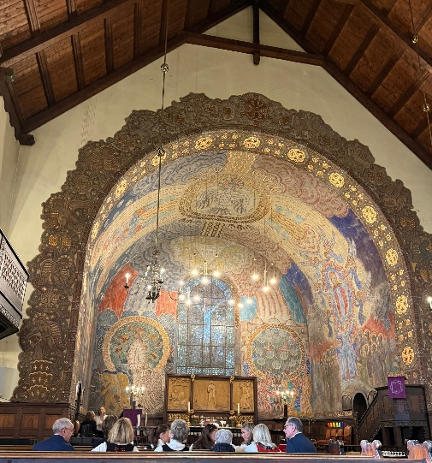 | 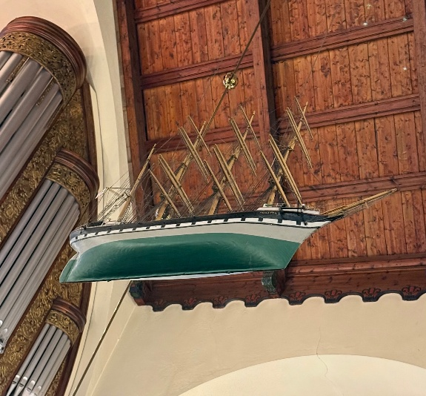

Bourne Abbey Church Pet Service
When: Saturday May 9th at 3pm
Where: Bourne Abbey Church
Pets:
- Dogs welcome on leads
- Other smaller pets welcome in carriers/cages
- Larger animals welcome outside the Church in Church Walk
- Bring a photo of pets no longer with us
- All welcome, with or without a pet
Refreshments afterwards (pets and owners) in Abbey Church Hall
* A pet who has started early to make it by 9th May

THE APRIL QUIZ 26
- The highest mountain in the Alps, Mont Blanc, is how high to the nearest thousand metres?
- In which year did only Fools and Horses first air?
- What is the first name of Inspector Maigret?
- What is the heraldic word for purple?
- Who played Bert Lynch in the series Z-Cars?
- Which country is the largest by area, Mali, Meici or Mozambique?
- CH is the postcode for which UK city?
- What does the term glissade mean?
- The song Ye Banks and Braes is about which Scottish river?
- In which Swiss lakeside town is there a bronze statue of Freddie Mercury?
- Which European football plays its home games at the Phillips stadium?
- The Little Yellow Train runs through which mountain range?
- In which county is Clacton-on-Sea?
- Which US state has Olympia as its capital?
- What does the red horse represent in the Four Horsemen of the Apocalyse?
- How many golf holes have been played when someone is ‘at the turn’?
- What is the national flower of Germany?
- The name of which Canadian province includes the name of two dog breeds?
- What type of creatures are Chip ‘n Dale in the cartoon series?
- What was the title of Whitney Houston’s first UK no1?
! March answers

1 Rosinante 2 Sicily 3 Cirrostratus 4 Electrical resistance 5 Nine 6 Venus 7 Neptune 8 Nirvana 9 Tubers 10 4000 (c.4010) 11 France (1954) 12 The Pacific Plate 13 Croquet and polo 14 Corvidae (crows) 15 Economics 16 Jeremy Lloyd and David Croft 17 Angelina Jolie 18 Surrey 19 Bartholomew and Wiseman 20 Hypethalamus
Jesus’ granny The little boy came home from his first day at Sunday School and casually told his mother that his Sunday school teacher was Jesus’ granny. Astonished, his mother asked: “Whatever makes you think that?” “Well, it’s pretty obvious,” said her son. “She never stopped talking about Him all morning. She told us Jesus is smarter and stronger and better-behaved than anyone else she knows. She even showed us a picture of Him.”

WHAT’S ON IN APRIL
Wedn’sday 1st | 2.15pm In the Church Hall
 | MU Meeting : Looking at ‘ Faces of Christ’ All Welcome
Friday 3rd | 10am in the Church Hall
 | Messy Church For families and accompanied children
Saturday 4th | 10 -12 noon in the Church Hall
Nibble 'n’ Natter Coffee Morning
Book stall, raffle and refreshments. All welcome. Proceeds to Church funds.
Wedn’day 15th | 2 – 4pm in the Church Hall
 | Knit and Sew Friendship Group All very welcome !
Thursday 16th | 7.00pm in the Abbey
 | ANNUAL PAROCHIAL CHURCH MEETING Open to all. A chance to celebrate the life of the church and discuss any issues in its ministry and mission.
Friday 17th | 10 – 11.30am at 34 Arnhem Way, PE10 9UD
 | The Abbey at Home: Christian Fellowship, Bible study and Prayer
Friday 24th | 10am in the Abbey
 | Team Clean All welcome! Bring dusters and handhelds!
Easter Flowers
Our thanks to all those ladies who arranged the lilies and other Easter flowers, and to Ian Cole for the window crosses. A full list of those who gave lilies ‘in memoriam’ will be in next month’s magazine
Nice The nice thing about becoming forgetful is that you can hide your own Easter eggs.
Don’t delay Never put off until tomorrow what you can do today, because by that time there will be a tax on it.
Behind every successful man is a surprised mother-in-law.

THE PENULTIMATE PAGE
There are over 600 churches in our diocese, all sizes and ages, all types of architecture, and all with seats. Of course there are seats, I hear you say, we need to be able to sit down during the service – and then you may go on to complain about the hardness of said seats, especially if your arthritis means you’re stiff, and even if you do bring a cushion! The chairs in other churches may then favourably be compared with our pews. Even the Vicar has been heard to say that he is glad of the comfort of his stall compared with the plight of the people in the pews!
No doubt the seating in your home has changed over the years and probably the way you use the rooms. Kitchen-diner, riser-recliner, the 2/3 sofa rule? We adapt the space we have according to how we see our needs, and what we think important. Churches are just the same. If we were building a new church now, we would plan very differently from our forebears. Heating and sanitation would have a far higher priority with the provision and placing of seating important too.

When Baldwin FitzGilbert de Clare caused the Abbey to be built in the twelfth century, he provided a nave for the people to gather. They gathered to hear a brief service in a language they did not understand, intoned by a priest beyond a screen. Most important was the elevation of the Host, the raising of the communion wafer above the priest’s head. The bell rang to alert the people to this sacred moment. Most people actually took communion once a year. Gazing at the Host was lay communion. There was no need to sit which meant that nothing was provided to sit on. There may have been a stone ledge along the wall for those who couldn’t stand for long. We still have the saying; The weakest go to the wall.
As time went on, there were changes in what was felt to be important, and eventually seats began to appear, driven by sermons, comfort and social hierarchy but that’s another story. Benches, stools, pews boxed and rented, pitch pine and oak, all part of the ever-changing church interior. Meanwhile, if your bones ache from pew-sitting, be thankful that there are pews on which to sit!

THE ABBEY CHURCH OF ST PETER AND ST PAUL
Church Walk, Bourne PE10 9UQ what3words:///petrified wrong trees
https://bourneabbey.uk Charity number:1132631

Vicar
Rev. Father Stephen Buckman | The Vicarage, Church Walk PE10 9UQ
Please note that the Vicar’s normal rest day is Friday | revstephen@btinternet.com | 01778 782779 07464 728545
Curate
Rev. Father Isaac Frisby | curate@bourneabbey.uk | 07587893966
Authorised Lay Ministers
Jennifer Maclean | j.maclean36@btinternet.com | 01778 393590
Marilyn Roberts | marilynroberts17@gmail.com | 07443 599217
Churchwardens
Jennifer Maclean | j.maclean36@btinternet.com | 01778 393590
Vicky Buckman | vbuckman@btinternet.com | 07769 804138
Director of Music | Vacant
Treasurer and Ringers
Alan Payne | alanpayne684@gmail.com | 01778 560633
Safeguarding Officer
Karen Key | karenkey@nhs.net | 07354 668966
Website Manager
Jennifer Maclean | j.maclean36@btinternet.com | 01778 393590
Hall Bookings& Magazine Editor
Celia Howes | celia.howes45@gmail.com | 01778 702627
Flowers in Church
Ann Northen | mikeann24@sky.com | 01778 423353

