
The Abbey Church of St Peter & St Paul
serving the communities of Bourne
Dyke Twenty and Cawthorpe

PARISH MAGAZINE


MARCH 2026 50p
www.bourneabbey.uk Bourne Abbey Church Group
WORSHIP AT THE ABBEY DURING MARCH, HOLY WEEK AND EASTER
Morning Prayer and Evening Prayer are said every weekday at 9.00am and 5.30pm The Abbey is open between 9am and 6pm.

Sunday 1st | Second Sunday of Lent | Sung Eucharist CW | 11.00am
 |  | Sung Evensong | 6.30pm
Tuesday 3rd |  | Said Eucharist CW | 7.00pm
Thursday 5th |  | Holy Communion BCP | 10.00am
Sunday 8th | Third Sunday of Lent | Sung Eucharist CW | 11.00am
Tuesday 10th |  | Said Eucharist CW | 7.00pm
Thursday 12th |  | Holy Communion BCP | 10.00am
Sunday 15th | Mothering Sunday | Said Eucharist CW | 9.00am
 |  | All Age Eucharist | 11.00am
 |  | Sung Evensong | 6.30pm
Tuesday 17th |  | Said Eucharist CW | 7.00pm
Thursday 19th | MU Corporate Communion | Holy Communion BCP | 10.00am
Sunday 22nd | Fifth Sunday of Lent-  beginning of Passiontide | Sung Eucharist CW | 11.00am
Tuesday 24th |  | Said Eucharist CW | 7.00pm
 |  | Holy Communion BCP | 10.00am
Sunday 29th | Palm Sunday with Abbey  Band | Sung Eucharist CW | 11.00am
 |  | Sung Evensong | 6.30pm
Monday  30th | Monday in Holy Week | Said Eucharist | 6.30pm
Tuesday 31st | Tuesday in Holy Week | Said Eucharist | 6.30pm
April 1st | Wednesday in Holy Week | Said Eucharist | 6.30pm
April 2nd | Maundy Thursday | Said Eucharist BCP | 10.00am
April 3rd | Good Friday | Messy Church in Hall | 10.00am
 |  | Stations of the Cross | 12.00pm
 |  | Good Friday Meditation | 1.00pm
 |  | Good Friday Liturgy | 2.00pm
April 4th | Holy Saturday | Easter Vigil | 8.00pm
April 5th | Easter Day | Said Eucharist | 9.00pm
 |  | All Age Eucharist | 11.00am
 |  | Sung Evensong | 6.30pm

We welcome the names of those who are ill or awaiting an operation so that prayers may be
offered for them. We also welcome the names of loved ones departed to be inscribed in the Abbey’s Book of Remembrance. Contact Churchwarden Jennifer Maclean.

REMEMBERING ESPECIALLY AT THIS TIME . . .
John Carlton, passed away on 4th February. He served as Church Warden with Mike Northen, was on the P.C.C and .Deanery Synod and was a Social Committee member for many years.
Brenda Jones, for more than 40 years an appreciative, responsive - and smartly be-hatted! - member of our congregation. Always ready, with Jim, to work practically and energetically to do whatever needed doing in the Abbey and in the town, especially at Baldocks Mill.
Funeral at 10.30am on Monday 16th March.

THE ABBEY’S BOOK OF REMEMBRANCE FOR MARCH

2nd Thomas Young : Robert Kitchener : 3rd Pauline Cummings
5th Colin Blackman : Kevin O'Dell : 6th Mavis Hill, Peter Oakley
7th Eileen Smith : Claude Rolt : Alan Shaw : Sharon Spooner
8th Thelma Keefe : 9th Andrew Bridle : Harold Bloodworth
10th Joseph Revill : Leslie Sutton : 11th Geoffrey Grummitt
12th Tracy Watson
13th Megan Lewis : Reginald Tabor : Wilfred Bond
14th Frank Woodman : Frances Newman : Margaret Warner
17th Herbert McMaster : 18th Doris Lewis, : Ritson Savage
19th Ada Glenn : Alan Rowland : Maureen Sibborn
20th Pearl Roberts : Rev Deacon Joseph Rogan : Anthony Reeson
22nd Frank Allen : 23rd John Steel : Ralph Baker : David Jehu
24th Michael Payne : 26th Irene Pulham
27th Roy Kelby : Peggy Morrison : Sheila Shipley : Janet Sauter Christopher Charles Moxley
28th Vera Marvin : 29th Susan Heather
30th Molly Dawson : Mary Hercock : 31st Hilda Fisher



EASTER LILIES

Lilies will be arranged at Easter in memory of loved ones. Please forward names of those you wish to be commemorated, plus £5 towards a lily, to:
Ann Northen, 24, Fir Avenue, Bourne. PE10 9RY.
e-Mail mikeann24@sky.com.by Sunday 22nd March at the latest.
Payment options : i) Cash ii) Cheque payable to Bourne Parochial
Church Council Flower Fund iii) BACS Bourne Parochial Church
Council, sort code 40-12-32, Acc. No 63016307

THE VICAR’S LETTER

Dear Friends in Christ,
St Francis of Assisi is accredited with saying these words: Start by doing what’s necessary; then do what is possible; and suddenly you are doing the impossible.
St Francis of Assisi, a man of humility, simplicity and profound faith, left us many pearls of wisdom. Few of those wonderful sayings are as practical and inspiring as these words. In a world that often feels overwhelming, his guidance reminds us that even the most daunting tasks begin with a single, faithful step.
Every day we are faced with choice. Some of those choices are grand and complex, but most are simple, necessary acts of love, service and responsibility. Those simple tasks are not the dramatic moments of sainthood, but small acts of obedience. This is the place, St Francis tells us, from which the journey begins. The journey does not begin with a fanfare, but with faithfulness. Jesus himself modelled this. His ministry did not begin with miracles, but by being baptized, praying, fasting and walking from village to village. Jesus began with what was necessary.

As we practise faith in the daily and the mundane, something begins to shift. Our spiritual muscles grow; our hearts expand. We start to believe that maybe we can serve in a ministry or speak a word of hope or help someone in crisis. Suddenly, what seemed out of reach becomes possible because we have been faithful in the small things.
The Apostle Paul encourages us in a similar way in his letter to the Philippians: I can do all things through Christ who strengthens me. To understand and embrace these words we need to grasp the fact that strength is built through a process – a process of doing what we can, one step at a time. As we take those steps, almost without realizing it, we will come to find ourselves doing the impossible: loving those we thought of as unlovable; starting a mission that changes lives; healing wounds that we thought of as being incurable; moving mountains because God works through those who step forward in faith.
St Francis was certainly not born a saint. He was a wealthy young man who gave up everything to follow Christ. He did not begin by preaching to crowds or rebuilding the Church. He started by tending to lepers, praying in silence and repairing a broken-down chapel. Over time, these simple acts became a movement that inspired millions.
As a Church, we often long to do great things. We long to reach the lost, to transform our communities, to bring about justice and peace. Of course, these goals are good and godly. But, let us not forget how they are achieved – by beginning with what is necessary. Our high-minded goals are achieved by showing up, by being present and by saying, ‘Yes,’ to the next right thing. Then, we are in a position to do the possible, as a community, as individuals, as a Christian family. Then, as we trust God, we will find ourselves in a position where we will look back in awe, realizing we have walked into the impossible – not through our own power, but through a faithful journey with the One who makes all things possible.

May we walk in the footsteps of St Francis, and more importantly, in the footsteps of Christ.
With every blessing to you all,
Fr Stephen

LINCOLNSHIRE COMMUNITY HEALTHCARE CHAPLAINCY
This article is adapted from one by Rowena Ward-Barrow, a chaplain who works in two GP practices in Stamford and Bourne.
We all know that there are enormous pressures in Primary Health Care. GPs generally have restricted appointment times in which to meet not only the physical but also the emotional and psychological needs of their patients. This increases the need for patients to have someone else to talk to. Key issues are bereavement, loneliness, anxiety, relationship problems and mental health.
The original vision for a chaplaincy service in general practice, came in 2012 from a Christian GP in Barton-on-Humber. The present team of 10 Volunteers are lay people from several Christian denominations, working in 10 GP practices across Lincolnshire. There are teams like this in other counties too.
Chaplains meet regularly for training, development and supervision. There is a part time paid manager, an executive team and an administrator.
How does the Chaplaincy service work?
- Appointments are currently made through the practice booking system following referral by a GP, another member of practice staff or by self-referral.
- Appointments usually last for up to an hour with an average time of around 3040 minutes.
- At present the service can only offer appointments to those aged 18 and over.
- The chaplaincy service is open to patients and staff.
- Patients can be of any faith or none. However, chaplains are motivated by their personal faith and desire to improve holistic wellbeing.
What do LCHC chaplains do?
- Offer a confidential service* on an individual basis
- Actively listen to a patient’s unique story or experience
- Help a patient discuss their concerns
- Offer reflection and support
- May help open up choices for the patient
- May offer suggestions of other helpful agencies
- May offer to pray with or for a patient or help them with their spiritual journey but only when this is appropriate and desired by the patient
* Chaplains will always refer the patient back to the GP if needed and have an obligation to pass on any safeguarding concerns.

Feedback from Lincolnshire GPs:
Feedback from GP surgeries, to date, indicates that GPs welcome the option of a referral to the service, and report good outcomes.
“An absolutely brilliant service, great feedback from patients. Great for those patients who need extra support/talking time that we can’t give them.”

“I have found the chaplaincy service really positive. It has given me, as a GP, another option in treating patients without necessarily having to prescribe meds or refer to counselling. I have suggested to a
significant number of patients that they self-refer to the Chaplains. All who have done so have found it extremely beneficial. Unlike traditional counselling, most only need a couple of sessions so have not ended up being dependent. I would like to see the service expanded and would recommend it to all GP practices.”

With more volunteers the service could extend more widely. Interested, or know someone who might be? Please contact pa@lincolnshiremethodist.org.uk or phone 01522 370126.

XXXXXXXXXXXXXXXXXXXXXXXXXXXXXXXXXXXXXXXXXXXXXXXXXXXXXXXXXXXXXXX
WHAT IS THE QUINQUENNIAL – AND WHY DOES IT MATTER FOR OUR PARISH?
Every five years, every Church of England parish undergoes what’s known as the Quinquennial Inspection. It’s essentially a detailed “health check” for our church building, carried out by an accredited architect or surveyor. Their task is to look closely at the fabric of the church—roof, stonework, drainage, electrics, heating, accessibility, and everything in between—to ensure the building remains safe, sound, and fit for worship and community use. Here at the Abbey, this will happen at the end of March.
Although it may sound rather technical, the Quinquennial is really about stewardship. Our church is both a place of prayer and a historic treasure entrusted to us. The inspection helps us understand what needs attention now, what may need work in the coming years and how best to care for the building, so it continues to serve future generations.
The report we receive afterwards is more than a list of repairs; it helps us with our planning. Some recommendations are urgent and need addressing quickly; others are longer-term, allowing us to budget sensibly and apply for grants where appropriate. It also helps the PCC prioritise projects, from essential maintenance to improvements that support our mission.
As we look ahead, the findings of the Quinquennial will shape our conversations about what we want our church to be in five, ten, or twenty years’ time. It invites us to think not only about preserving the past but also about enabling the future: a building that supports worship, hospitality, community life and the quiet moments of grace that happen within its walls.
Caring for our church is a shared responsibility—and the Quinquennial helps us do it wisely and faithfully.
Vicky Buckman

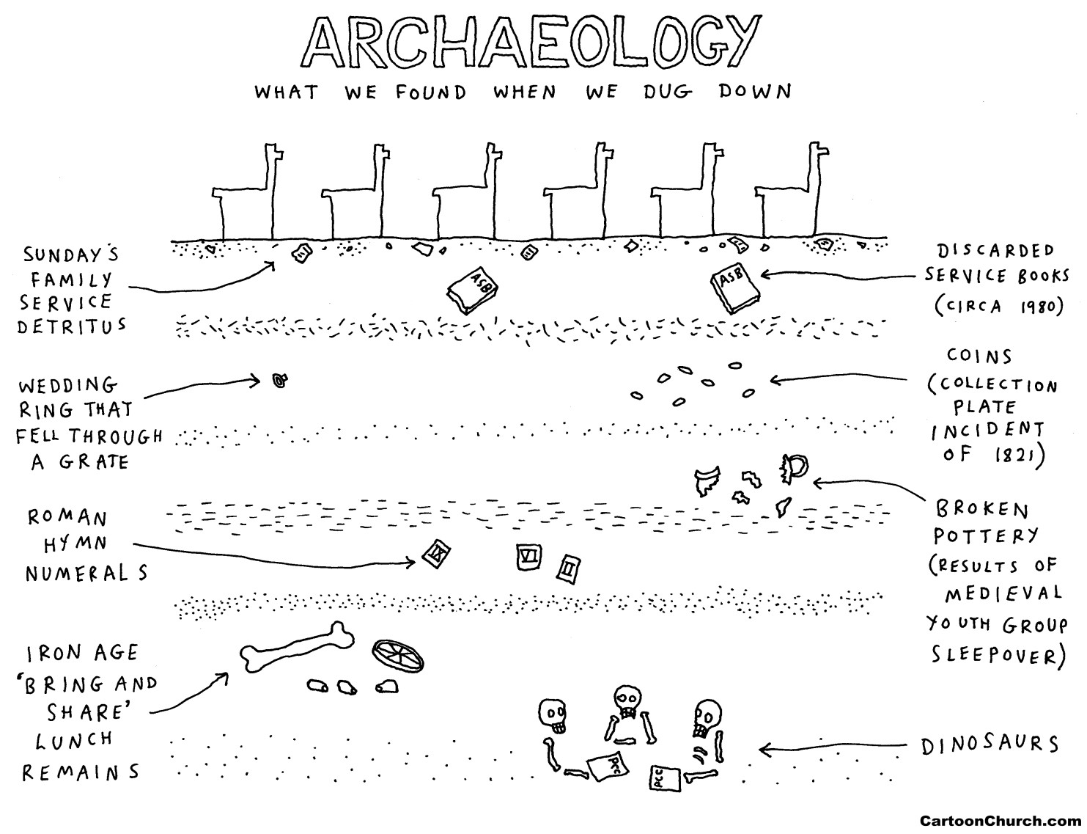

MOTHERS’ UNION LUNCH PARTY
A full turn out of members and their friends (30 in all) enjoyed lunch in the church hall in February, organised and served by committee members. Our thanks to Elizabeth who generously provided a cheese board, which was very popular. Thanks also to those who contributed prizes for the raffle which made a total of £69.


Our March meeting will be a talk by Eileen Dilley on “The
H
istory
of Afternoon Tea” which will sadly not be accompanied by a full
afternoon tea for everyone, but there will be the usual light
refreshments. All welcome.

15
th

March
is
There are certain small things that you notice,

Little things you have started to do, That prompt you to question, and wonder If the face in the mirror is you.
The realisation is dawning,
As one year hurtles after another,
That in word, thought and deed,
In gesture and glance,
You have somehow turned into your mother!
Daphne Kitching

Children are the anchors that hold a mother to life. – Sophocles
One good mother is worth a hundred schoolmasters. – George Herbert


A Quiz with a Difference
At 7pm in the church hall on Saturday 20th March
£5.00 per person Teams of Four
Light Refreshments Bring your own drinks
For more details contact Merryn Woodland on 01778 423232


2026

S
ervice
W
ritten by the
Women of Nigeria

2.00pm on Friday 6th March in Bourne Abbey
World Day of Prayer is a global ecumenical movement led by
Christian women who welcome you to join in prayer and action for peace and justice.

‘I SEE THE STARS’
Our new “Ancient and Modern” hymn book has grown since I remember it as a chorister in the early 1950s. I don’t remember this hymn appearing in the earlier selection:
“O Lord my God, when I in awesome wonder consider all the works Thy hands have made,
I see the stars, I hear the rolling thunder,
Thy pow'r throughout the universe displayed!

Then sings my soul, my Saviour God, to Thee: How great Thou art.”
I first heard the English translation of this international hymn following its inclusion in the Billy Graham crusades in the 1950s. My memory of these lines of “awesome wonder” had come to mind one dark starry night while on the deck of a Royal Navy ship crossing the North Sea. A matelot had joined me on deck and remarked how the starry wonder above us made him think of a creator behind it.
Meanwhile the officer of the watch would be referring to the plot using the same celestial bodies to navigate the ship. What to us on deck that night might have seemed impressive, to the navigation officer on watch, it was a reliable means of plotting our exact position in a dark watery expanse.
Then I remembered we were on a warship designed to hunt and kill the enemy during the dark days of the second world war. Years later I would be studying at a Bible college with international students including a German colleague who had lost his father while serving in the Kriegsmarine. Former conflicts had separated our parents but then we were reconciled in our common faith in Christ. We sang at college assemblies in English and German of our awesome wonder and reconciling power of our Creator and Redeemer.
With thanks to Him,
‘He determines the number of the stars and calls them each by name.’ Psalm147.4
Malcolm

MARGARET’S PAGE
For the last five years of my teaching career, I taught in Stamford at The Priory School, a boarding school which sadly had to close because of the Recession. For some of that time and when I first retired I lived at Tixover Grange, a few miles away from Stamford. This was originally a large mansion with extensive grounds which was eventually sold to become a retirement complex for people over fifty-five years of age and not necessarily for those who had already retired. The house was converted into flats and the stables into individual houses. The grounds were fantastic and I spent many summer evenings strolling beside the lake revelling in the sheer beauty of my surroundings.
The first time I was there in spring I couldn’t believe my luck, for the ground near the lake was covered in snowdrops; I had never seen anything like it before in my life. It was like my own little bit of paradise. I eventually decided to move from Tixover as I realised it would be impossible when I could no longer drive and Tixover had no bus service. I needed to be nearer my older sister who lived in Sleaford so I moved to Bourne where I have been extremely happy, but I missed the lake and especially I missed the snowdrops.
By sheer luck I discovered the lake at Belton House and for many years I paid it a visit at this time of year. The snowdrops are not actually beside the lake but you walk through hundreds of them in the woods on the way down to the water. Unfortunately it is a long way down to the lake and my legs no longer want to tackle it, so a few years ago I discovered Easton Walled Garden which is famous for its snowdrops. The majority of the snowdrops grow beside the stream, which is at the bottom of a very steep hill and I realised last year that I would have to find an alternative as I can get down the hill but I can’t get up it.
This year I was reading the ‘Mercury’ and saw a photo of the snowdrops in the churchyard at Uffington. I decided to drive over to have a look at them, but the weather was not co-operative and even I don’t enjoy walking through rain to see snowdrops. Yesterday, at last, we had a dry day and I set off to explore. I drove through Tallington without having to stop at the railway crossing (a real miracle) and arrived at the village of Uffington. Luckily the church has a very tall steeple so I was able to find it easily. However there was nowhere near the church to park, so I did some quick thinking and realised there must be a car park somewhere near the church for use when there is a wedding or funeral. So I drove up the next side road round to the back of the church and found the car park. More importantly, I found the snowdrops, thousands and thousands of them, all over the graveyard. At last I had found something to brighten up a long, dreary winter. It was well worth the effort. Admittedly, there was no lake but you can’t have everything! I had arrived too late to go into the church as it closed at 4 o’clock, but I had achieved my aim and I was able to believe that spring is on its way.




PAWS FOR THOUGHT

Saturday May 9th is a date all animal lovers in Bourne should make a note of. That is when a special Pet Service will be taking place at Bourne Abbey Church.

The Service will begin at 3pm, last no more than 45 minutes and offer the opportunity for pet owners to thank God for all the joy their furry friends bring to their lives. After the Service, pets (and their owners!) are welcome to have treats and refreshments in the Church Hall.

To make sure that all animals feel safe and comfortable, dogs must be toilettrained and kept on a lead at all times. Smaller animals such as cats and hamsters are equally welcome, but they must be kept in a pet carrier. It will even be possible for larger animals to take part in the Service: they can remain outside the Church with their owners, but the doors will be open so that everyone can feel involved. Those who would like to remember a pet who is no longer with us are also very welcome to bring along a photo for a blessing. And finally, if you don’t have a pet but would like to take part in the Service, do feel free to come along.

Even if we don’t have the same array of animals we saw in The Vicar of Dibley’s Pet Service, we are sure nevertheless that it will be an un – fur – gettable occasion! 


Come and Sing

Stainer’s ‘THE CRUCIFIXION’

Conducted by Revd Stephen Buckman

Saturday 28th March 2026 in Bourne Abbey
Registration (£10) from 1.30pm for Workshop at 2pm
Student Rates will apply
PERFORMANCE at 7pm Cost £5 All welcome
For information contact: events @bourne abbey.uk
___________________________________________________________


How many words does it take?

Pythagorean Theorem – 24 words
Lord’s Prayer – 66 words
Archimedes’ Principle – 67 words
Ten Commandments – 179 words
Shakespeare’s ‘To be, or not to be’ soliloquy – 260 words
Churchill’s speech ‘We Shall Fight on the Beaches’- 308 words
US Constitution with all 27 Amendments – 7,818 words
EU regulations on the sale of cabbages – 26,911 words

Puts things into perspective, doesn’t it?



For families and accompanied children
No need to book – just come along


Saturday 7th March from 2pm to 4pm in the Church Hall Our theme : Stand up and be counted
AND
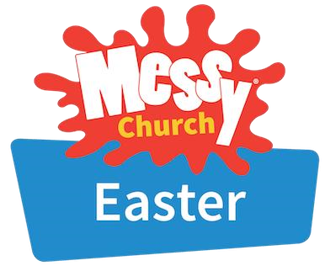
Good Friday 3
rd

April from 10am to noon

Our theme: Courage to follow Jesus



THE MARCH QUIZ
- In literature, what is the name of Don Quixote’s horse?
- Syracruse is a province in which region of Italy?
- What is measured in ohms?
- What type of high-altitude cloud is typically thin and consists of ice crystals?
- In cricket, how many inches wide is each wicket (three stumps)?
- Which planet precedes ‘flytrap’ to make the name of a carnivorous plant?
- The moons Despina and Larissa orbit which planet?
- What is the ultimate goal for Buddhists?
- In what form are dahlias planted?
- To the nearest thousand, how long is the Amazon River?
- Which country hosted the inaugural Rugby League World Cup?
- Which is the largest of Earth’s tectonic plates?
- In which two sports would a mallet be used?
- The jay belongs to which family of birds?
- In what field is the Frenchman Thomas Piketty (b.1971) a well-known name?
- Who created the TV series Are You Being Served?
- Which US actress was presented with an honorary damehood by Queen Elizabeth II for her anti-war campaigns?
- In which county is the parliamentary constituency of Mole Valley?
- What were the real surnames of Eric and Ernie?
- What part of the brain regulates body temperature?
February Answers
1 A Tale of Two Cities 2 Drop the Dead Donkey 3 Lake Superior 4 Nottingham
5 The kitchen 6 Bucks (or jacks) 7 1553 8 Brighton 9 Silkworm 10 What
You Will 11 15 years old 12 Scottish 13 Barn owl 14 The Italian Job 15 Beauty 16 Volkswagen 17 Bolt 18 Arabian Desert 19 George Carey 20 A fossilised animal
Coming and going
Your child has started growing up when he stops asking you where he came from and starts refusing to tell you where he’s going.

Monday 2nd | 10am in the Abbey
 | Julian Group – prayer and meditation
Wedn’sday 4th | 2.15pm In the Church Hall
 | MU meeting: ‘A History of Afternoon Tea’ with Eileen Dilley
Thursday 5th  12th 19th 26th | 10.45am in the Abbey following the 10am service
 | Lent Course: ‘The Return of the Prodigal Son’
Friday 6th | 2pm in the Abbey See p.11
 | World Day of Prayer: Nigeria –‘I will give you rest, come’
Saturday 7th | 10-12 noon in the Church Hall
Nibble 'n’ Natter Coffee Morning
Book stall, raffle and refreshments. All welcome. Proceeds to Church funds.
 | 2 -4pm in the hall, and 10- 12 on 3rd April See p 16
 | Messy Church For families and accompanied children
Wedn’day 18th | 2 – 4pm in the Church Hall
 | Knit and Sew Friendship Group All very welcome !
Saturday 20th | 7.00pm in the hall
 | ‘Quingo’ - a quiz with a difference See p.11
Wedn’day 25th | 7.00pm in the Abbey
 | Bourne Grammar School Concert
Friday 27th | 10am in the Abbey
 | Team Clean All welcome! Bring dusters and handhelds!
 | 1.00pm in the Abbey
 | Bourne Grammar School Lunchtime Concert
Saturday 28th | 2.00pm in the Abbey See p.15
 | ‘Come and Sing’ Stainer’s ‘Crucifixion’
 | 7.00pm in the Abbey
 | Performance of Stainer’s ‘Crucifixion’. All welcome

THE PENULTIMATE PAGE
Last month this page explored the possible whereabouts of the grave of Humphrey Hyde, Vicar of Bourne for 44 years. Perhaps next to the black marble slab for his wife, and therefore under the west end of the main aisle carpet? Well, dear reader, I was wrong! Eileen Palmer plays the organ at occasional services in local churches , as well as singing in our choir. In Dowsby St Andrew church, on the chancel wall, she saw a familiar name. You can see it too by following this link: https://slha.org.uk/catalogue_item/dowsby-st-andrew-chancel-memorial-hyde
It’s a stone tablet to the memory of the Revd. Humphrey Hyde, Rector of this parish and
Vicar of Bourn, died 12th January 1807, and of his sister Mary. I’d not have misled you if I had read his will. ‘ I direct that my body be interred in a decent manner and as becometh my station in the chancel of the Parish Church of Dowsby.’ Why Dowsby?
These days we are used to our clergy being in charge of more than one parish, linked in groups working together, or trying to! Bourne is quite an exception in being a single parish. The diocese plans the groups according to the number of clergy that can be afforded. Their stipends(salaries) are paid by the diocese, funded by parishioner donations, investments and diocesan funds.
It was different in the eighteenth century. Priests were paid through tithes, a compulsory tax of one-tenth of agricultural produce, and glebe, land owned by the church. Rectors got ‘great tithes’(corn, hay, wood) and often managed their own income by farming the parish glebe land. Vicars got the ‘small tithes’ – mixed produce and sheep. Often noblemen and landowners owned church livings and the tithes that went with them and hired a vicar to do the work vicariously. Some of the owners were also patrons. They had the right to choose the parish priest. That priest then gained the right to the tithes of that parish.
And if you weren’t lucky enough to be a rector or a vicar? Well, there was no limit to the number of parishes one priest could hold, nor did you have to retire. So a rector or vicar, too ill, too old or too busy to look after his church or churches, would pay a curate from his own pocket – often at a very low rate!
Mr Hyde, Vicar of Bourne, was given in addition the living of his birthplace, Dowsby, by the Duke of Ancaster. No doubt he was pleased to be a Rector. Rectors were reckoned to have greater social status and better income.. Being buried where he was Rector ‘became his station’. No record of whether he paid a curate to do the actual work!

THE ABBEY CHURCH OF ST PETER AND ST PAUL
Church Walk, Bourne PE10 9UQ what3words:///petrified wrong trees
https://bourneabbey.uk Charity number:1132631

Vicar
Rev. Father Stephen Buckman | The Vicarage, Church Walk PE10 9UQ
Please note that the Vicar’s normal rest day is Friday | revstephen@btinternet.com | 01778 782779 07464 728545
Curate
Rev. Father Isaac Frisby | curate@bourneabbey.uk | 07587893966
Authorised Lay Ministers
Jennifer Maclean | j.maclean36@btinternet.com | 01778 393590
Marilyn Roberts | marilynroberts17@gmail.com | 07443 599217
Churchwardens
Jennifer Maclean | j.maclean36@btinternet.com | 01778 393590
Vicky Buckman | vbuckman@btinternet.com | 07769 804138
Director of Music | Vacant
Treasurer and Ringers
Alan Payne | alanpayne684@gmail.com | 01778 560633
Safeguarding Officer
Karen Key | karenkey@nhs.net | 07354 668966
Website Manager
Jennifer Maclean | j.maclean36@btinternet.com | 01778 393590
Hall Bookings& Magazine Editor
Celia Howes | celia.howes45@gmail.com | 01778 702627
Flowers in Church
Ann Northen | mikeann24@sky.com | 01778 423353

