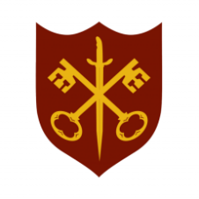 | This Week at the Abbey
 | 22 February – 1 March 2026
The church is open during the day.

SUNDAY 22nd | 9.00 a.m. | Said Eucharist
 | 11.00 a.m. | Sung Eucharist
MONDAY 23rd | 9.00 a.m. | Morning Prayer
 | 11.30 a.m. | Memorial Service –  Paul Boothman
 | 5.30 p.m. | Evening Prayer
TUESDAY 24th | 9.00 a.m. | Morning Prayer
 | 2.00 p.m. | Garden Group
 | 5.30 p.m. | Evening Prayer
 | 7.00 p.m. | Said Eucharist
WEDNESDAY 25th | 9.00 a.m. | Morning Prayer
 | 9 30 a.m. | Electrician to carry out PAT
 | 5.30 p.m. | Evening Prayer
 | 7.00 p.m. | Band practice
THURSDAY 26th | 9.00 a.m. | Morning Prayer
 | 10.00 a.m. | Said Eucharist (BCP)
 | 10.5 a.m. | Lent course (1/5)
 | 5.30 p.m. | Evening Prayer
FRIDAY 27th | 9.00 a.m. | Morning Prayer
 | 10.00 a.m. | Team Clean
 | 5.30 p.m. | Evening Prayer
 | 6.30 p.m. | Choir Practice
SATURDAY 28th | 9.00 a.m. | Morning Prayer
 | 5.30 p.m. | Evening Prayer
SUNDAY 1st | 11.00 a.m. | Sung Eucharist
 | 6.30 p.m. | Sung Evensong

