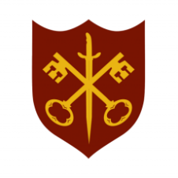 | This Week at the Abbey
4 – 11 January 2026
The church is open during the day.

Day | Time | Details
SUNDAY 4th | Feast of the Epiphany |  |  | 
 | 11.00 a.m. | Sung Eucharist
 | 6.30 p.m. | Sung Evensong
MONDAY 5th | 9.00 a.m. | Morning Prayer
 | 10.00 a.m. | Julian Group
 | 5.30 p.m. | Evening Prayer
TUESDAY 6th | 9.00 a.m. | Morning Prayer
 | 5.30 p.m. | Evening Prayer
 | 7.00 p.m. | Said Eucharist
WEDNESDAY 7th | 9.00 a.m. | Morning Prayer
 | 2.15 p.m. | MU AGM – Church Hall
 | 5.30 p.m. | Evening Prayer
THURSDAY 8th | 9.00 a.m. | Morning Prayer
 | 10.00 a.m. | Said Eucharist (BCP)
 | 10.45 a.m. | Pilgrim Course (1/6)
 | 5.30 p.m. | Evening Prayer
FRIDAY 9th | 9.00 a.m. | Morning Prayer
 | 5.30 p.m. | Evening Prayer
 | 6.30 p.m. | Choir Practice
SATURDAY 10th | 9.00 a.m. | Morning Prayer
 | 5.30 p.m. | Evening Prayer
SUNDAY 11th | Baptism of Christ
 | 11.00 a.m. | Sung Eucharist

