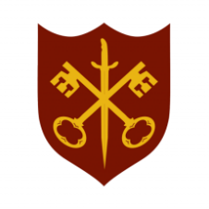 | This Week at the Abbey
 | 25 January – 1 February 2026
The church is open during the day.

SUNDAY 25th | 9.00 a.m. | Said Eucharist
 | 11.00 a.m. | All Age Eucharist
MONDAY 26th | 9.00 a.m. | Morning Prayer
 | 5.30 p.m. | Evening Prayer
TUESDAY 27th | 9.00 a.m. | Morning Prayer
 | 12.30 p.m. | Memorial Service –  Brian Salmon
 | 5.30 p.m. | Evening Prayer
 | 7.00 p.m. | Said Eucharist
WEDNESDAY 28th | 9.00 a.m. | Morning Prayer
 | 5.30 p.m. | Evening Prayer
 | 7.00 p.m. | Band Practice
THURSDAY 29th | 9.00 a.m. | Morning Prayer
 | 10.00 a.m. | Said Eucharist (BCP)
 | 10.45 a.m. | Pilgrim Course (4/6)
 | 5.30 p.m. | Evening Prayer
FRIDAY 30th | 9.00 a.m. | Morning Prayer
 | 5.30 p.m. | Evening Prayer
 | 6.30 p.m. | Choir Practice
SATURDAY 31st | 9.00 a.m. | Morning Prayer
 | 11.30 a.m. | Baptism
 | 5.30 p.m. | Evening Prayer
SUNDAY 1st | 11.00 a.m. | Sung Eucharist
 | 6.30 p.m. | Sung Evensong

