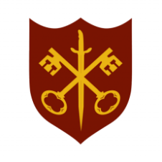 | This Week at the Abbey
11 – 18 January 2026
The church is open during the day.

Day | Time | Details
SUNDAY 11th | Baptism of Christ
 | 11.00 a.m. | Sung Eucharist
MONDAY 12th | 9.00 a.m. | Morning Prayer
 | 5.30 p.m. | Evening Prayer
TUESDAY 13th | 9.00 a.m. | Morning Prayer
 | 5.30 p.m. | Evening Prayer
 | 7.00 p.m. | Said Eucharist
WEDNESDAY 14th | 9.00 a.m. | Morning Prayer
 | 9.30 a.m. | Plumber on site
 | 5.30 p.m. | Evening Prayer
THURSDAY 15th | 9.00 a.m. | Morning Prayer
 | 9.30 a.m. | Plumber possibly on site
 | 10.00 a.m. | Said Eucharist (BCP)
 | 10.45 a.m. | Pilgrim Course (2/6)
 | 5.30 p.m. | Evening Prayer
FRIDAY 16th | 9.00 a.m. | Morning Prayer
 | 10.00 a.m. | Abbey at Home – see noticeboard for details
 | 5.30 p.m. | Evening Prayer
 | 6.30 p.m. | Choir Practice
SATURDAY 17th | 9.00 a.m. | Morning Prayer
 | 5.30 p.m. | Evening Prayer
SUNDAY 18th | 11.00 a.m. | Sung Eucharist
 | 6.30 p.m. | Service for the Week of Prayer for Christian Unity

