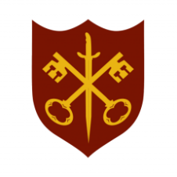 | This Week at the Abbey
28 December 2025 – 4 January 2026
The church is open during the day.

Day | Time | Details
SUNDAY 28th | 9.00 a.m. | Said Eucharist
 | 11.00 a.m. | All Age Eucharist
MONDAY 29th | 9.00 a.m. | Morning Prayer
 | 11.00 a.m. | Funeral – Michael Northen
 | 5.30 p.m. | Evening Prayer
TUESDAY 30th | 9.00 a.m. | Morning Prayer
 | 5.30 p.m. | Evening Prayer
 | 7.00 p.m. | Said Eucharist
WEDNESDAY 31st | 9.00 a.m. | Morning Prayer
 | 5.30 p.m. | Evening Prayer
THURSDAY 1st | 9.00 a.m. | Morning Prayer
 | 10.00 a.m. | Said Eucharist (BCP)
 | 5.30 p.m. | Evening Prayer
FRIDAY 2nd | 9.00 a.m. | Morning Prayer
 | 5.30 p.m. | Evening Prayer
 | 6.30 p.m. | Choir Practice
SATURDAY 3rd | 9.00 a.m. | Morning Prayer
 | 10.00 a.m. | Nibble & Natter, Church Hall
 | 5.30 p.m. | Evening Prayer
SUNDAY 4th | 11.00 a.m. | Sung Eucharist
 | 6.30 p.m. | Sung Evensong

