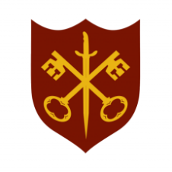 | This Week at the Abbey
5 - 12 October 2025
The church is open during the day.

Day | Time | Details
SUNDAY 5th | 11.00 a.m. | All Age Eucharist & Harvest
 | 6.30 p.m. | Sung Evensong
MONDAY 6th | 9.00 a.m. | Morning Prayer
 | 10.00 a.m. | Julian Group
 | 5.30 p.m. | Evening Prayer
 | 6.45 p.m. | Bourne Choral rehearsal
TUESDAY 7th | 9.00 a.m. | Morning Prayer
 | 5.30 p.m. | Evening Prayer
 | 7.00 p.m. | Said Eucharist
WEDNESDAY 8th | 9.00 a.m. | Morning Prayer
 | 5.30 p.m. | Evening Prayer
 | 7.00 p.m. | Band Practice
THURSDAY 9th | 9.00 a.m. | Morning Prayer
 | 10.00 a.m. | Said Eucharist (BCP)
 | 2.00 p.m. | Bourne Abbey & Elsea Park PAs’ Harvest service
 | 5.30 p.m. | Evening Prayer
FRIDAY 10th | 9.00 a.m. | Morning Prayer
 | 5.30 p.m. | Evening Prayer
 | 6.30 p.m. | Choir practice
 | 6.30 p.m. | Harvest Supper, Church Hall (ticketed event – see notice inside)
SATURDAY 11th | 9.00 a.m. | Morning Prayer
 | 5.30 p.m. | Evening Prayer
SUNDAY 12th | 11.00 a.m. | Sung Eucharist

