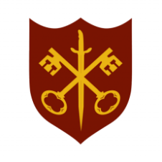 | This Week at the Abbey
26 October – 2 November 2025
The church is open during the day.

Day | Time | Details
SUNDAY 26th | 9.00 a.m. | Said Eucharist
 | 11.00 a.m. | All Age Eucharist
MONDAY 27th | 9.00 a.m. | Morning Prayer
 | 5.30 p.m. | Evening Prayer
 | 6.45 p.m. | Bourne Choral rehearsal
TUESDAY 28th | 9.00 a.m. | Morning Prayer
 | 2.00 p.m. | Garden Group
 | 5.30 p.m. | Evening Prayer
 | 7.00 p.m. | Said Eucharist
WEDNESDAY 29th | 9.00 a.m. | Morning Prayer
 | 5.30 p.m. | Evening Prayer
 | 7.00 p.m. | Band Practice
THURSDAY 30th | 9.00 a.m. | Morning Prayer
 | 10.00 a.m. | Said Eucharist (BCP)
 | 5.30 p.m. | Evening Prayer
FRIDAY 31st | 9.00 a.m. | Morning Prayer
 | 5.00 p.m. –  6.30 p.m. | Messy Church Festival of Light, Church Hall
 | 5.30 p.m. | Evening Prayer
 | 6.30 p.m. | Choir practice
SATURDAY 1st | 9.00 a.m. | Morning Prayer
 | 10.00 a.m. | Nibble & Natter, Church Hall
 | 3.00 p.m. | Service of Light & Remembrance
 | 5.30 p.m. | Evening Prayer
SUNDAY 2nd | 11.00 a.m. | Sung Eucharist
 | 6.30 p.m. | Sung Evensong

