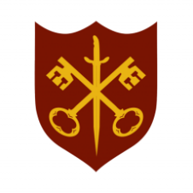 | This Week at the Abbey
19 - 26 October 2025
The church is open during the day.

Day | Time | Details
SUNDAY 19th | 11.00 a.m. | Sung Eucharist
 | 6.30 p.m. | Choral Evensong
MONDAY 20th | 9.00 a.m. | Morning Prayer
 | 9.30 a.m. | Boiler service
 | 5.30 p.m. | Evening Prayer
 | 6.45 p.m. | Bourne Choral rehearsal
TUESDAY 21st | 9.00 a.m. | Morning Prayer
 | 5.30 p.m. | Evening Prayer
 | 7.00 p.m. | Said Eucharist
WEDNESDAY 22nd | 9.00 a.m. | Morning Prayer
 | c. 10.00 a.m. | Probus Visit
 | 5.30 p.m. | Evening Prayer
 | 7.00 p.m. | Band Practice
THURSDAY 23rd | 9.00 a.m. | Morning Prayer
 | 10.00 a.m. | Said Eucharist (BCP)
 | 5.30 p.m. | Evening Prayer
FRIDAY 24th | 9.00 a.m. | Morning Prayer
 | 10.00 a.m. | Team Clean
 | 5.30 p.m. | Evening Prayer
 | 6.30 p.m. | Choir practice
SATURDAY 25th | 9.00 a.m. | Morning Prayer
 | 5.30 p.m. | Evening Prayer
 | Overnight | British Summer Time ends
SUNDAY 26th | 9.00 a.m. | Said Eucharist
 | 11.00 a.m. | All Age Eucharist

