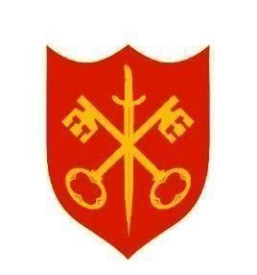
The Abbey Church of St Peter & St Paul
serving the communities of Bourne
Dyke Twenty and Cawthorpe

PARISH MAGAZINE



NOVEMBER 2025 50p www.bourneabbey.uk Bourne Abbey Church Group

WORSHIP AT THE ABBEY DURING NOVEMBER
Morning Prayer and Evening Prayer are said every weekday at 9.00am and 5.30pm

The Abbey is open during the hours of daylight. Do come in to pray, to light a candle or just to enjoy a moment of peace and quiet.
Saturday 1st | Service of Light and Remembrance |  | 3.00pm
Sunday 2nd | Fourth Sunday before Advent | Sung Eucharist CW | 11.00am
 |  | Sung Evensong | 6.30pm
Tuesday 4th |  | Said Eucharist CW | 7.00pm
Thursday 6th |  | Holy Communion BCP | 10.00am
Sunday 9th | Remembrance Sunday | Said Eucharist CW | 9.00am
 | The Two Minutes Silence will be marked in the Abbey at 11.00am | Service of Remembrance | 11.20am
Tuesday 11th |  | Said Eucharist CW | 7.00pm
Thursday 13th |  | Holy Communion BCP | 10.00am
Sunday 16th | Second Sunday before Advent | Sung Eucharist CW | 11.00am
 |  | Choral Evensong | 6.30pm
Tuesday 18th |  | Said Eucharist CW | 7.00pm
Thursday 20th | MU Corporate Communion | Holy Communion BCP | 10.00am
Sunday 23rd | Christ the King | Said Eucharist CW | 9.00am
 |  | All Age Eucharist | 11.00am
Tuesday 25th |  | Said Eucharist CW | 7.00pm
Thursday 27th |  | Holy Communion BCP | 10.00am
Sunday 30th | First Sunday of Advent | Sung Eucharist CW | 11.00am

We welcome the names of those who are ill or awaiting an operation so that prayers may be offered for them. We also welcome the names of loved ones departed to be inscribed in the Abbey’s Book of Remembrance. Contact Churchwarden Jennifer Maclean.

From the Abbey’s Book of Remembrance for November

1st Iris Halls : Norman Steel
2nd Thomas Ferguson : Margaret Mapleston : 3rd Gilbert Pickering
4th Barry Waltham : Kim Sykes : Trudie Hewitt : John Wright
5th James Murray : Anne Holmes : Reginald Hodgkin : Carole Harry
6th Garion Dagger ; Leslie Mapleston : Richard Porter
7th Mary Paterson Ward : Lucy Rose : Roger Revell : Edward Blackman
9th Philip Orbell : Keith Barratt : Donald Fowler
10th Audrey Bloodworth : Hazel Winifred Johnson

11th George Cole : Audrey Scotney : Vernon Bannister : Paul Crosby
14th Roy Jones : Christopher Notley
15th Peter Bentley : Dudley Guppy
16th Derek Britton : Stephen Wells
17th Barry Creaser : John Falkner
18th Edwin Powell : Reg Frazer : Patricia Edmunds : Barbara Stewart
19th George Newman : 20th Ralph Musgrove
21st Michael Atkins : 23rd Eileen Bostock : Amelia Rolt : Derek Bontoft
24th Ernest Belton : Maisie Roberts
25th William Dandridge ; Doreen Lewis ; Monica Pain
26th Alfred Dawson : David Nethergate
27th Kenneth Cubey : Lily Orbell : Margaret Pickering : Sadie Pick
28th David Lingard : Jessie Nunn
THE VICAR’S LETTER

Dear Friends in Christ,
On Remembrance Day, a time dedicated to honouring those who have sacrificed their lives for our freedom, we are reminded of the profound connection between our past and our future. The 19th century English philosopher, political economist, politician and civil servant, wrote these poignant words: “I inherit my history but I can choose my future.” These words resonate deeply within the context of this time of Remembrance. They echo the teachings of Jesus Christ, who urged us to reflect on our past, learn from it and step forward with purposeful intent.

Our history is a tapestry woven with threads of sacrifice, courage and resilience. On Remembrance Day we pause to honour the soldiers who laid down their lives in the service of their country. Their legacy is our inheritance, a reminder of the values they fought to preserve – freedom, justice and peace. Just as Mill acknowledged the weight of our historical inheritance, Jesus too emphasized the importance of remembering and honouring our past. In John 15:13 Jesus teaches: “No one has greater love than this, to lay down his life for one’s friends.” This ultimate act of selflessness is mirrored in the bravery of those we commemorate on Remembrance Day.
While our history shapes us, it does not dictate our future. Mill’s assertion that we have the power to choose our future aligns with Jesus’ teachings on free will and redemption. In Matthew 7:13-14, Jesus speaks of the narrow gate, encouraging us to make choices that lead to life and righteousness. Our ability to choose future grounded in the teachings of Christ is a testament to God’s grace and the transformative power of faith. By embracing the lessons of our past, we can make informed decisions that honour our heritage and pave the way for a brighter, more hopeful future.
Remembrance Day is not only about looking back, but also about moving forward with intention. As Christians, we are called to live in accordance with Jesus’ teachings – teachings which emphasize love, compassion and service. In John 13:34 Jesus commands, “I give you a new commandment, that you love one another. Just as I have loved you, you also should love one another.” This commandment compels us to act with kindness and empathy, ensuring that the sacrifices of those we remember are not in vain.
In choosing our future, we must rely on our faith as a guiding light. Proverbs 3:5-6 advises, “Trust in the Lord with all your heart, and do not rely on your own insight. In all your ways acknowledge him, and he will make straight your paths.” As we navigate the complexities of this world, let us turn to the teachings of Jesus for wisdom and direction. By doing so, we honour our past whilst embracing a future filled with promise and divine purpose.
John Stuart Mill’s words remind us that while we inherit our history, we possess the power to shape our own futures. During this season of Remembrance, let us reflect on the sacrifices that have been made; let us honour the legacy we have inherited; and let us choose a future inspired by the teachings of Jesus Christ. May we strive to live lives of love, faith and service, ensuring that the lessons of our past guide us toward a future of peace and righteousness.

With every blessing to you all,
Fr Stephen

CHURCHWARDENS CHAT The new hymn books… Vicky Buckman
I know I am not alone in scanning the hymn numbers at the start of a service to judge whether we are in for a good sing. We each have favourites learned at school or in church but the selection is quite narrow, and becomes narrower with each generation. Ask anyone to pick a hymn for a wedding or a funeral and “Sing hosanna”, “All things bright and beautiful” and “One more step along the world I go” tend to be favourites.
The hymn book, as we recognise it, first appeared in 1707 and has since gone through thousands of editions. Hymns give comfort through familiar tunes and words that roll easily off the tongue. But, in the same way that language evolves over time, some of the sentiments and phrases of the old hymns sound dated or out of step with modern worship. And some of the tunes are less memorable.
CF Alexander, author of beloved hymns such as “There Is a Green Hill Far Away” and “Once in Royal David City,” wrote these lines:
The saints of God, their conflict past,
They live not only in their tombs,
or in the churchyard green;
they live in every Christian heart
where Christ himself is seen.
Such verses may have been popular in Victorian times but are rather sombre for a Sunday morning, which helps explain why they no longer appear even in Father Stephen’s extensive collection of books!
It is, however, possible for old tunes to endure simply by being paired with new texts. My own favourite, “Alleluia, Sing to Jesus,” is a communion hymn set to the distinctive tune Hyfrydol. The tune’s common meter has inspired multiple texts; I can think of at least two versions, and there are probably many more in circulation.
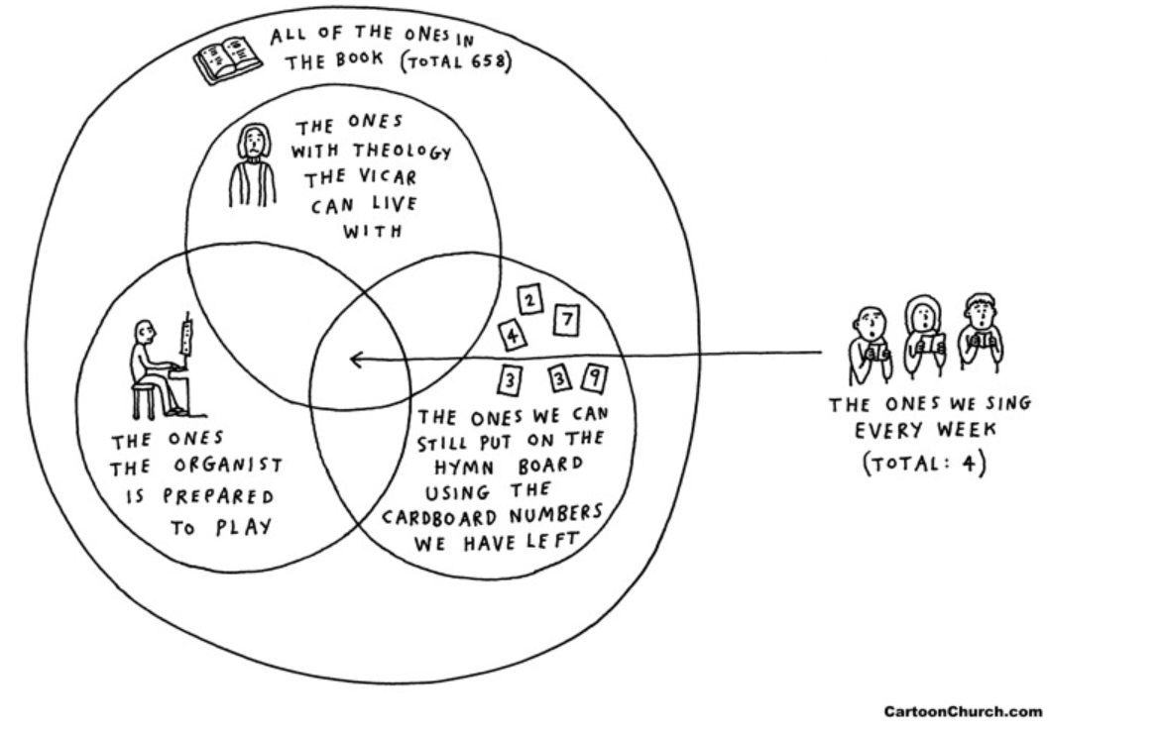
So why a new book? Our new hymn book keeps the old favourites while introducing contemporary hymns set to familiar tunes and introduces some new tunes which are more engaging. The result is a collection that honours tradition but speaks more clearly to today’s congregation.

‘YOU CAN DO THIS AT HOME’ - The MU learns some new skills
Crafting is an activity loved by some and approached nervously by others. For our October meeting our demonstrator, Tina Lovesey, sat in the midst of us at a long table with members round her and her relaxed approach soon put us all at ease. She showed us how to make a paper gift bag with card pockets. You would not believe the creative diversity displayed in the folding of a slip of paper into a concertina and sticking it to cards to form the pockets. How do teachers manage to make things with children? Some of the finished bags showed a certain deviation from the original model but everyone was delighted with their own product to take home. And if that were not enough we were then shown how to fold a gift envelope from a square of good quality paper with an attractive design. This had the advantage of not requiring paste which was helpful to those who had managed to stick themselves as well as the paper in the previous exercise. A great afternoon was had by all and the atmosphere of mutual assistance in the group task extended to a great deal of team assistance putting everything away afterwards. Thanks to one and all, and especially to Tina who very unexpectedly turned out to have a link with the current MU leader, whose husband had conducted Tina’s marriage service at Pickworth Church in 1988.
Our November meeting welcomes Fr. Peter Lister as our speaker. Do not miss it!


Our Mad Life Revisited – Bishop Hall Speers reflects on his recent visit
Madagascar has been in the news. President Macron at the Gaza summit in Egypt refused to confirm or deny that the President Rajoelina of Madagascar had fled the country in a French military aircraft but simply described the situation in Madagascar as “worrying”.
Demonstrations began in the capital with young people shouting, “Water needed, Electricity needed”. (The average age of the population is under 20.) These demonstrators were shot at by the gendarmes resulting in over 20 dead and many severely affected by the tear gas. The CAPSAT army unit sided with the demonstrators and eventually took control and dissolved all institutions except the National Assembly which then impeached the President. This was the same army unit that brought him to power in a coup d’état. A new President, General Michael Randrianirina, has been sworn in to lead a military government. He is a devout Lutheran Christian with a healing ministry.
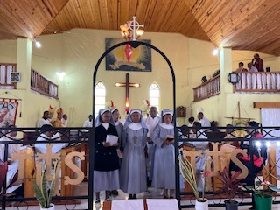
In July I visited Madagascar for the 40th Anniversary of the founding of the Anglican Sisters and experienced the frequent electricity outages and once again I found myself doing sermon preparation by candlelight. The Sisters had a great Thanksgiving Service on the Sunday followed by the official opening of a new building and a splendid lunch for 200 guests so the frequent outages were, to put it mildly, inconvenient.

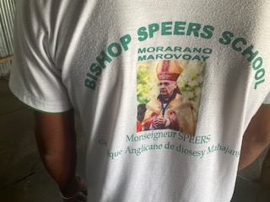
My successor in Mahajanga, Bishop Darrell, very generously had me flown to Mahajanga where an extraordinary welcome greeted me. The airport terminal was packed with people dancing and singing and waving ‘Welcome Bishop Speers’ flags and I was driven in a cavalcade complete with outriders to the cathedral for speeches of welcome and thence to a meal with the bishop and his family and the servers from the cathedral.
Each day was action packed. On the first morning we had a two-hour drive to Morarano for the laying of the foundation stone for a new classroom block at the Bishop Speers primary school. The money for this had been raised at a concert organised by the bishop’s teenage son. The building was completed in time for the start of term last month! The children had tee shirts with the name of the school and the motto emblazoned on the back, ”Enseigement de cerveau et de l’âme”. The teachers also have uniform. Theirs has the picture of a rather critical looking old man on the back!
It was wonderful seeing all my old friends again and delighting in the temperature but not so much fun to discover that the mosquitoes make a meal of me as much as ever. On the Sunday I was preaching in the cathedral which was followed by a wonderful meal before I got a flight to the capital and my return to England the following night.
Everywhere I was conscious of the rapidly increasing population without the services and food supply to support it and one doesn’t need the statistics to see that Madagascar remains one of the poorest nations in the world. However the churches were vibrant and expanding and the warmth of the fellowship that I experienced was absolutely overwhelming. It was such a privilege to be part of all that is happening and once again leaves me asking, how can we encourage the Malagasy in the midst of grinding poverty and how can we in the affluent countries learn to celebrate joyfully and be thankful for what we have and share their trust in God?
+Hall
October 2025
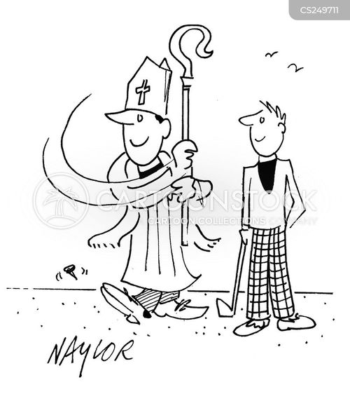
---------------------------------------------------------------------------------------------------------------------LOOKING FORWARD
BISHOP HALL SPEERS GIVES A PRESENTATION
ON HIS TIME AS A BISHOP IN MADAGASCAR
At BELTON PARK GOLF CLUB
At 12 noon on 28th February
£35 welcome drink & ample lunch
This promises to be an entertaining talk
All proceeds to St Denys’ Church, Aswarby
Apply to Penny Herdman 07714 690199
penherdman@aol.com

DRAWING ON EXPERIENCE
This computer aided design used in March 2023, based on an Art study of Peterborough cathedral, has some underlying work shown plus an additional poppy now included in the picture. It seemed to remind me that both construction and destruction are sadly part of our experience.
As creatures capable of building great cathedrals or designing modern wonders of engineering we also have the means to destroy ourselves. Much design and money go into the process of making weapons in case we need them. History shows that we frequently do. Arguments abound as we defend our corners.
As a Cold War veteran, I think my RAF colleagues preferred peace, having seen the consequences of WW2. I notice the poppy here ironically resembles the mushroom cloud we saw on Christmas Island. What foundation could prevent the overwhelming destruction this weapon would cause?
Veterans we were, but many of us saw the need for faith to bring peace in our time. “The church’s one foundation is Jesus Christ her Lord.” Christian Japanese survivors of Hiroshima and Nagasaki would also agree. We may wonder what forces have prevented us from using these weapons again, while various conflicts still persist in our world. Whatever the perceived outcome, should we not encourage our generation to consider praying again for peace, as did the generation of King George VI when he called the nation to prayer?
Our generation has been shaken by political turbulence and celebrity scandal, but many of us still see the need for faith in the one master builder whose foundation still supports his new creation.
With constructional hope, Malcolm
9th November – Remembrance Sunday
In late 1914, WW1 erupted across Northern France and Flanders. Great swathes of previously green fields and forests were blasted and bombed, leaving them bleak and barren, with seemingly every living thing destroyed.

But then in the Spring of 1915, something beautiful began to come out of all the destruction. Tens of thousands of bright red Flanders poppies began to put out tentative shoots across the endless vistas of mud. These resilient little flowers had actually flourished in the middle of so much chaos and destruction, because their seeds grow when exposed to sunlight, through disturbances to soil.
We all know that these endless fields of cheerful poppies, growing in the midst of such misery and destruction, were what inspired the Canadian doctor, Lieutenant Colonel John McCrae, to write the now famous poem ‘In Flanders Fields’.
And it was McCrae’s poem which inspired an American academic named Moina Michael to adopt the poppy in memory of those who had fallen in the war. She got it adopted as an official symbol of Remembrance across the United States, and worked with others who were trying to do the same in Canada, Australia, and the UK.
A French woman, Anna Guérin who was in the UK in 1921, caught the same vision, and planned to sell the poppies in London. There she met Earl Haig, the founder of the Royal British Legion, who was persuaded to adopt the poppy as its emblem in the UK.
The Royal British Legion, which had been formed in 1921, ordered nine million poppies and sold them on 11 November that year. Ever since then, the red poppy has been a symbol of Remembrance, of support for the Armed Forces community, and also of hope for a peaceful future.


THE KINGDOM SEASON
Wondered about the cover picture? Read on.
Each year we make a pilgrimage of faith. We journey through Advent, Christmas, Epiphany, Lent, Easter, Trinity and Ordinary Time. Now, as November begins, we seek the glory of God’s Kingdom. The ‘Kingdom Season’ takes us from All Saints’ to Advent. It is not really a separate ‘season', like Epiphany or Lent, but these November Sundays feel like one.
On November 1st we celebrate All Saints to remember all saints and martyrs, known and unknown, throughout Christian history. We think of all those who have led the Christ-life here on earth and have gone before us into heaven.
All Souls Day on the 2nd is a time when we particularly remember the faithful departed, those who have finished their earthly life and with whom we share the hope of resurrection from the dead.
The colour of red is much used in church during this month. It is the colour for blood and fire, saints and martyrs, and reflects both the work of the Holy Spirit and the sacrifice that Jesus made on the cross. Red poppies symbolise Remembrance as a symbol of remembrance for people who have died or suffered in war or conflict.
The final Sunday of our pilgrimage through the year celebrates Christ the King who has completed God's work through his life, death and resurrection. The acronym INRI which appeared on the cross was a cynical reference by Jesus’ Roman torturers to his kingship. The letters spell out in Latin Iēsus Nazarēnus, Rēx Iūdaeōrum, Jesus of Nazareth, king of the Jews. Now we wait for the New Kingdom to be revealed in all its fullness.
All too often it is too tempting to think of ourselves as individuals in the life of faith. It is good therefore to have a period in the Church’s year when the focus is on something much broader. Not just the gathered church community where we worship, not just Bourne Abbey or Church of England or Anglican Communion - all capable of petty argument and dispute. Rather, we are called to rejoice with the whole of the Church, the body of Christ, known and unknown, who join us in worship throughout the ages and to all eternity. Each week we pray ‘with angels and archangels and all the company of heaven’ and we ask that the Kingdom will come on earth as it is in heaven. We believe that Christ will reign over all things in the peaceable Kingdom of God. The Kingdom Season shouts out our hope and our belief.
Dyke WI News
Dyke WI has always enjoyed a close association with Dyke Village and its welcoming Village Hall where members have met monthly for over 60 years.
This year’s Scarecrow Day on Sunday 14th September commanded much of our attention as we planned our entry for the Scarecrow Competition. We came up with an idea of creating a nursery rhyme scene depicting The Old Woman Who Lived in a Shoe. Thinking caps were on and ideas shared!
The Old Woman was made using knitting wool for her hair and old clothes and wellies! Her numerous children were scarecrow babies made from Babygro’s and tights and donated baby clothes and hollow fibre filling. Then, of course we needed a shoe in which they would live! Our luck was in because a local farmer made a 2D shoe from plywood. Just before the event we erected the shoe and set the scene with our Old Woman and her babies.
Dyke WI didn’t leave it there though. They wanted to shout to the world how proud they were to celebrate 110 Years of the WI. So, the display was adorned with a statement to explain the celebration together with sunflowers and Suffragette Flag.
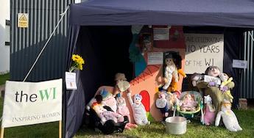

Dyke WI meet every third Thursday.
Next Meeting 20th November 2025 at 7.30pm in Dyke Village Hall. The Christine Bryce Craft Evening.
If you would like to join us, please contact: Helen Whitfield 01778 571789


MARGARET’S PAGE
I have just returned from a holiday in Kent with Shaw’s coaches. My friend and I were very relieved to discover that Reg’s, the firm which has taken over from the family form of Shaw’s, has continued with many of the things we have appreciated for many years. The big difference between them and other coach firms is that they pick you up at the door, a great boon if you are elderly or disabled or both. We were also delighted that our favourite driver, Graham, has stayed with the new company. I really cannot speak highly enough of Graham – he looks after us as though we are members of his own family and copes with my friend’s ‘walker’ with great care and patience.
Our favourite trip was on a heritage railway, the Romney, Hythe and Dymchurch steam railway all the way to Dungeness. I had worried that we would not be able to climb up into the carriages but in fact the chief problem was bending down far enough and curling into a ball to get into the tiny carriages – completely different to any other train journey and reasonably comfortable once we were in. We passed through the Romney Marshes where I saw more sheep than I have ever seen before, literally thousands of them.
Another unusual outing was to a 16-acre garden, Hole Park, owned by four generations of the Barham family, beautiful at any time but we were able to enjoy the autumn colours of the shrubs and trees in all their glory. We were met by the owner himself, accompanied by his three delightful black Labradors who ran up and down the coach saying hello to everyone. We started with a cup of coffee, accompanied by the dogs, and our visit included a delicious ploughman’s lunch. When we returned to the dining area, who was there to greet us – yes, the Labradors. They were no trouble and beautifully behaved but those of you who have owned Labradors who how appealing their eyes are, so I felt compelled to go to the café to buy them some bonios.
Throughout our holiday I was very impressed by how helpful everyone was. When my friend was struggling to get her rollator up steps, someone always came to help. When she gave up completely in the medieval town of Cranbrook, people stopped to chat to her while I explored on my own. Think of the difficulty some of us have trying to go up Crown Walk past the Angel and you will appreciate that living in a town where the main street, both road and paths is even more difficult to walk on is not easy for the elderly!
We enjoyed our holiday and met some delightful people. Our fellow passengers were so friendly and, as always, our driver Graham was outstanding. I now need a rest to recover from it all.


Smile Lines : Grave certainties

As a bagpiper, I play many gigs. Recently I was asked by a funeral director to play at a graveside service for a homeless man with no family or friends. The service was to be at a cemetery some distance away. As I was not familiar with the area, I got lost and finally arrived an hour late. The funeral director and hearse were long gone. There were only the diggers left and they were eating lunch. I went to the side of the grave and looked down. The lid was partially covered with soil. The diggers stared at me over their sandwiches, and I sensed their reproach that I had deserted this dead man in his final hour of need. I didn’t know what else to do, so I started to play.
The diggers looked quite startled at this and put down their lunches. But they stood quietly enough while I played out my heart and soul for this man with no family and friends. And as I played ‘Amazing Grace,’ the workers began to weep. They wept, I wept, we all wept together.
When I finished, I packed up my bagpipes and started for my car. Though my head hung low, my heart was full. As I opened the door to my car, I heard one of the workers say, “I never seen nothin’ like that before, and I’ve been putting in septic tanks for twenty years.”
Apparently, I’m still lost….
On Saturday 8th November from 2 – 4pm in Bourne Church Hall


Our theme:

How can I be a Peacemaker? 
For all families and accompanied children
xxxxxxxxxxxxxxxxxxxxxxxxxxxxxxxxxxxxxxxxxxxxxxxxxx


In the Abbey at 7.30pm on Saturday 29 November

The Stamford Concert Singers
Present Music for Everyone!
ANOTHER OP’NIN’,
ANOTHER Show!
£12.50 to include refreshments
To reserve tickets, contact Celia on 01778 702627 or pay at door
Proceeds to be shared between Singers and Abbey Charity number 1132631

THE NOVEMBER QUIZ
- What nationality were Roald Dahl’s parents?
- In which year was Brighton and Hove awarded city status?
- In the musical Cats, which character sings the song Memory?
- Who play the title characters in the TV series Shakespeare & Hathaway?
- The TV series Crossroads was set on the outskirts of which village?
- What is Gulliver’s first name in Gulliver’s Travels?
- In which decade were hand signals dropped from the driving test?
- Who was the subject of the 1998 musical Spend Spend Spend?
- Which vegetable is also known as a kumara in New Zealand?
- What is the name of the school featured in The Inbetweeners?
- In relation to railways, what is the English equivalent of a caboose?
- In which year was the Ultra Low Emission Zone introduced in London?
- Associated with the tag Life’s Good, what do the initials of the electronics firm LG actually stand for?
- What is the cube root of 216?
- Which film won the Best Picture Oscar earlier: Grand Hotel or Gone with the Wind?
- What is the first name of the escaped convict Magwitch in Great Expectations?
- Which part of the body would be affected by myalgia?
- The Korean War took place in which decade?
- In which English county would you find the Polden Hills?
- What is the American name for candy floss?

October answers
1 William Morris 2 Lesotho 3 The Time Traveler’s Wife (Audrey Niffenegger) 4 West 5 12 6 Lynn 7 001 8 Tallahassee 9 Surrey 10 Hydrogen 11 Ganesha 12 Guernsey 13 Dublin 14 Three Men on the Bummel 15 Cyprus 16 Rampant 17 Scotland 18 Mata Hari 19 Stephen 20 Wrestling (WWE)

A pessimist’s blood type is always b-negative.
I’m proud to announce that I have completed the first item on my bucket list. I have the bucket.

WHAT’S ON IN NOVEMBER - AND BEYOND
Saturday 1st | 10- 12 noon in the Church Hall
 | Nibble ‘n Natter Stalls to include Books, Raffle and Refreshments. All Welcome. Proceeds to Abbey Church funds.
Monday 3rd | 10am In the Abbey
 | Julian Group Meeting Prayer and meditation
Wednesday 5th | 2.15pm in the Church Hall
 | Mothers Union Meeting Speaker: Fr Peter Lister
Thursday 6th | 7pm in the Abbey
 | PCC Meeting
Wednesday 19th | 2 – 4pm in the Church Hall
 | Knit and Sew Friendship Group All very welcome
Friday 21st | at 34 Arnhem Way, Bourne PE10 9UD
The Abbey at Home Christian Fellowship with Prayer
Rev Sylvia extends a warm welcome to all.
Friday 28th | 10am in the Abbey
 | Church Clean Bring dusters and handhelds!
Saturday 29th | 7.30pm in the Abbey
 | The Stamford Concert Singers See page 16
In the Abbey on Tuesdays 2nd 9th 16th December at 10.30am
ADVENT BIBLE STUDIES
Led by the Vicar

A big thank you to all the flower arrangers and helpers who helped decorate the Abbey Church so beautifully for the festival. Marilyn Roberts, Joan Payne, Ann Northen, Cynthia Penhay, Linda Lee, Pat Gray and to Celia and Ray who arranged all the donated tins, packets etc. The Food Bank says it may be the biggest Harvest donation ever, 311 kilos, over a third of a ton!
THE PENULTIMATE PAGE
Arthur Mee, whose book on Lincolnshire began this delving into Bourne’s past, mentions, of course, ‘the Red Hall near the station, charming with its gables and weather-beaten sundial, its mullioned windows and two-storied porch, and its grey mossy roof.’ He notes how trains now run where once the terraces and gardens were, and that, before the advent of the railway, the Hall had been the home of the Digbys.
In 1796 James Digby brought his new wife to live in the Hall. She did not travel far, just across the road, for Catherine was the Vicar’s daughter and the Vicarage at that time was on the corner opposite Baldock’s Mill. Now its white walls are shaken by heavy lorries negotiating that South Street bend but then it was a fit residence for the well-connected Rev. Humphrey Hyde who had built it twenty years before.
Over the years James acquired and inherited more property. When he died fifteen years later, he left his wife very well off. Catherine lived on in the Red Hall as a person of considerable consequence, especially in those class-conscious days. She became known in Bourne as ‘Lady Catherine’, a title which will remind Jane Austen fans of the overbearing character of that name in ‘Pride and Prejudice’. Bourne’s Lady Catherine seems to have been more likeable than Darcy’s aunt!
Birkbeck’s ‘History of Bourne’ quotes her will – a staunch Anglican, a thoughtful benefactrix both to the general community and to personal acquaintances and a woman of strong feeling in family matters. She left money for her burial in the chancel of the church, £100 for a marble monument, and the dividends of a £500 investment to be paid yearly to the organist at the Abbey. Catherine also provided an annuity for a school mistress, donations to various charities and left bequests to her servants, including an annuity to a woman who would look after her dog, Flora, if still alive.

Was this person needed in 1836 when ‘Lady Catherine’ died, a year before Queen Victoria came to throne? We don’t know but we can admire the tearful cherub who perches precariously on her monument, the grandest in the Abbey chancel. Her resting place is about as far from her childhood home as her married home was in the other direction. A true daughter of Bourne.
Celia Howes

THE ABBEY CHURCH OF ST PETER AND ST PAUL
Church Walk, Bourne PE10 9JH
what3words:///petrified wrong trees
https://bourneabbey.uk

Vicar
Rev. Father Stephen Buckman | The Vicarage, Church Walk PE10 9UQ
Please note that the Vicar’s normal rest day is Friday | revstephen@btinternet.com | 01778 782779 07464 728545
Associate Priest
Rev. Father Peter Lister SSC | pwr.lister@btinternet.com | 01778 423730
Curate
Rev. Father Isaac Frisby | curate@bourneabbey.uk | 07587893966
Authorised Lay Ministers
Jennifer Maclean | j.maclean36@btinternet.com | 01778 393590
Marilyn Roberts | marilynroberts17@gmail.com | 07443 599217
Churchwardens
Jennifer Maclean | j.maclean36@btinternet.com | 01778 393590
Vicky Buckman | vbuckman@btinternet.com | 07769 804138
Director of Music
John Saunders | jclementsaunders@gmail.com | 07923 650684
Treasurer and Ringers
Alan Payne | alanpayne684@gmail.com | 01778 560633
Safeguarding Officer
Karen Key | karenkey@nhs.net | 07354 668966
Website Manager
Jennifer Maclean | j.maclean36@btinternet.com | 01778 393590
Hall Bookings& Magazine Editor
Celia Howes | celia.howes45@gmail.com | 01778 702627
Flowers in Church
Ann Northen | mikeann24@sky.com | 01778 423353

