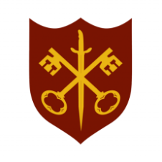 | This Week at the Abbey
7 – 14 September 2025
The church is open during the day.

Day | Time | Details
SUNDAY 7th | 11.00 a.m. | Sung Eucharist
 | 6.30 p.m. | Sung Evensong
MONDAY 8th | 9.00 a.m. | Morning Prayer
 | 5.30 p.m. | Evening Prayer
 | 6.45 p.m. | Bourne Choral rehearsal
TUESDAY 9th | 9.00 a.m. | Morning Prayer
 | 5.30 p.m. | Evening Prayer
 | 7.00 p.m. | Said Eucharist
WEDNESDAY 10th | 9.00 a.m. | Morning Prayer
 | 5.30 p.m. | Evening Prayer
 | 7.00 p.m. | Band Practice
THURSDAY 11th | 9.00 a.m. | Morning Prayer
 | 10.00 a.m. | Said Eucharist (BCP)
 | 5.30 p.m. | Evening Prayer
FRIDAY 12th | 9.00 a.m. | Morning Prayer
 | 5.30 p.m. | Evening Prayer
 | 6.30 p.m. | Choir practice
SATURDAY 13th | 9.00 a.m. | Morning Prayer
 | 11.00 a.m. | Holy Baptism
 | 5.30 p.m. | Evening Prayer
SUNDAY 14th | 11.00 a.m. | Sung Eucharist and Civic Service

