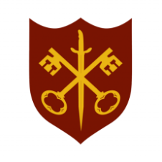 | This Week at the Abbey
14 - 21 September 2025
The church is open during the day.

Day | Time | Details
SUNDAY 14th | 11.00 a.m. | Sung Eucharist and Civic Service
MONDAY 15th | 9.00 a.m. | Morning Prayer
 | 5.30 p.m. | Evening Prayer
 | 6.45 p.m. | Bourne Choral rehearsal
TUESDAY 16th | 9.00 a.m. | Morning Prayer
 | 5.30 p.m. | Evening Prayer
 | 7.00 p.m. | Said Eucharist
WEDNESDAY 17th | 9.00 a.m. | Morning Prayer
 | 5.30 p.m. | Evening Prayer
 | 7.00 p.m. | Band Practice
THURSDAY 18th | 9.00 a.m. | Morning Prayer
 | 10.00 a.m. | Said Eucharist (BCP)
 | 5.30 p.m. | Evening Prayer
FRIDAY 19th | 9.00 a.m. | Morning Prayer
 | 11.30 a.m. | Funeral – Trevor Hollinshead
 | 5.30 p.m. | Evening Prayer
 | 6.30 p.m. | Choir practice
SATURDAY 20th | 9.00 a.m. | Morning Prayer
 | 5.30 p.m. | Evening Prayer
SUNDAY 21st | 11.00 a.m. | Sung Eucharist
 | 6.30 p.m. | Choral Evensong

