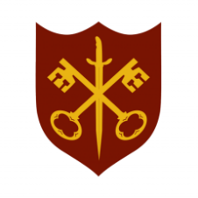 | This Week at the Abbey
12 - 19 October 2025
The church is open during the day.

Day | Time | Details
SUNDAY 12th | 11.00 a.m. | Sung Eucharist
MONDAY 13th | 9.00 a.m. | Morning Prayer
 | 5.30 p.m. | Evening Prayer
 | 6.45 p.m. | Bourne Choral rehearsal
TUESDAY 14th | 9.00 a.m. | Morning Prayer
 | 5.30 p.m. | Evening Prayer
 | 7.00 p.m. | Said Eucharist
WEDNESDAY 15th | 9.00 a.m. | Morning Prayer
 | 5.30 p.m. | Evening Prayer
 | 7.00 p.m. | Band Practice
THURSDAY 16th | 9.00 a.m. | Morning Prayer
 | 10.00 a.m. | Said Eucharist (BCP)
 | 5.30 p.m. | Evening Prayer
FRIDAY 17th | 9.00 a.m. | Morning Prayer
 | 10.00 a.m. | Abbey at Home – see internal noticeboard for details
 | 1.00 p.m. | Bourne Grammar School lunchtime concert – all welcome
 | 5.30 p.m. | Evening Prayer
 | 6.30 p.m. | Choir practice
SATURDAY 18th | 9.00 a.m. | Morning Prayer
 | 5.30 p.m. | Evening Prayer
SUNDAY 19th | 11.00 a.m. | Sung Eucharist
 | 6.30 p.m. | Choral Evensong

