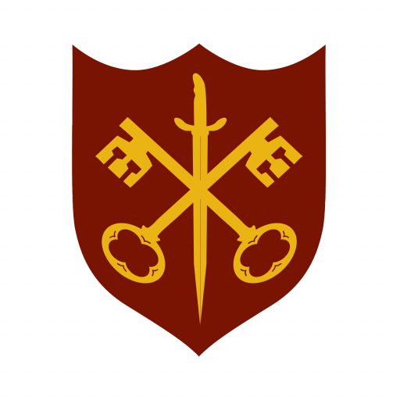 | The Abbey Church  of Ss. Peter & Paul

Services for October 2025

Sunday / Tuesday / Thursday
2nd | 10.00 a.m. | Said Eucharist (BCP)
5th | 11.00 a.m. | Sung Eucharist & Harvest
 | 6.30 p.m. | Sung Evensong
7th | 7.00 p.m. | Said Eucharist
9th | 10.00 a.m. | Said Eucharist (BCP)
12th | 11.00 a.m. | Sung Eucharist
14th | 7.00 p.m. | Said Eucharist
16th | 10.00 a.m. | Said Eucharist (BCP)
19th | 11.00 a.m. | Sung Eucharist
 | 6.30 p.m. | Choral Evensong
21st | 7.00 p.m. | Said Eucharist
23rd | 10.00 a.m. | Said Eucharist (BCP)
26th | 9.00 a.m. | Said Eucharist
 | 11.00 a.m. | All Age Eucharist
28th | 7.00 p.m. | Said Eucharist
30th | 10.00 a.m. | Said Eucharist (BCP)

