Sunday 14th September 2025
The Thirteenth Sunday after Trinity
A warm welcome to all!
Are you visiting the Abbey today?
If you are a communicant member of your own church, you are invited to take communion here.

If you prefer to receive a blessing, please come forward with the service booklet as an indication to the priest.

Gluten-free wafers are available – please ask a greeter before the start of the service.
Services this week
Tuesday 16th September | 1900 | Said Eucharist (CW)
Thursday 18th September | 1000 | Said Eucharist (BCP)
Sunday 21st September | 1100 | Sung Eucharist
 | 1830 | Choral Evensong
Morning and Evening Prayer at 0900 and 1730 Monday to Saturday

Today’s readings: Exodus 32:7-14, 1 Timothy 1:12-17, Luke 15:1-10
Dates for Your Diary

Parish Magazine deadline is 21st September – all items to Celia, please.
The Gardening group will meet on Tuesday 23rd September 1400; please come along if you can.
The next Messy Church is on Saturday 27th September from 1400-1600; all welcome!
Our Harvest Festival is Sunday 5th October at 1100.
Please put harvest gifts into the box at the back of church from now until the service itself. Some will be used to decorate the church and then all will be donated to the Bourne Foodbank.
The Harvest Supper is on October 10th at 1830; tickets available from Sue Casey from 21st September.
Can you help?
Food Bank urgently needs pasta sauce, custard, squash, snack bars, fruit juice, UHT milk, washing powder, toilet paper and tins of meat, fruit and veg.
Please pray for

The diocese, parish and deanery: for Bishops Stephen and Nicholas, Fr Stephen, Fr Peter, Fr Isaac, Bishop Hall, Rev. Sylvia, Canon David, and our Ministry Team.

Goodwill between nations; guide those in authority with wisdom, honesty and compassion.
Those suffering hunger, disease, oppression, and injustice.
Those who have gone before us in faith and whose year’s mind falls this week.
The recently departed remembering particularly Trevor Hollinshead.
Is there someone you would like us to pray for? Perhaps a family member, friend or neighbour who is sick or in any other kind of need? Please add them to the Prayer List at the back of the Abbey. If you would like someone to visit them, please speak to one of the clergy.

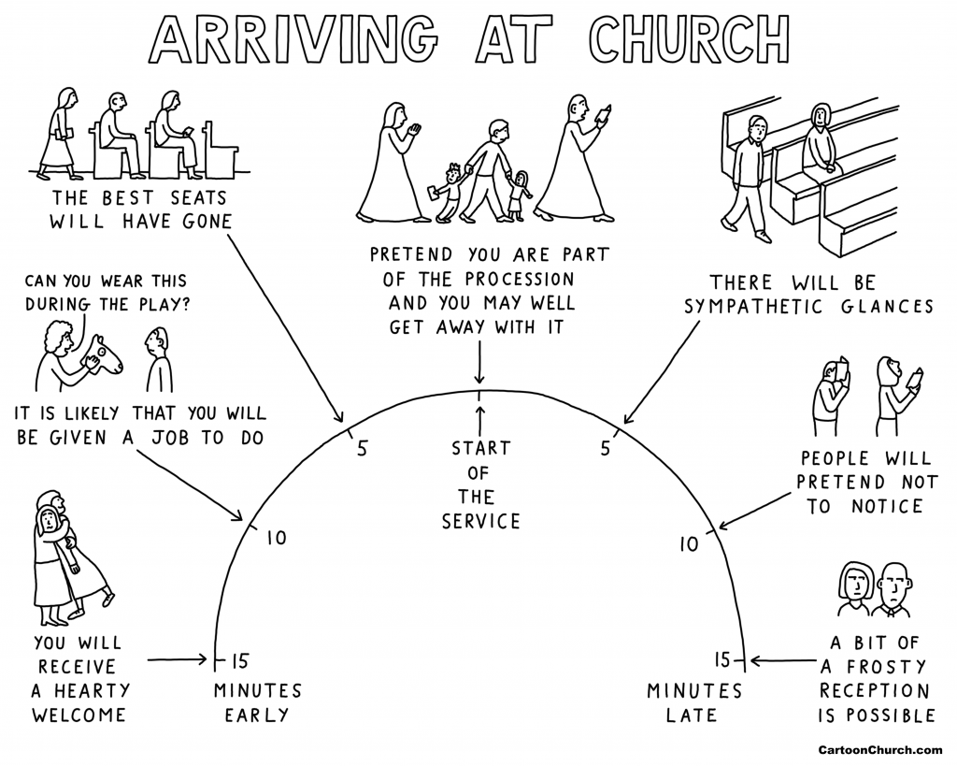
This CartoonChurch.com cartoon by Dave Walker originally appeared in the Church Times.

