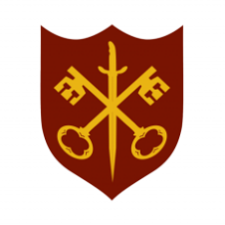 | This Week at the Abbey
24 – 31 August 2025
The church is open during the day.
Day | Time | Details
SUNDAY 24th | 9.00 a.m. | Said Eucharist
 | 11.00 a.m. | All Age Eucharist
MONDAY 25th | 9.00 a.m. | Morning Prayer
 | 5.30 p.m. | Evening Prayer
TUESDAY 26th | 9.00 a.m. | Morning Prayer
 | 2.00 p.m. | Garden Group
 | 5.30 p.m. | Evening Prayer
 | 7.00 p.m. | Said Eucharist
WEDNESDAY 27th | 9.00 a.m. | Morning Prayer
 | 5.30 p.m. | Evening Prayer
 | 7.00 p.m. | Band Practice
THURSDAY 28th | 9.00 a.m. | Morning Prayer
 | 10.00 a.m. | Said Eucharist (BCP)
 | 10.45 a.m. | Pilgrim Course (5/6)
 | 5.30 p.m. | Evening Prayer
FRIDAY 29th | 9.00 a.m. | Morning Prayer
 | 5.30 p.m. | Evening Prayer
 | 6.30 p.m. | Choir practice
SATURDAY 30th | 9.00 a.m. | Morning Prayer
 | 1.00 p.m. | Holy Baptism
 | 5.30 p.m. | Evening Prayer
SUNDAY 31st | 11.00 a.m. | Sung Eucharist

