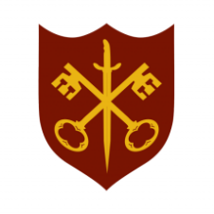 | This Week at the Abbey
17 – 24 August 2025
The church is open during the day.
Day | Time | Details
SUNDAY 17th | 11.00 a.m. | Sung Eucharist
 | 6.30 p.m. | Sung Evensong
MONDAY 18th | 9.00 a.m. | Morning Prayer
 | 5.30 p.m. | Evening Prayer
TUESDAY 19th | 9.00 a.m. | Morning Prayer
 | 2.00 p.m. | Garden Group extra session
 | 4.00 p.m. | Administration meeting
 | 5.30 p.m. | Evening Prayer
 | 7.00 p.m. | Said Eucharist
WEDNESDAY 20th | 9.00 a.m. | Morning Prayer
 | 5.30 p.m. | Evening Prayer
THURSDAY 21st | 9.00 a.m. | Morning Prayer
 | 10.00 a.m. | Said Eucharist (BCP)
 | 10.45 a.m. | Pilgrim Course (4/6)
 | 1.30 p.m. | Funeral – Keith Stanley
 | 5.30 p.m. | Evening Prayer
FRIDAY 22nd | 9.00 a.m. | Morning Prayer
 | 10.00 a.m. | Team Clean
 | 2.40 p.m. | Visiting bell ringers
 | 5.30 p.m. | Evening Prayer
 | 6.30 p.m. | Choir practice
SATURDAY 23rd | 9.00 a.m. | Morning Prayer
 | 5.30 p.m. | Evening Prayer
SUNDAY 24th | 9.00 a.m. | Said Eucharist
 | 11.00 a.m. | All Age Eucharist

