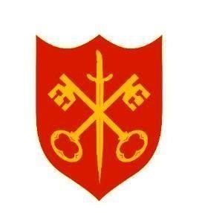**The Abbey Church of St Peter & St Paul serving the communities of Bourne**

**Dyke Twenty and Cawthorpe**

**PARISH MAGAZINE**

**September 2025 50p**

[www.bourneabbey.u](http://www.bourneabbey.u)[k](http://www.bourneabbey.uk/)  Bourne Abbey Church Group

**WORSHIP AT THE ABBEY DURING SEPTEMBER**

**Morning Prayer and Evening Prayer are said every weekday at 9.00am and 5.30pm**

|  |  |  |  |
| --- | --- | --- | --- |
| Tuesday 2nd |  | Said Eucharist CW | 7.00pm |
| Thursday 4th |  | Holy Communion BCP | 10.00am |
| **\*** | **\*** | **\*** | **\*** |
| Sunday 7th | 12th Sunday after Trinity | Sung Eucharist CW | 11.00am |
|  |  | Sung Evensong | 6.30pm |
| Tuesday 9th |  | Said Eucharist CW | 7.00pm |
| Thursday 11th |  | Holy Communion BCP | 10.00am |
| * | **\*** | **\*** | **\*** |
| Sunday 14th | 13th Sunday after Trinity | Sung Eucharist CW & Civic Service | 11. 00am |
| Tuesday 16th |  | Said Eucharist CW | 7.00pm |
| Thursday 18th | MU Corporate Communion | Holy Communion BCP | 10.00am |
| * | * | * | * |
| Sunday 21st | 14th Sunday after Trinity | Sung Eucharist CW | 11.00am |
|  |  | Choral Evensong | 6.30pm |
| Tuesday 23rd |  | Said Eucharist CW | 7.00pm |
| Thursday 25th |  | Holy Communion BCP | 10.00am |
| Saturday 27th | For families and accompanied children | Messy Church in the Church Hall | 2 – 4pm |
| * | * | * | * |
| Sunday 28th | 15th Sunday after Trinity | Said Eucharist CW | 9.00am |
|  |  | All Age Eucharist | 11.00am |
| Tuesday 30th |  | Said Eucharist CW | 7.00pm |

The Abbey is open during the hours of daylight. Do come in to pray, to light a candle or just to enjoy a moment of peace and quiet.

We welcome the names of those who are ill or awaiting an operation so that prayers may be offered for them. We also welcome the names of loved ones departed to be inscribed in the Abbey’s Book of Remembrance. Contact Churchwarden Jennifer Maclean.

**From the Abbey’s Book of Remembrance for September**

1st Gwendoline Challoner : John Houldershaw

3rd Mieczyslaw Gregory Cejer

4th Hilda McMaster : 5th Thelma Moss

7th Arthur Barnard : Julie Marriott : Thomas Hewitt : Thomas Key

8th Millie Bentley : Ronald How : 9th Bernard Clarke

10th Harry Greenwood : Henry Hewitt

14th Joseph Bratley : Angela Baxter

15th Cecil Wright : James Haggerty : 16th William Payne

17th Daphne Brown : 20th Nettie Musgrove

22nd Norah Peggs : 23rd Eric Howarth

24th Patricia Hewitt : Marjorie Spencer : Alice Woolf : Frank Wye

26th Ada Barnard : 28th Patrick Lingard (priest) : Rebecca Adnitt

|  |
| --- |
| He said not : thou shalt not be tempested,  thou shalt not be travailed,  thou shalt not be afflicted,  but he said : thou shalt not be overcome.  MOTHER JULIAN OF NORWICH |

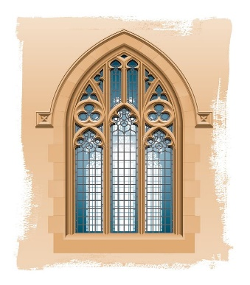

***THE VICAR’S LETTER***

*Dear Friends in Christ,*

The English novelist, L. P. Hartley, once wrote, *“The past is a foreign country; they do things differently there.”* This evocative quote serves as a reminder of the myriad ways in which our ancestors lived, believed and practised their faith. As we sit in our churches, sometimes surrounded by the familiar comforts and technologies of the twenty-first century, it is important that we should reflect on how the very essence of worship and community has evolved over the centuries.

Faith, in its many forms, has been a guiding light for humanity through the ages. Our predecessors’ lives were steeped in traditions and customs that, while foreign to us today, shaped the very foundation of our beliefs. The rituals, hymns and prayers that once echoed through ancient cathedrals were imbued with a sense of piety and reverence that can sometimes seem distant to our contemporary sensibilities.

In earlier times, the Church was not merely a place of worship but a vibrant hub of community life. It was where villagers gathered to celebrate life’s milestones, to seek solace in times of hardship and to find a sense of belonging. The church bell tolled not just for daily prayers, but also for communal gatherings, signalling moments of joy and mourning alike.

Consider the changes in worship practices during our own lifetimes. Our ancestors adhered to long-standing traditions that dictated specific rites and ceremonies. The language of worship, sometimes Latin, was a sacred tongue that carried the weight of divine reverence. Contrast this with today’s services, which are usually conducted in the vernacular, embracing inclusivity and accessibility. Modern worship has adapted, sometimes incorporating contemporary music and interactive elements that engage congregations more fully.

The architecture of our churches has also been transformed. From awe-inspiring Gothic cathedrals, with their soaring spires and stained glass windows we now see more minimalist and functional designs utilised for our worship spaces. Each era’s sacred spaces reflect the spiritual and cultural values of the time. Walking through these structures, one can sense the shift in how worshippers connect their faith and their God.

In earlier times, faith was woven into the very fabric of daily life in ways that seem unfamiliar to us. Religious festivals and holy days dictated the rhythm of the year, with entire communities coming together to observe these occasions. The Church’s teachings influenced social norms, from dietary practices to moral conduct, shaping a cohesive moral framework for society.

As we navigate our own spiritual journeys, it is invaluable to look back at the past – that foreign country of Hartley’s imagination – with a sense of curiosity and respect. The ways we worship, the community bonds and the architectural marvels remind us that faith is not static but a living, breathing entity that evolves with us.

In remembering the past, we can draw inspiration from the devotion and resilience of those who came before us. Their ways may be different, but their unwavering faith serves as a beacon, guiding us as we forge our own path in this ever-changing world. Let us embrace the richness of our religious heritage, cherishing the lessons it imparts while moving forward with a spirit of renewal and hope.

The past is indeed a foreign country, and as we explore it, we gain a deeper understanding of our own beliefs and the timeless nature of faith. I pray that we might honour the legacy of our ancestors by integrating their wisdom into our modern lives, ensuring that our faith continues to flourish for generations to come.

With every blessing to you all,

Fr Stephen

**MOTHERS’ UNION CELEBRATES FOUNDER MARY SUMNER**

The Abbey branch welcomed members from Thurlby and Deeping branches for a coffee morning to mark Mary Sumner Day on August 9th. Just when we were beginning to wonder where everyone was, we were relieved to have a last minute influx which filled up the empty seats.

The Rev. Sylvia had prepared a special service with which we began. Fr Stephen played the hymns for us with no prior warning while Derek and Eileen, as members of the music group which had included the Rev. Richard Rice-Oxley, led the singing. It was a prayerful and unifying start to the fellowship which followed, with generous refreshments and stalls to raise money for the MU national appeal Summer of Hope (see below). Members had brought gift bags with a variety of contents, some of which were more concealed than others. The great money spinner was Janetta’s hand-crafted candles which brought in £80. We are most grateful to her. There were apples from Thurlby. Sadly the spider plants who were looking for a new home all had to go back to where they came from. The total raised was £186.

Thank you to everyone who gave generously. It was a particular pleasure that Frs. Stephen and Isaac joined us as the Mothers’ Union strives to support the clergy in their ministry both prayerfully and in action.

Our September meeting takes us on a church visit all the way to Morton.

Sarah Speers

**THE MU SUMMER OF HOPE** is raising money to help women in some of the world’s crisis-hit communities. Julienne lives in the Democatic Republic of Congo where conflict between the M23 rebels and government forces has devastated communities for years. Julienne has spent much of her life in fear – of violence, of abuse, of instability. Displaced by conflict in the DRC, and trapped in an abusive marriage, she fled with almost nothing. For over a decade, she tried to survive, without education or a safe way to earn a living.

Then she joined a Mothers’ Union literacy circle.

With this support, Julienne learned to read and write for the first time. She began to understand her rights – and how often she had been denied them. “It felt like moving from darkness into light” – Julienne.

**BOURNE NATIONAL SCHOOL TRUST FUND**

The Trustees for Bourne National School Trust Fund are looking for a new Clerk/Treasurer to assist them in their work to provide educational grants to children and young people in the local area.

The Trustees meet 3 times a year with the Clerk/Treasurer helping to draft agendas and taking minutes of the meetings. Following meetings, payment of any approved grants would need to be made. Usually this amounts to no more than 5 or 6 transactions a year. The Clerk/Treasurer would need to keep up-to-date accounts of these transactions as well as the income from the Trust’s investments and bank interest. Currently these total around £2500 annually. The Charity Commission need to receive audited financial statements and to be kept informed of changes in Trustees.

Trustees would be able to offer a small allowance of £200 per year plus expenses for postage, stationery, etc.

If you are interested, or know of anyone who may be able to fulfil this role, please contact the Chair of Trustees, Bill Peasley ([wpeasley@btinternet.com](mailto:wpeasley@btinternet.com)) or Fr Peter Lister for further information



Gratitude may help you recover more quickly from a heart attack. So says a study by the University of California, who examined gratitude as part of an outlook that involves appreciating the positive aspects of life, and often goes hand in hand with spirituality.

It was found that people who have a life attitude of being grateful are also likely to have a better mood, better sleep, less fatigue, and lower levels of inflammatory biomarkers related to cardiac health.  Researchers said they were surprised to find that gratitude accounted for such beneficial effects. As one scientist put it, “It seems that a more grateful heart is indeed a healthier heart.”

How can you express gratitude in an easy-to-remember and daily way? Why not bring back the habit of pausing to say a simple grace of thanks before each meal? And why not take a few minutes to say your prayers before bed each night?

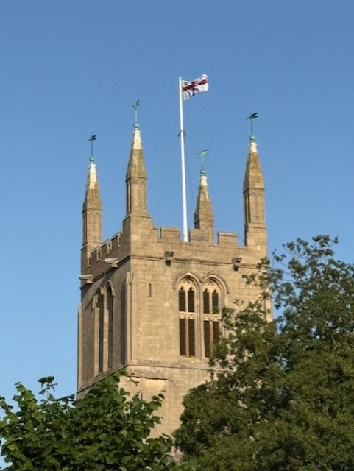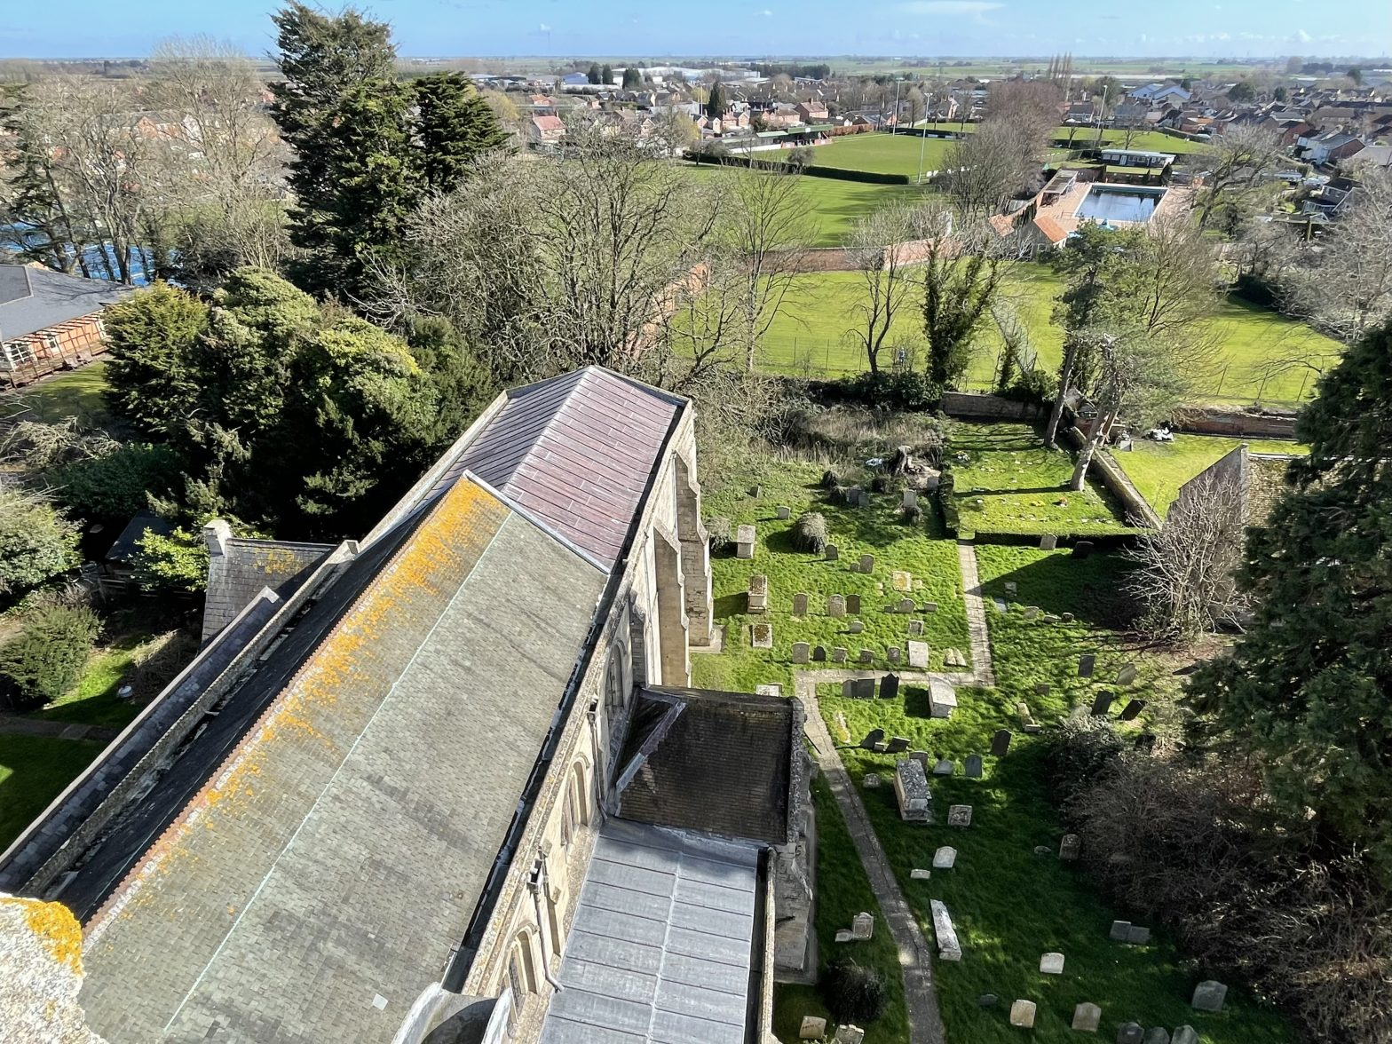

**THE FLAG IS FLYING!**

When you take on any new role, there is always a part that is not mentioned until you are signed up and safely on board. For me, as the new Churchwarden, that particular duty has been making sure the flag is flying from the flagpole atop the tower on special days.

VJ Day saw Jenny and me climbing the 115 spiral steps to the top of the tower, passing bells and clocks on the way. Jenny climbed confidently and happily, calling out the sights as we passed them; me somewhat more cautiously! But the view from the top is fantastic and, on a lovely clear day, I was able to see for miles over Bourne and to the countryside beyond.

Jenny had the flag hoisted in no time and then she pointed out some of the souvenir “scratchings” that had been left by previous visitors. In particular, the Cub Pack of 1949 conjured up some wonderful images and I can’t say, in these times of ‘elf’n’safety’, I would want to supervise even a small group of excited 7-11 year olds on the tower, even if the view is glorious. These are different times. The whole staircase up to the tower is fascinating; the bottom half being clearly well used and maintained to reach both bells and clock; the last 40-odd steps are only for the brave – narrow, dark and definitely for shorter folk. To actually get out to the flagpole, one has to crawl through a small door.

“Don’t lean on the balustrade to your left”, remarked Jenny. “It’s not entirely safe!” Oh good.

Going back down involves going backwards for the first 10 steps until it is wide enough to turn. However, I am delighted to have done it and I now know what to expect; note to self – bring a head-torch next time and take more pictures at the top Vicky Buckman

*Editor: Vicky didn’t take the picture of the view from the tower. This is one from my store, taken a while ago. With sharp eyes and perhaps a magnifying glass, you can pick out the hedge in front of the Garden of Remembrance, next to the old Grammar School, just above the inset picture. That box hedge succumbed to a box moth attack two years ago. It is being replaced by a yew hedge when the little cuttings have had time to grow. Our thanks go to our friends of the U3A garden group who have raised the cuttings and planted the new hedge.*

*________________________________________________________________________*

**Using the English language…**

If lawyers are disbarred and clergymen defrocked, doesn’t it follow that. . .electricians could be delighted, musicians denoted, cowboys deranged, models deposed, and dry cleaners depressed? Likewise, bedmakers might be debunked, bulldozer operators degraded, organ donors delivered, software engineers detested, and underwear manufacturers debriefed?

And won’t all composers one day decompose? On a more positive note, perhaps we can hope politicians will someday be devoted…

**MESSY CHURCH IN AUGUST**

**The theme:** Can I trust God? A new direction. **The story:** Philip meets the Ethiopian official on the road to Gaza

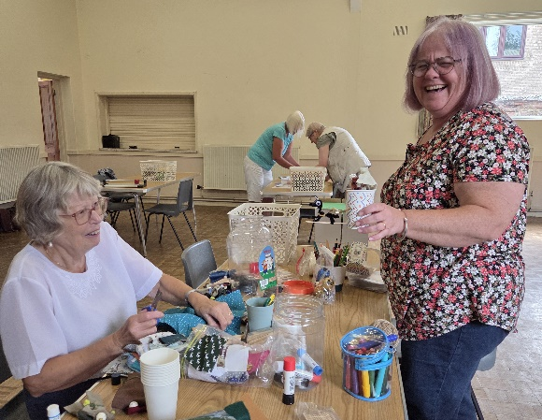**The preparation:** On 2nd August the helpers gathered in the hall, opening with a time of reflection on the story and how Philip shared the Good News of Jesus. We talked about how churches differ in baptising infants and adults. How could we encourage those in Messy Church to consider baptism which is the way we are welcomed into God’s family.

We then spent a happy hour designing and creating chariots and crafts for the next Messy Church. Karen and Becks loved the pipe cleaner horse they had created with its goggly eyes. (Not visible here!)

**The Messy Church service:** It was 26th August, the onset of a fourth heatwave, We were concerned it would be too hot to meet. Thankfully the temperature dropped. We went ahead.

Children and parents spent the first hour dipping into all the crafts on offer. Paper cup chariots, Christian name bracelets, prayer doves and painting ‘my family’ on fabric to make a quilt. Everything linked in with the signs used in baptism. A lifesized chariot was created – later displayed in the children’s area of the Abbey.

Sensory play involved homemade playdough, which proved so popular with all the children that we resolved to use it again. Father Stephen led our celebration using a ball of wool to guide us on baptism and our Christian life journey.

We finished with a yummy buffet tea, children and adults alike enjoying Elizabeth’s strawberry birds and fruit kebabs.

Messy blessings,

Helena

**Our next Messy Church will be on Saturday 27th September**

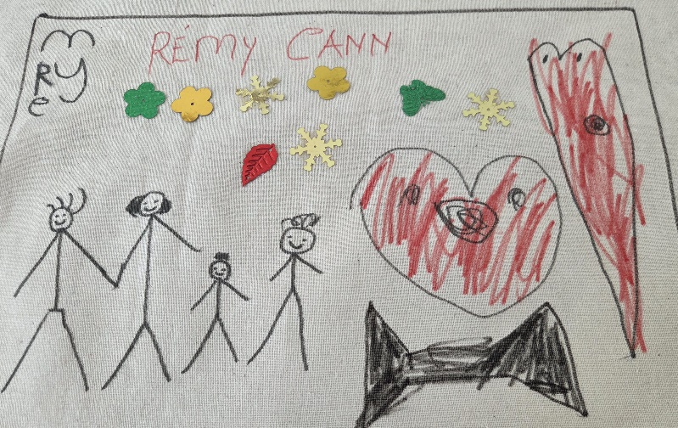**starting at 2pm.**

**Our theme will be: Hope: putting your trust in God.**



You are invited to our  
Harvest Supper

on Friday 10th October  
in the Church Hall at 6.30p.m.  
Cost : £12.00

Menu and tickets will be available from Sunday 14th September

or contact Sue Casey 01778 424365

**THE MOST PRODUCTIVE NIGHTMARE OF ALL TIME?**

1600 years ago, Europe’s top scholar was an Italian called Jerome; he loved the works of Cicero. One night he dreamt that he had died and reached the gates of heaven. The gatekeeper spoke to him: ‘Who are you?’

“Christianus sum.” replied Jerome. “I’m a Christian.

“No.” said the gatekeeper. “You’re not a Christian. You’re a Ciceronian!” He went on to explain: “You see, here in heaven we judge people by what they were most, when they lived on earth. And you dedicated everything to the classics and the works of Cicero. So, we judge you not to be a Christian, but a Ciceronian. You cannot enter.”

Jerome woke with a start and made his resolve. Not only did he begin truly to follow Christ, but he bent his academic ability into translating the Bible into the common language of Europe, Latin. It took him years. His translation became known as the Vulgate version.

That Bible served Europe for a thousand years. With the Bible’s message becoming the foundation of European civilisation, its culture became united. Once we take Christianity and the Bible out of Europe – and all that we would be left with is a collection of squabbling, heathen tribes. It’s time for Europe – like Jerome – to be woken up again.

*This was written by Prebendary Richard Bewes (1935-2019), described as ‘one of the most talented Anglican parish clergy of his generation’. If you have sung Psalm 46 to the tune of the Dam-busters March, you owe it to him. As well as penning twenty hymns, he was an author and broadcaster, often on Radio 4’s ‘Thought for the Day.’’ He was a life-long friend of Billy Graham. To his intense disappointment, ill-health meant he could not fulfil the long-standing invitation of the Graham family to preach at Billy’s funeral*.

**A BRIGHT HORIZON**

Does this unfinished sketch require an explanation? The bright effect on the horizon was caused by a timely patch of sunlight falling on the painting. Such brightening is not unknown in the real light conditions of the sky.

Which is more important, the picture or the actual landing it imitates? Does that depend on whether you are an artist or a pilot or both? The picture can be worked comfortably as time allows, but the aircraft could not be conveniently parked in that position while the pilot contemplated the landing. How do Graphic and Performing Arts require respect for the reality of timing?

When Eric Coates composed the music for the Dambusters March, he had been carrying out an exercise in composing a march that emulated the musical forms of Edward Elgar. Later he was reluctantly persuaded that it would make a perfect overture for the epic wartime film, and it has since become a moving melody in various causes, including a setting of Psalm 46 from where we learn that despite the timing of repeated conflicts God still causes wars to cease.

If Elgar’s melodies inspired Coates to create a march which would eventually accompany the film of an epic wartime story, the unfolding of that story was preceded by much work at the drawing board. The designing and delivery of a weapon is now part of the post-war legacy but where do we go from here?

Artists like to design and in such a way we only reflect the creative attributes of our heavenly Father. How can we complete the work of the drawing board to direct us from harmful conflicts into timely paths of peace? What Divine light can be shed on our work to inspire hope in a bright horizon?

In prayerful hope,

Malcolm

**MARGARET’S PAGE**

Last weekend I went to Corby Glen to visit the Willoughby Memorial Trust Art Gallery. It is situated just off the main road at the end of the village and is usually well worth a visit. It was founded in 1965 by the late Lord Ancaster in memory of his son, Lord Willoughby de Eresby who died in 1963. The gallery holds a number of art exhibitions from March to November and is open Tuesday to Sunday from 12 noon to 5p.m. Unfortunately the art work is displayed on the first floor and there is no lift, making it inaccessible to people who can’t cope with stairs.

I belong to two art groups, one in Bourne and one in Thurlby. A number of our members, including myself, enter the Open Art Competition held at the end of the year for adults and children who live in Lincolnshire. This year it will be held from 5th November to 28th November, and I hope some of our readers might be interested in going to see it or even competing in it. Prizes are awarded by the official judges but there is also a chance for visitors to vote for their own favourite. Visitors can also buy exhibited paintings if they wish to. Admission to the gallery is free.

Just across the road from the art gallery is a very good public house, called the Woodhouse Arms, which I can heartily recommend as I have had many delicious meals there. The one drawback is the car park is set at a very awkward angle and on a steep slope, so it is not easy to cope with. However, I assure you it is worth the effort and well worth a visit.

In the middle of the village is another public house, whose name I have forgotten, but I remember from a visit many years ago when I had some fantastic chips there. I would guess the owner may have changed by now, but someday I shall go to find

out. I parked outside this pub last week because I wanted to visit the lovely little café just across the road and its car park was almost full.

The parking angle there is even more hair-raising than the one at the Woodhouse Arms and I couldn’t help recalling the time a few years ago when I was on holiday and somebody asked where I came from. When I replied ‘From Lincolnshire’ she responded with “Oh, that’s very flat, isn’t it?” She had obviously never tried to park at Corby Glen.

The café was very busy with a group of ladies who were obviously celebrating a special occasion. I had a very good pot of tea and a fruit scone and then debated whether to visit the church, which I have never been into as it is not always open. I am told it is well worth a visit but it is situated at the top of a very steep little hill which I would have to climb on foot, so I decided I had had enough hills for one day so perhaps I will be more successful next time. In the meantime I am trying to think of a suitable subject for my competition entry. I have never won a prize but I did once sell a painting. However, it’s the taking part that matters and I always enjoy that, especially as my friend and I make it an excuse for visiting the Woodhouse Arms for lunch.

SOME RELECTIONS ON LIFE

Millions long for immortality who don’t know what to do with themselves on a rainy Sunday afternoon. – Susan Ertz

If you want to forget all your other troubles, wear too tight shoes. – Anon

Experience is that marvellous thing that enables you to recognise a mistake when you make it again. – FP Jones

**THE SEPTEMBER QUIZ**

1. Which of Dvorak ‘s symphonies is known as the *New World Symphony?*
2. How many countries does Bolivia border?
3. Which of the Great lakes is 307 miles in length and118 miles at its widest?
4. Rathlin Island Cliffs RSPB reserve is in which UK county?
5. What nationality is actress Rebel Wilson?
6. What would a quern-stone have been used for?
7. What biscuit brand shares its name with a word meaning ‘to chat informally’?
8. Smriti is a major text in which religion?
9. In which European country is the Mateus Palace located?
10. On which racecourse is the Welsh Grand national run every year?
11. The village of Loxley is associated with which legendary figure?
12. Which actor returned to the boxing ring for a professional bout in 2014 aged 62?
13. Which occurred earlier, the second Boer War or the Boxer rebellion?
14. How old was Edward VI when he became King of England?
15. The name of which condition comes from the Greek for ‘to breathe hard’?
16. What type of creature is a Swedish Blue?
17. In 1785, which future US president was appointed ambassador to Great Britain?
18. Which small Ford car was last produced in 1967 and replaced by the Escort?
19. Who had a *Midnight Garden* in the title of a 1958 children’s book?
20. What is the second largest of the Channel Islands?

*Omitted last month, answer 13: The Minch is a channel in the Hebrides, Scotland.*

**Answers to August Quiz**

1 Nose 2 Greyfriars 3 Hurdles 4 M5 5 Spain 6 The Netherlands 7 Mrs Jumbo 8 Germany 9 Sir Terry Wogan 10 Fish 11 Four 12 Charlotte 13 Chantilly 14 Jupiter 15 Forcing 16 Promissory note 17 Cilia 18 March (St David and St Patrick) 19 Great Ormond Street Hospital for Children 20 Dmitri

**Remembering Albert Schweitzer**

Sixty years ago, on 4th September 1965, Albert Schweitzer, German-born French theologian, philosopher, organist, physician and missionary doctor to Africa, died. He was winner of the 1952 Nobel Peace Prize.

Schweitzer was a devout Christian with a passionate allegiance to Jesus. His key philosophy was “reverence for life”: no-one, he felt, should harm or destroy life unless it was absolutely necessary. It was this philosophy that gained him the Nobel Peace Prize, and led him in later life to campaign against nuclear weapons.

He was born in 1875 in Alsaçe, where his father was a Lutheran-Evangelical pastor, and he made an impression first in the world of music, becoming a musical scholar and organist, as well as dedicating himself to the restoration and study of historic pipe organs.

In 1903 he became Principal of the Theological College of Saint Thomas, from which he had graduated. In 1906 he published his key work, *The Quest of the Historical Jesus*, which was published in English in 1910.

Schweitzer made a proposal in 1912 to work at his own expense as a physician in the Paris Missionary Society’s mission at Lambaréné on the Ogooué river, in what is now Gabon, in Africa, then a French colony. He would not go before a committee to have his doctrine examined, but met committee members individually and was eventually accepted, raising his own funding partly through concerts. His wife, Helene, served as an anaesthetist for surgical operations.

There was some criticism much later of the informal, spartan arrangements (patients living on the hospital grounds during treatment, for instance), but his biographer – also a volunteer surgeon – pointed out that surgical survival rates were as high as in many fully equipped western hospitals.

Schweitzer died at Lambaréné, his grave marked by a cross he made himself.

**WHAT’S ON IN SEPTEMBER**

|  |  |
| --- | --- |
| Wednesday 3rd | **MOTHERS UNION** visit Morton |
| Saturday 6th | 10 – 12noon in the Church Hall  **NIBBLE ‘N NATTER**  Stalls will include Books, Raffle and Refreshments. All welcome. Proceeds to Bourne Abbey Church. |
| Monday 8th | 10 – 10.30am in the Abbey  **JULIAN GROUP** Prayer and meditation |
| Wednesday 17th | 2 – 4pm in the Church Hall  **KNIT AND SEW FRIENDSHIP GROUP** All welcome |
| Friday 19th | 10 – 11.30am at the home of Rev, Sylvia Rice Oxley  **THE ABBEY AT HOME**  Christian Fellowship with Prayer |
| Monday 22nd | 1 – 5pm in the Church Hall  **MESSY CHURCH PREPARATION** |
| Saturday 27th | 2 – 4pm in the Church Hall  **MESSY CHURCH** For all the family and accompanied children. Songs, crafts and lots more |

**Friday October 10th Harvest Supper in the Abbey Church Hall. 6.30p.m.** Details to follow. See p.11

**Sunday 5th October. 11.00a.m. All age Service, with Abbey band.** Gifts of tins and packets of food most welcome for the Bourne Food Bank please.

**Flowers in Church.** Thanks to all the ladies arranging flowers in Bourne Abbey.  Ann Northen, Merryn Woodland, Marilyn Roberts, Eleanor Boss, Di Grace, Sue Casey, Joan Payne and Cynthia Penhay

**THE PENULTIMATE PAGE**

In his book on Lincolnshire, Arthur Mee described how in1571 “Bourne was flooded to the midway of the church during a tempest which affected the whole district,” but there was some doubt whether such a tempest also took place in 1810 and flooded the Abbey all over again. Your editor asked whether a local historian could shed light on this dramatic event. John Riley rose to the occasion. Thank you, John.

He confirms that, according to Holinshed’s Chronicle( quoted by Birkbeck in his “History of Bourne”, 1970) there was indeed a mighty tempest in 1571. There is however no mention of Bourne Abbey being flooded during the storm of 10th November 1810.

One contemporary report states: “Friskney and Leverton sea-banks were broken in many places, Freiston new bank entirely swept away, and the other banks in that vicinity demolished in several parts.  By these several breaches of banks the tide drove in, and the whole surrounding country was deluged by the sea.  The flood swept cattle and every thing before it in its progress to find a level; the inhabitants of many farmhouses were environed by the water before they knew of danger [ ……. ] At Fosdyke the tide came upon the lands so suddenly, that a servant maid of Mr Birkett, of that place, was surrounded by the sea whilst milking the cows in a pasture not far from the house, and perished before assistance could be given.  Another person in that parish, an elderly woman, was in the course of the night washed out of an upper window of her cottage, and drowned.”

The main damage at “Bourn Abbey (Mrs Pochin’s)” was reported to be the loss of 13 trees; but hundreds of large trees were lost in the various country parks, including Burghley, Walcot, Exton, Burley, Apethorpe  and Normanton, and “300 on or near the road between Stamford and Leicester”.  The water level  at the bridge in Stamford was the highest for 15 years.

The tree loss sounds like the great storm of 1987 which Michael Fish assured the nation it would not have, doesn’t it? But ‘Bourn Abbey (Mrs. Pochin’s)’? Who was this lady? I hope to be able to answer this conundrum in next month’s exciting episode on The Penultimate Page!

|  |  |
| --- | --- |
| St Peter and St Paul Catholic Voluntary Academy | **The Abbey Church**  **of St Peter & St Paul** |

**Church Walk, Bourne PE10 9UQ**

**what3words:** ///petrified.wrong.trees

**https: //bourneabbey.uk**

|  |  |  |
| --- | --- | --- |
| **Vicar** |  |  |
| Rev. Father Stephen Buckman | The Vicarage, Church Walk PE10 9UQ |  |
| *Please note that the Vicar’s normal rest day is Friday* | revstephen@btinternet.com | 01778 782779 07464 728545 |
| **Associate Priest** |  |  |
| Rev. Father Peter Lister SSC | pwr.lister@btinternet.com | 01778 423730 |
| **Curate** |  |  |
| Rev. Father Isaac Frisby | curate@bourneabbey.uk | 07587893966 |
| **Authorised Lay Ministers** |  |  |
| Jennifer Maclean | j.maclean36@btinternet.com | 01778 393590 |
| Marilyn Roberts | marilynroberts17@gmail.com | 07443 599217 |
| **Churchwardens** |  |  |
| Jennifer Maclean | j.maclean36@btinternet.com | 01778 393590 |
| Vicky Buckman | vbuckman@btinternet.com | 07769 804138 |
| **Director of Music** |  |  |
| John Saunders | jclementsaunders@gmail.com | 07923 650684 |
| **Treasurer and Ringers** |  |  |
| Alan Payne | alanpayne684@gmail.com | 01778 560633 |
| **Safeguarding Officer** |  |  |
| Karen Key | karenkey@nhs.net | 07354 668966 |
| **Website Manager** |  |  |
| Jennifer Maclean | j.maclean36@btinternet.com | 01778 393590 |
| **Hall Bookings& Magazine Editor** |  |  |
| Celia Howes | celia.howes45@gmail.com | 01778 702627 |
| **Flowers in Church** |  |  |
| Ann Northen | mikeann24@sky.com | 01778 423353 |