|  |  |  |
| --- | --- | --- |
| **Sunday 17th August 2025** | | |
| **Ninth Sunday after Trinity** | | |
| **A warm welcome to all!** | | |
| **Are you visiting the Abbey today?**  If you are a communicant member of your own church, you are invited to take communion here.  If you prefer to receive a blessing, please come forward with the service booklet as an indication to the priest.  Gluten-free wafers are available – please ask a greeter before the start of the service. | | |
| **Services this week:** | | |
| **Sunday 17th August** | 1830 | Sung Evensong |
| **Tuesday 19th August** | 1900 | Said Eucharist (CW) |
| **Thursday 21st August** | 1000 | Said Eucharist (BCP) |
| **Sunday 24th August** | 0900  1100 | Said Eucharist (CW)  All Age Eucharist |
| **Morning and Evening Prayer** at 0900 and 1730 Monday to Saturday | | |
| **Dates for Your Diary** | | |
| **The Gardening group** will meet twice this month Extra weeding on 19th August at 1400 and also on Tuesday 26th August at 1400; all are welcome! | | |
| **Church Clean** is 1000 on Friday 22nd August – do come along and give a hand to keep the Abbey looking at its best. (Bring a duster and anything else you might use…) Everyone welcome! | | |
| **Parish Magazine** material for the September issue to Celia by 24th August, please. | | |
| **PCC** will meet on 4th September at 1900 in the Abbey. | | |
| **The Pilgrim Course** is every Thursday at 1045; the theme is ‘The Commandments’. | | |
| **Greeters wanted!** Could you join our Greeters team, welcoming people to services? Please talk to Marilyn for further details. | | |

|  |
| --- |
| **Please pray for:** |
| **The diocese, parish and deanery**: for Bishops Stephen and Nicholas, Fr Stephen, Fr Peter, Fr Isaac , Bishop Hall, Rev. Sylvia , Canon David, and our Ministry Team. |
| **Peace and goodwill within and between nations.** |
| **Those suffering hunger, disease, oppression, injustice and exploitation.** |
| **Those who are sick in body, mind or spirit.** |
| **Those whose year’s mind falls this week.** |
| **The recently departed** remembering particularly Angela Maltby, Keith Stanley and Trevor Hollinshead. |
| We welcome the names of those who are ill or awaiting an operation, so that prayers may be offered for them, and/or a visit arranged. |

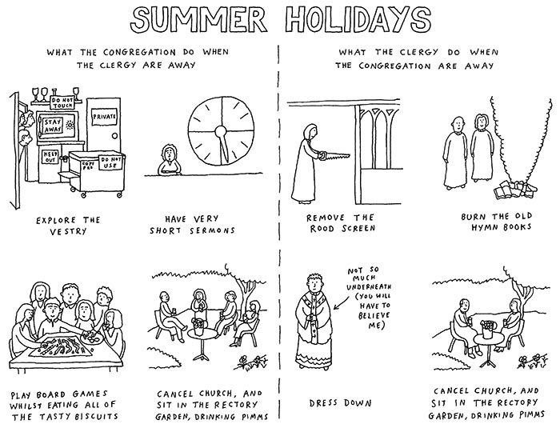

# Sunday 17 August – Trinity 9 – Proper 15

**Collect**

Almighty God,

who sent your Holy Spirit

to be the life and light of your Church:

open our hearts to the riches of your grace,

that we may bring forth the fruit of the Spirit

in love and joy and peace;

through Jesus Christ your Son our Lord,

who is alive and reigns with you,

in the unity of the Holy Spirit,

one God, now and for ever.

**First Reading – Jeremiah 23:23-29**

Am I a God near by, says the LORD, and not a God far off? Who can hide in secret places so that I cannot see them? says the LORD. Do I not fill heaven and earth? says the LORD. I have heard what the prophets have said who prophesy lies in my name, saying, ‘I have dreamed, I have dreamed!’ How long? Will the hearts of the prophets ever turn back – those who prophesy lies, and who prophesy the deceit of their own heart? They plan to make my people forget my name by their dreams that they tell one another, just as their ancestors forgot my name for Baal. Let the prophet who has a dream tell the dream, but let the one who has my word speak my word faithfully. What has straw in common with wheat? says the LORD. Is not my word like fire, says the LORD, and like a hammer that breaks a rock in pieces?

**Second Reading – Hebrews 11:29 – 12:2**

By faith the people passed of Israel through the Red Sea as if it were dry land, but when the Egyptians attempted to do so they were drowned. By faith the walls of Jericho fell after they had been encircled for seven days. By faith Rahab the prostitute did not perish with those who were disobedient, because she had received the spies in peace. And what more should I say? For time would fail me to tell of Gideon, Barak, Samson, Jephthah, of David and Samuel and the prophets – who through faith conquered kingdoms, administered justice, obtained promises, shut the mouths of lions, quenched raging fire, escaped the edge of the sword, won strength out of weakness, became mighty in war, put foreign armies to flight. Women received their dead by resurrection. Others were tortured, refusing to accept release, in order to obtain a better resurrection. Others suffered mocking and flogging, and even chains and imprisonment. They were stoned to death, they were sawn in two, they were killed by the sword; they went about in skins of sheep and goats, destitute, persecuted, tormented – of whom the world was not worthy. They wandered in deserts and mountains, and in caves and holes in the ground. Yet all these, though they were commended for their faith, did not receive what was promised, since God had provided something better so that they would not, apart from us, be made perfect. Therefore, since we are surrounded by so great a cloud of witnesses, let us also lay aside every weight and the sin that clings so closely, and let us run with perseverance the race that is set before us, looking to Jesus the pioneer and perfecter of our faith, who for the sake of the joy that was set before him endured the cross, disregarding its shame, and has taken his seat at the right hand of the throne of God.

**Gospel Acclamation**

Alleluia, alleluia.

I am the way, the truth, and the life, says the Lord.

No one comes to the Father except through me.

**Alleluia.**

**Gospel Reading – Luke 12:49-56**

Jesus said to his disciples: ‘I came to bring fire to the earth, and how I wish it were already kindled! I have a baptism with which to be baptized, and what stress I am under until it is completed! Do you think that I have come to bring peace to the earth? No, I tell you, but rather division! From now on five in one household will be divided, three against two and two against three; they will be divided: father against son and son against father, mother against daughter and daughter against mother, mother- in-law against her daughter-in-law and daughter-in-law against mother-in-law.’ He also said to the crowds, ‘When you see a cloud rising in the west, you immediately say, “It is going to rain”; and so it happens. And when you see the south wind blowing, you say, “There will be scorching heat”; and it happens. You hypocrites! You know how to interpret the appearance of earth and sky, but why do you not know how to interpret the present time?’

**Post Communion Prayer**

Holy Father,

who gathered us here around the table of your Son

to share this meal with the whole household of God:

in that new world where you reveal the fullness of your peace,

gather people of every race and language

to share in the eternal banquet of Jesus Christ our Lord.